**[CVBG Abraham Lincoln (CVN-72)](https://en.wikipedia.org/wiki/USS_Abraham_Lincoln_(CVN-72))**

CVN-72 or ‘**Abe**’ isdeployed to the Pacific Fleet as planned in 1991 to join *CVN-68 Nimitz* as the second nuclear powered carrier on the west coast. When war starts she’s in the process of deploying to the Indian Ocean, enroute to the Persian Gulf to replace the *Nimitz* for an 8-month deployment. Departing the US before Christmas 1993 she conducted an exercise with *CV-62 Independence* and *CV-63 Kitty Hawk* (just returning from the Persian Gulf) off of the Philippines in January, followed by a port visit to Sydney Australia at the beginning of February. She is heading to the Indian Ocean at war start but will almost immediately be recalled to the Pacific to help stabilize maters there.

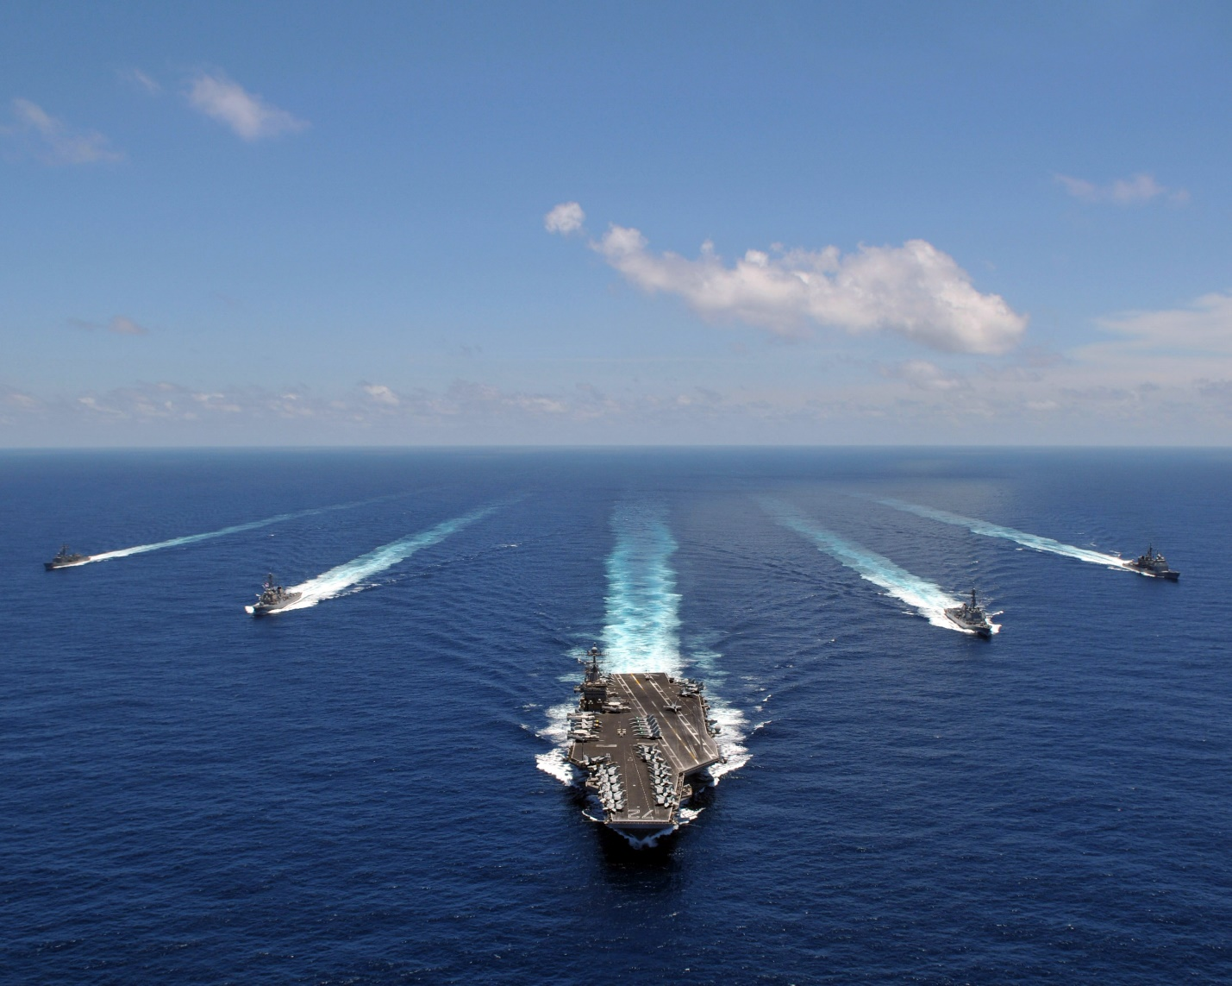

USS Abraham Lincoln CVBG

* CVN-72 Abraham Lincoln (FLAG)
  + CVW 11
    - VF-213 Black Lions F-14A
    - VF-102 Diamondbacks F-14A
    - VFA-22 Fighting Redcocks F/A-18C (N)
    - VFA-94 Mighty Shrikes F/A-18C (N)
    - VFMA-314 Black Knights F/A-18A
    - VA-95 Green Lizards A-6E SWIP (From 1 March)
    - VAQ-135 Black Ravens EA-6B
    - VAW-117 Wallbangers E-2C
    - VS-29 Dragonfires S-3B
    - HS-6 Indians SH-60F, HH-60H
    - VQ-5(El) Sea Shadows ES-3A
  + CG-51 Thomas S. Gates
  + CG-30 Horne
  + CG-24 Reeves
  + DDG-54 Curtis Wilber
  + DD-981 John Hancock
  + FFG-51 Gary
  + FFG-32 John L. Hall

Notes

1. VA-95, deploys when the Navy reactivates 6x A-6E Sqns (only 8 AC)