**[USS America (CV-66)](https://en.wikipedia.org/wiki/USS_America_(CV-66))**

CV-66, nicknamed ‘**The Big A**’ had just returned from an 8-month patrol in the Mediterranean a week before war start. She’d been replaced by *CVN-69 Eisenhower* and was long overdue for a 4-6-month maintenance overhaul in dry-dock. She enters dry-dock two days after war start and her air group (CVW-1) and battle group are dispersed amongst the fleet. She hastily emerges from the Navy Yard in April of 94 with a rebuilt air group based on the East Coast Reserve wing CVWR-20 and is in time to joint the fleet actions in May.

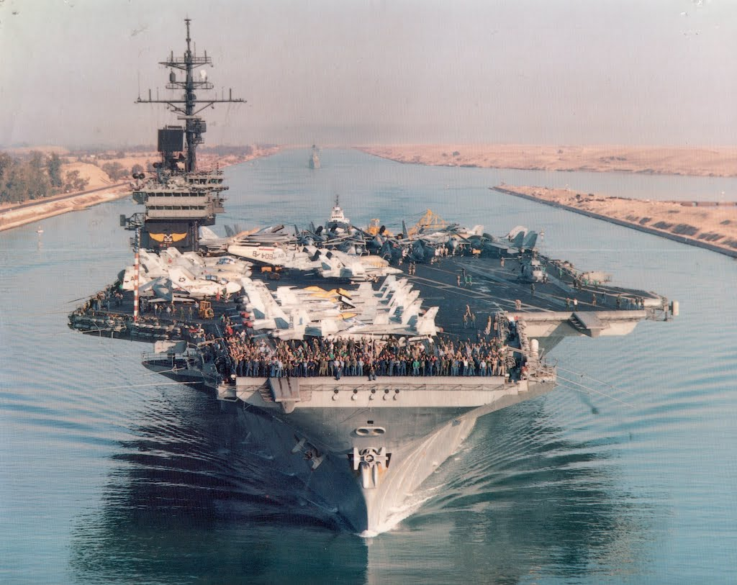

USS America CVBG

* CV-66 America
  + CVW-1
    - VF-33 Starfighters F-14A (To CVW-3 on Eisenhower)
    - VF-102 Diamondbacks F-14A (To CVW-11 on Lincoln)
    - VFA-86 Sidewinders F/A-18C (To Training Depot for replacements)
    - VFA-136 Knighthawks F/A-18C (To CVW-6 on Enterprise)
    - VAQ-137 Rooks EA-6B (To Training Depot for replacements)
    - VAW-123 Screwtops E-2C (To Training Depot for replacements)
    - VS-32 Mauleers S-3B (To CVW-7 on Kennedy)
    - HS-11 Dragon Slayers SH-3H (To CVW-7 on Kennedy)
  + CVWR-20 (Formed Apr and deploy to re-launched CV-66 May 94)
    - VF-201 Hunters F-14A
    - VF-202 Superheats F-14A
    - VFA-203 Blue Dolphins F/A-18C
    - VFA-204 River Rattlers F/A-18C
    - VAQ-137 Rooks EA-6B (From Training Depot)
    - VAW-123 Screwtops E-2C (From Training Depot)
    - VS-35 Boomerangs S-3B
    - HS-209 Golden Gates SH-3H
  + Escorts formed as required