**[CVBG Carl Vinson (CVN-70)](https://en.wikipedia.org/wiki/USS_Carl_Vinson)**

In Northern Fury, when the *USS Carl Vinson* or ‘**BattleStar**’ came out of Comprehensive Overhaul (COH) in April of 1993, she was re-based from San Diego to Norfolk to address the gap in combat power in the Atlantic while the Enterprise was in its Refueling and COH (RCOH). Consequently, *CVN-72, George Washington* moved to the Pacific after her workups later in 93. Historically the *Washington* was in 2nd Fleet in the Atlantic while the *Vinson* was in 7th Fleet in the Pacific, this is a simple hull reversal but it left 4x CVNs in the Atlantic and 3x CVNs in the Pacific. Keeping the much older and smaller *USS Saratoga* was also a measure to balance the east-west mix. The *Carl Vinson* is tied up in Norfolk Virginia at the start of the war undergoing routine maintenance and training. She will be ready to deploy by 16 Feb and in action by 19 Feb.

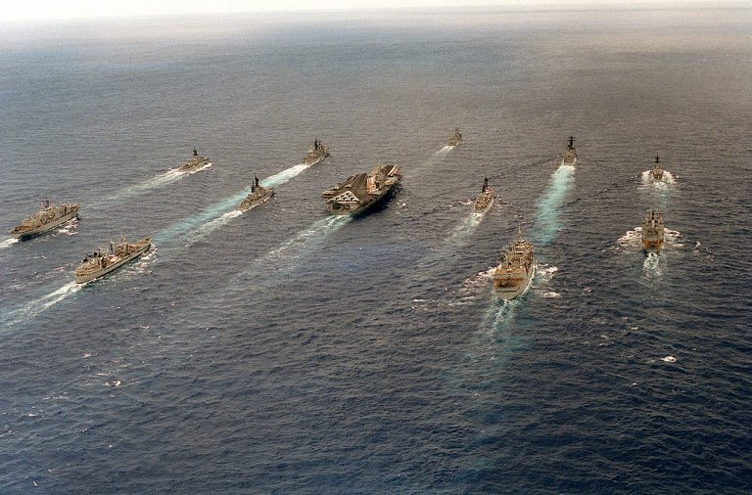

USS Carl Vinson CVBG

* CVN-70 Carl Vinson (FLAG)
  + CVW 17
    - VF-11 Red F-14D
    - VF-31 Tomcatters F-14D
    - VF-143 Pukin Dogs F-14B (From 22 Feb)
    - VFA-25 Fist of the Fleet F/A-18C
    - VFA-113 Stingers F/A-18C
    - VMFA-122 Werewolves F/A-18A (Until 25 Feb)
    - VA-65 Fighting Tigers A-6E (From 27 Feb)
    - VAQ-139 Cougars  EA-6B
    - VS-35 Blue Wolves S-3B
    - VAW-113 Black Eagles E-2C
    - VQ-4 (El) Shadows ES-3A
    - HS-8 Eightballers SH-60F & HH60H
  + CG-55 Leyte Gulf
  + CG-67 Shiloh
  + CGN-41 Arkansas
  + DDG-57 Mitscher
  + DDH-283 Algonquin (CAN)
  + DD-964 Paul F Foster
  + FFG-47 Nicholas
  + FFG-59 Kauffman
  + FFH-266 Nipigon (CAN)
  + FFH-333 Toronto (CAN)
  + AOE-6 Supply
* SSN-750 Newport News
* SSN-756 Scranton

1. VF-31 deploys to the Eisenhower from CVW-1 when the America enters Dry Dock on the 19th of Feb.
2. VMFA-312 departs for land based operations once the USMC is established on Iceland.
3. VA-85, deploys when the Navy reactivates 6x A-6E Sqns (only 8 AC)
4. F-83 and F-332 join the Eisenhower BG as she enters the Atlantic and proceeds north. F-93 joins the group after escorting the RN AOR, HMS Fort George to meet with the Eisenhower of the coast of Ireland.