CVBG Constellation (CV-64)

USS Constellation, or Connie was commissioned in 1961, but the 33-year-old carrier had completed a 3-year long Service Life Extension Program (SLEP) in March of 1993 which prepared her for another 20 years of sailing. When war breaks out she is conducting a training exercise with the Philippine Navy and Air Force after spending several months visiting various western Pacific countries. She was due to return to San Diego in late February but was re-tasked to support USS Independence (CV-62) instead. Here air group takes a beating in the first days of the war and she is withdrawn to the West Coast to reconstitute.

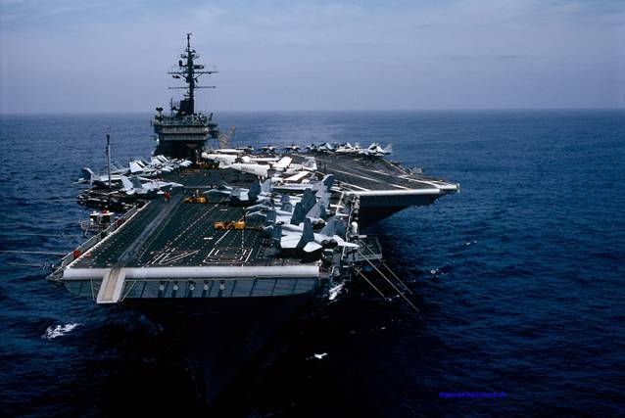

CVBG Constellation

* CV-64 Constellation (FLAG)
* CVWR 2
* VF-1 Wolfpack F-14A
* VF-2 Bounty Hunters F-14A
* VFA-151 Vigilantes F/A-18C (N)
* VMFA-323 Death Rattlers F/A-18D
* VAQ-131 Lancers EA-6B
* VAW-116 Sun Kings E-2C
* VS-31 Topcats S-3B
* HS-16 Bullfrogs SH-3H
* VQ-5(El) Sea Shadows ES-3A
* CG-21 Gridley
* CG-49 Vincennes
* CG-70 Lake Erie
* DD-965 Kinkaid
* DD-990 Ingersoll
* FFG-27 Mahlon S. Tisdale
* AO-180 Willamette