**[CVBG Eisenhower (CVN-69)](https://en.wikipedia.org/wiki/USS_Dwight_D._Eisenhower)**

*USS Eisenhower* or ‘**Ike**’starts the war on a routine patrol with 6th Fleet in the Western Mediterranean.  After a few days of intense fighting in the Med, including concentrated strikes on Libya, the CVBG is ordered to rapidly replenish and reinforce the North Atlantic.  The Nimitz Battle Group enters the Eastern Med through the Suez Canal as the Eisenhower departs through Gibraltar on 19 Feb.

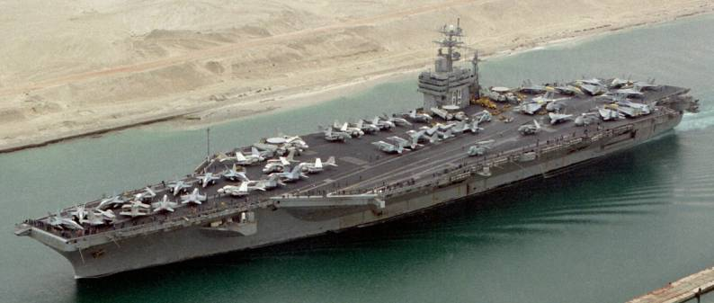

CVBG Eisenhower

* CVN 69 Eisenhower (FLAG)
  + CVW 3
    - VF-32 Fighting Swardsmen F-14B
    - VF-111 Starfighters F-14A (From 19 Feb)
    - VF-194 Red Lightnings F-14B
    - VFA-37 Bulls F/A-18C
    - VFA-105 Gunslingers F/A-18C
    - VMFA-312 Checkerboards F/A-18D (Until 26 Feb)
    - VA-85 Black Falcons A-6E (From 27 Feb)
    - VAQ-130 Zappers EA-6B
    - VS-22 Checkmates S-3B
    - VAW-126 Seahawks E-2C
    - VQ-6 (El) Black Ravens ES-3A
    - HS-7 Tridents SH-60F & HH60H
  + CGN-38 Virginia
  + CG-56 San Jacinto
  + CG-69 Vicksburg
  + DDG-51 Arleigh Burke
  + DD-971 David R Ray
  + FFG-40 Halyburton
  + FFG-45 De Wert
  + F-83 Numancia (ESP) (From 19 Feb)
  + F-93 Beaver (GBR) (From 21 Feb)
  + F-332 Corte Real (PRT) (From 19 Feb)
  + AOE-4 Detroit
* SSN 703 Boston
* SSN 706 Albuquerque

1. VF-31 deploys to the Eisenhower from CVW-1 when the America enters Dry Dock on the 19th of Feb.
2. VMFA-312 departs for land based operations once the USMC is established on Iceland.
3. VA-85, deploys when the Navy reactivates 6x A-6E Sqns (only 8 AC)
4. F-83 and F-332 join the Eisenhower BG as she enters the Atlantic and proceeds north. F-93 joins the group after escorting the RN AOR, HMS Fort George to meet with the Eisenhower of the coast of Ireland.