**[CVBG Enterprise (CVN-65)](https://en.wikipedia.org/wiki/USS_Enterprise_(CVN-65))**

The *USS Enterprise* or ‘**Big E**’ was rushed through her Complex Refueling and Overhaul (ROH), putting to sea for initial tests in late Jan 94, several months in advance of her historic schedule. The Big-E and elements of her Battle Group departed Norfolk on 4th of February to carry out workup trials and training in Puerto Rico, where the rest of the Battle Group joined them. On 11 Feb, 4 days into a 10-day testing and training schedule she is ordered north at best speed, destination the GIUK Gap. The start of the war finds her steaming northward toward her first engagement on the 17th of Feb.

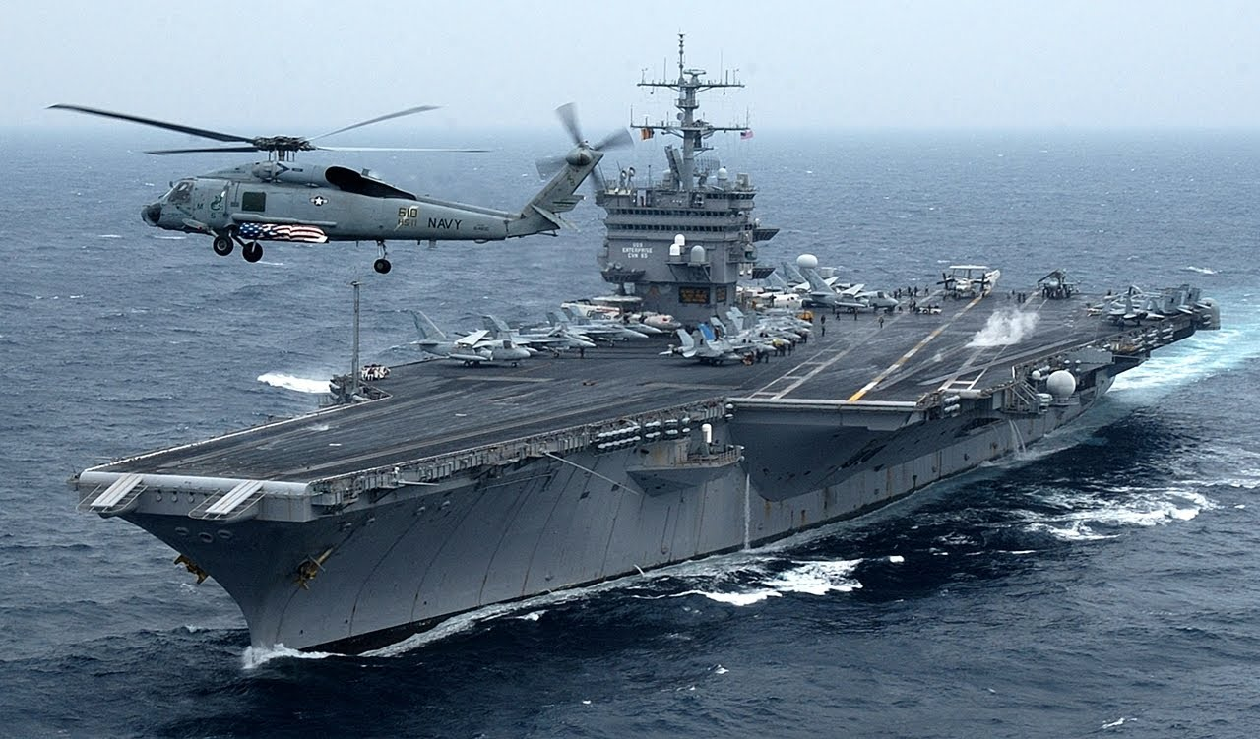

USS Enterprise CVBG

* CVN 65 Enterprise (FLAG)
  + CVW 6
    - VF-51, Screamin’ Eagles F-14A
    - VF-111 Sundowners F-14B
    - VFA-132 Privateers F/A-18C & C+
    - VFA-137, Kestrels F/A-18A
    - VFA-252 Knighthawks F/A-18C (From 18 Feb)
    - VMFA-251 Thunderbolts F/A-18A (Until 26 Feb)
    - VA-176, Thunderbolts A-6E
    - VAQ-133 Wizards EA-6B
    - VS-28 Gamblers S-3B
    - VAW-122 Steeljaws E-2C
    - VQ-4 (El) Shadows ES-3A
    - HS-15 Red Lions SH-60F & HH60H
  + CG 17 Yarnell
  + CG 63 Cowpens
  + CG 68 Anzio
  + DD 987 O’Bannon
  + DD 988 Thorne
  + FFG 38 Curts
  + FFG 56 Simpson
  + AOE 3 Seattle
* SSN 707 Portsmouth
* SSN 721 Chicago
* SSN 751 San Juan

**CVN-65 Timeline 1994**

|  |  |  |
| --- | --- | --- |
| **Date** | **Activity** | **Remarks** |
| 10-Jan | Exit Drydock & move to Norfolk |  |
| 15-Jan | Outfit ship |  |
| ~20 Jan | Day sail |  |
| ~28 Jan | 3 Day sail |  |
| 01-Feb | Prep to depart Norfolk |  |
| 04-Feb | Depart Norfolk with CG & 2 DD | 1200nm |
| 07-Feb | Enterprise arrives Puerto Ricco, links with remainder of BG and starts a scheduled 10-day training period |  |
| 11-Feb | Enterprise departs Puerto Ricco for Iceland | @18Knts = 6 days |