**[USS Forrestal (AVT-59)](https://en.wikipedia.org/wiki/USS_Forrestal_(CV-59))**

The *USS Forrestal*, or ‘**Zippo**’ moved to Naval Air Station Pensacola to replace the *USS Lexington* as the Navy’s training carrier in September of 92 when she was reclassified as an auxiliary and given the title ‘AVT’ (Training Aircraft Carrier). Historically this transition was cancelled early in 93 however, and the USN lost its only dedicated training carrier.  In Northern Fury the transition continued and by the end of 93 the *Forrestal* was fully operational as AVT-59.

Flight operations are conducted by Training Air wing 6 (TAW 6) and includes VT-86 Saberhawks equipped with the 24 of the new T-45C Goshawk.

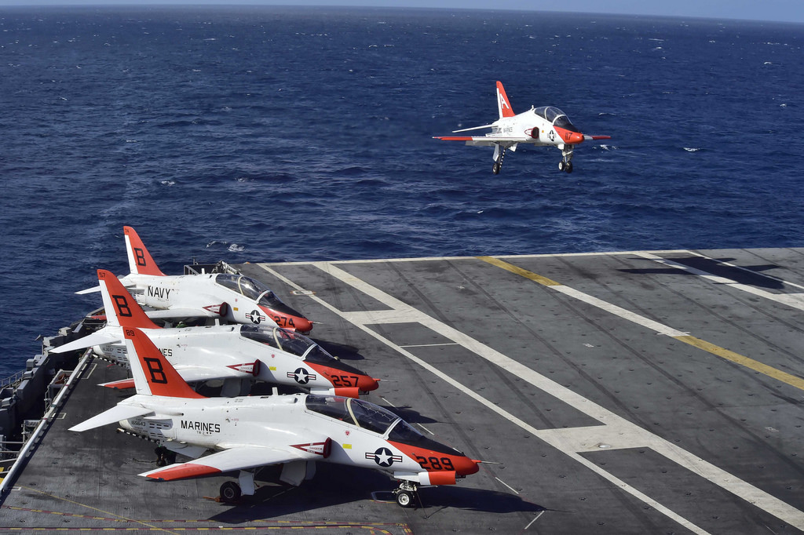

AVT Forrestal

Training Air Wing 6

* VT-4 Warbucks T-2C Buckeye
* VT-10 Wildcats T-34C Mentor
* VT-86 Saberhawks T-45C Goshawk

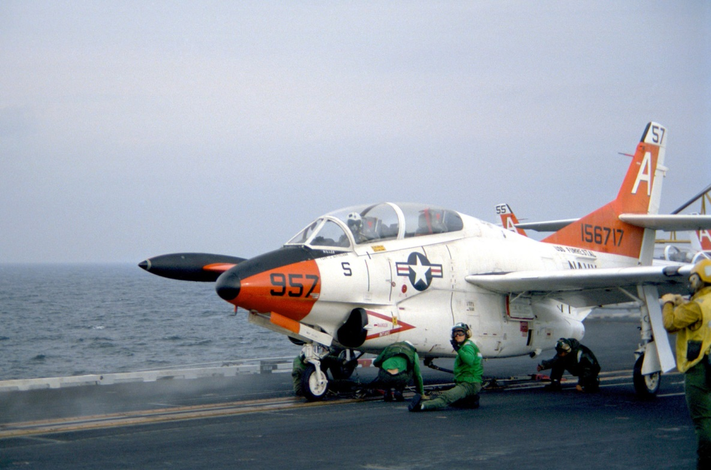

T-2C Buckeye

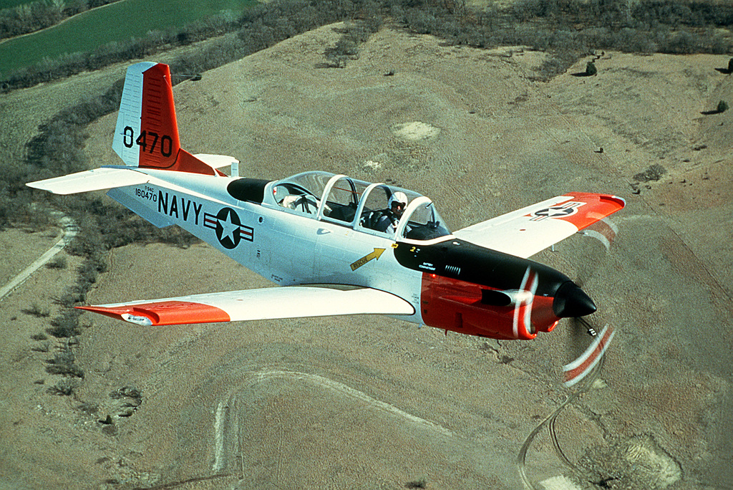

T-34C Mentor

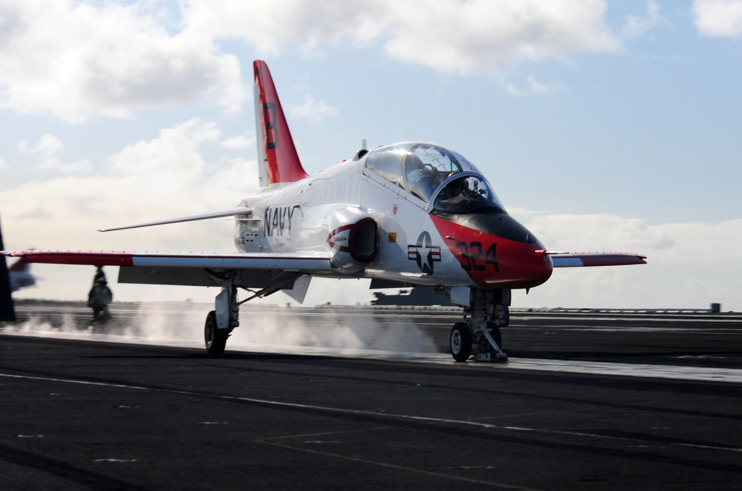

T-45C Goshawk