**[CVBG George Washington (CVN-73)](https://en.wikipedia.org/wiki/USS_George_Washington_(CVN-73))**

Because CVN-70 was kept in the Atlantic due to the increasingly aggressive stance of a resurgent Soviet Union, joining both *CVN-69 Dwight D. Eisenhower* and ultimately *CVN-71 Theodore Roosevelt*, the fleets were out of balance. Therefore, both *CVN-72 Abraham Lincoln* and *CVN-73 George Washington* were based in the Pacific immediately upon commissioning, joining *CVN-68 Nimitz* and equalizing the new carriers with three on each coast.

*USS Washington* or *‘****GW***” commenced here career with a 9-month tour of the Indian Ocean and Persian Gulf in 93 and has been conducting routine maintenance and training since returning San Diego in October of 93. She is currently the ready reaction carrier on the West Coast and when hostilities commence she will deploy on the 17th of Feb and head to the Philippines area.

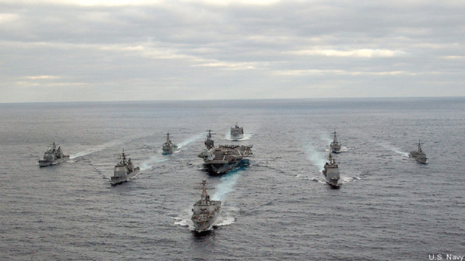

USS George Washington CVBG

* CVN-73 George Washington (FLAG)
  + CVW 10
    - VF-103 Sluggers F-14B
    - VF-142 Ghostriders F-14B
    - VFA-136 Knight Hawks F/A-18C (N)
    - VFA-161 Chargers F/A-18C (N)
    - VA-34 Blue Blasters A-6E SWIP (From 1 March)
    - VAW-111 Grey Berets E-2C
    - VS-35 Blue Wolves S-3B
    - HS-16 Nighthawks SH-60F, HH-60H
    - VQ-5(El) Sea Shadows ES-3A
  + CG-57 Lake Champlain
  + CG-59 Princeton
  + CG-65 Chosin
  + DDG-52 Berry
  + DD-966 Hewitt
  + FFG-36 Underwood
  + FFG-46 Rentz

Notes

1. VA-34, deploys when the Navy reactivates 6x A-6E Sqns (only 8 AC)
2. CVW-10 does not currently have a VAQ (Electronic Warfare) Sqn, but will pick up VAQ-131 ‘Lancers’ when CVW-2 disperses from *CV-64 Constellation* near the end of Feb 94.