**USN Aircraft Carriers**

Aircraft carriers are a key lynchpin in US global power projection policy. In peacetime they exhibit America’s military strength and interest wherever they’re deployed and at war they are fundamental in carrying out theatre level plans and operations. This [blog](http://northernfury.us/blog/post8/) explains in detail the situation regarding aircraft carriers at the start of Northern Fury. Below is a list of the aircraft carriers currently in commission.

[**Midway Class**](https://en.wikipedia.org/wiki/Midway-class_aircraft_carrier): Both remaining ships of this class were built in World War Two and served a long and productive career operating throughout the Cold War, Viet Nam and many other conflicts; they were modernized several times. ***Midway*** deployed to the Gulf war and ***Coral Sea*** earned the nickname ‘Ageless Warrior’. Both are retired to the inactive reserve and laid up at Bremerton Washington but could be re-commissioned with about 1 year of work. One major drawback to these carriers is that they were too small to operate the USNs primary air superiority fighter, the F-14 Tomcat, instead they would routinely deploy with three F/A-18 squadrons and two A-6E squadrons. With the A-6E retiring early in Northern Fury, they would need a full wing of F/A-18s.

|  |  |  |  |  |  |  |
| --- | --- | --- | --- | --- | --- | --- |
| Class | Ship | Pennant | Status | Location | Task | Available |
| Midway | Midway | CV-41 | Retired 1992 | West Coast | Reserve | Mar-95 |
|  | Coral Sea | CV-43 | Retired 1990 | West Coast | Reserve | May-95 |

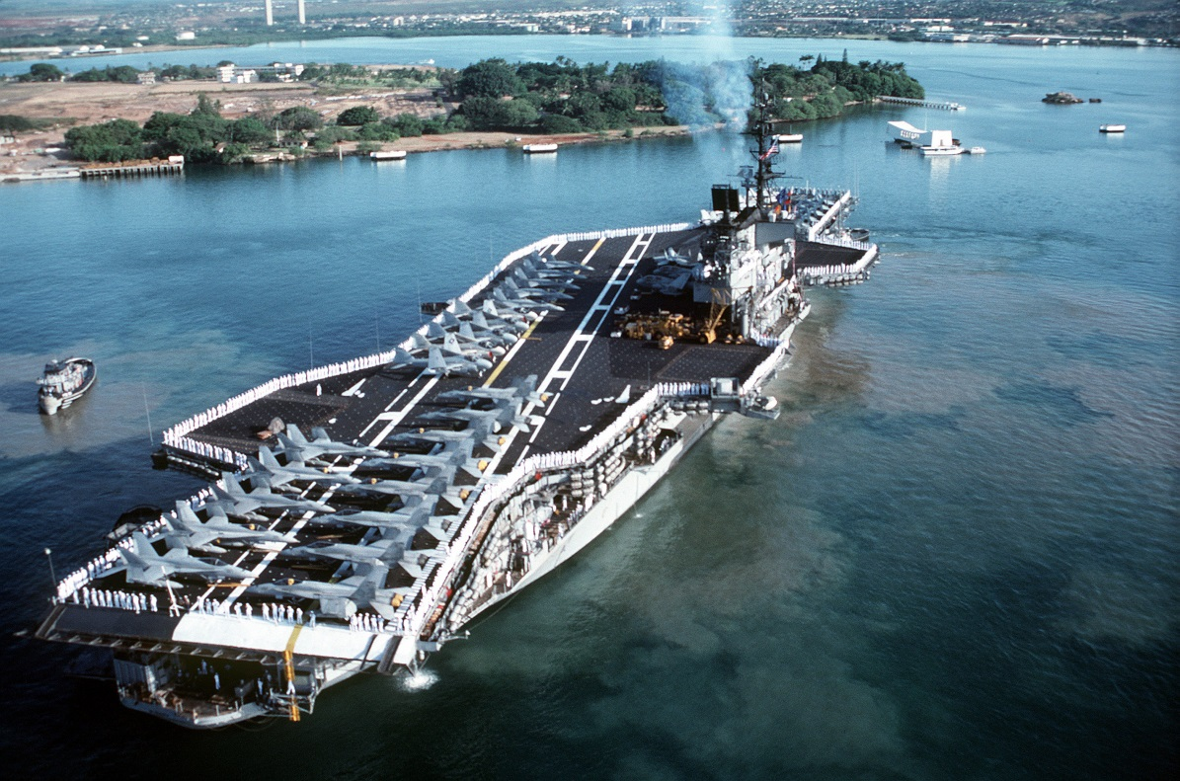

[**Forrestal Class**](https://en.wikipedia.org/wiki/Forrestal-class_aircraft_carrier): These four venerable ships have been sailing since the 50’s and have extensive combat experience. Built from the keel up as ‘Supercarriers’ they displaced 25% more than the Midway class, were 100 feet longer and also wider, and could operate 80-100 jet aircraft. They had a much deeper hull, an armored flight deck and four elevators. Although these ships were effective they were 40 years old and destined to retire as the Nimitz class ships come on line; until increased tensions caused a re-think on that plan. ***Saratoga*** and ***Independence*** are still operational, while ***Forrestal*** is operating as a training ship and ***Ranger*** is in active reserve with a skeleton crew, she will take 30-60 days to activate.

|  |  |  |  |  |  |  |
| --- | --- | --- | --- | --- | --- | --- |
| Class | Ship | Pennant | Status | Location | Task | Available |
| Forrestal | Forrestal | AVT-59 | Training | East Coast | Training |  |
|  | Saratoga | CV-60 | Active | Indian | Patrol |  |
|  | Ranger | CV-61 | Active Reserve | West Coast | Active Reserve | April-94 |
|  | Independence | CV-62 | Active | Pacific | Philippines |  |

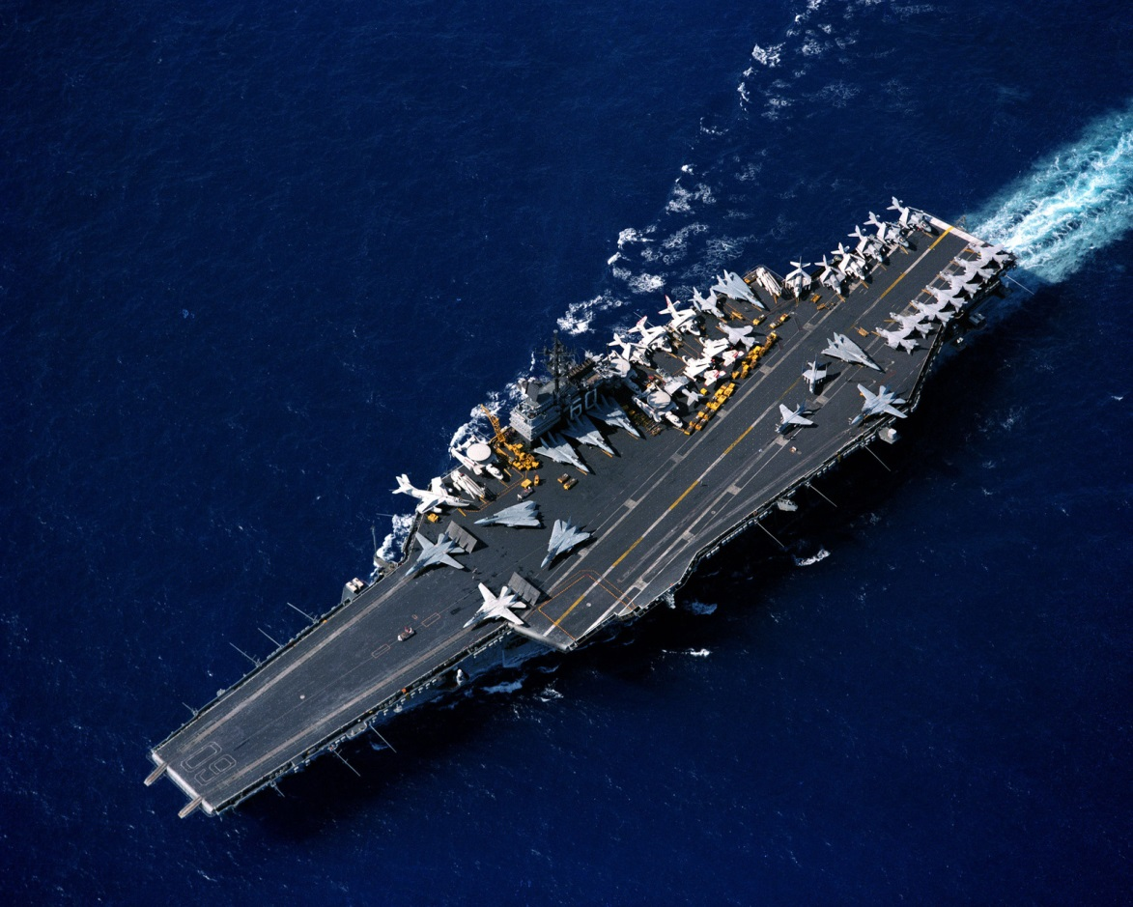

[**Kitty Hawk Class**](https://en.wikipedia.org/wiki/Kitty_Hawk-class_aircraft_carrier): Often called ‘Improved ***Forrestal***’***s***’ these four ships were newer, longer, and their elevators were repositioned to improve aircraft handling. Fourth in this class, the *John F. Kennedy* has so many variations from the original design that she is often considered a single ship class. These were the last conventionally powered aircraft carriers built; the ***USS* *Enterprise*** was built alongside the first two ships and claimed the ‘65’ pennant but more importantly paved the way for nuclear propulsion of the follow on ***Nimitz*** class.

|  |  |  |  |  |  |  |
| --- | --- | --- | --- | --- | --- | --- |
| Class | Ship | Pennant | Status | Location | Task | Available |
| Kitty Hawk | Kitty Hawk | CV-63 | Active | Pacific | Tied Up | Feb-94 |
|  | Constellation | CV-64 | Active | Pacific | Japan |  |
|  | America | CV-66 | Active | Atlantic | Refit | Jul-94 |
|  | John F Kennedy | CV-67 | Active | Caribbean | Patrol |  |

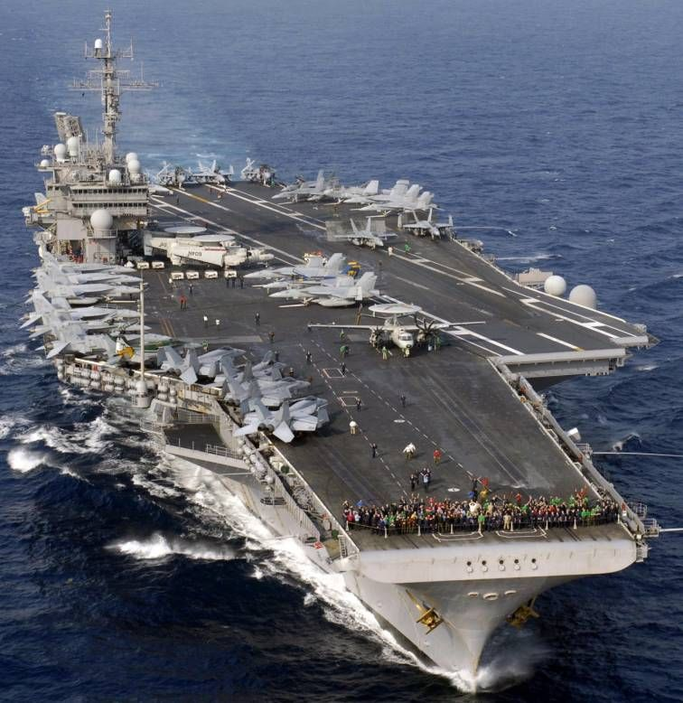

[**Enterprise**](https://en.wikipedia.org/wiki/USS_Enterprise_(CVN-65))**:** The ***Enterprise*** is the first nuclear powered aircraft carrier and although the plan was for a class of six ships, those plans were canceled and she became a single ship class. Lunched in 1961 she is just finishing her mid-life ‘Refueling and Complex Overhaul’ (RCOH) in 40 vice the actual 48 months that it took historically. She sails for workups in Puerto Rico on 4 Feb 94 and was re-routed for Iceland on 11 Feb in response to heighted threat.

|  |  |  |  |  |  |  |
| --- | --- | --- | --- | --- | --- | --- |
| Class | Ship | Pennant | Status | Location | Task | Available |
| Enterprise | Enterprise | CVN-65 | Active | P Rico | Workups |  |

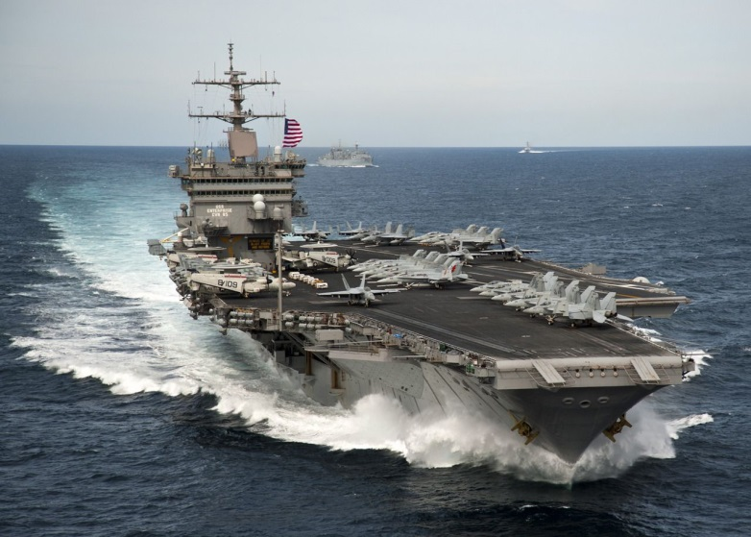

[**Nimitz Class**](https://en.wikipedia.org/wiki/Nimitz-class_aircraft_carrier)**:** The epitome of modern aircraft carriers, the ***Nimitz*** represents the culmination of 50 years’ evolution of aircraft carrier operations. Seven of the eventual ten ships of this class are represented in Northern Fury.  The seventh, ***CVN-74 John C. Stennis*** was started in Jan 1990 in response to the increased threat from the Soviet Union, immediately space was made available behind ***CVN-73 George Washington***. After starting work 14 months early she will be commissioned 20 months early in April of 94.

|  |  |  |  |  |  |  |
| --- | --- | --- | --- | --- | --- | --- |
| Class | Ship | Pennant | Status | Location | Task | Available |
| Nimitz | Nimitz | CVN-68 | Active | Persian Gulf | Patrol |  |
|  | Dwight D Eisenhower | CVN-69 | Active | Mediterranean | Patrol |  |
|  | Carl Vinson | CVN-70 | Active | Atlantic | Tied Up | Feb-94 |
|  | Theodore Roosevelt | CVN-71 | Active | Atlantic | Tied Up | Feb-94 |
|  | Abraham Lincoln | CVN-72 | Active | Indian | Patrol |  |
|  | George Washington | CVN-73 | Active | Pacific | Tied Up |  |
|  | John C Stennis | CVN-74 | Building | Newport |  | Apr-94 |

