NATO/US Navy/US Navy CVBGs

**CVBG John F Kennedy (CV-67)**

USS John F Kennedy was the newest conventionally powered Aircraft Carrier in the American Fleet, and at 25 years of service had emerged from a mid-life refit in 1993.  Departing Norfolk just after Christmas, she and parts of her Battle Group were conducting training in the Gulf of Mexico and Caribbean when war broke out.  After some intense action she is destined to reconfigure her air group and take up duties securing the Sea Lines of Communications.

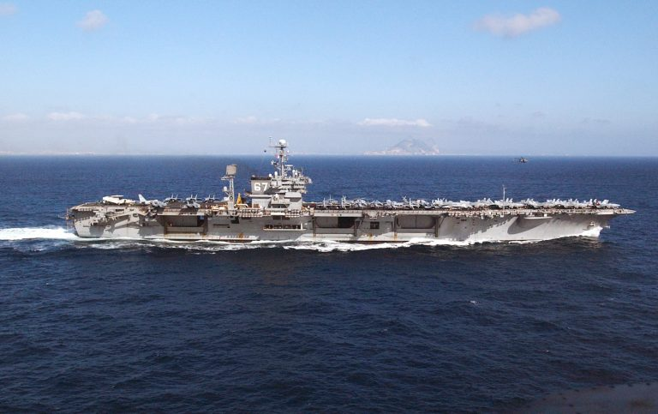

CVBG John F Kennedy

* CV-67 John F Kennedy(FLAG)
* CVW 10
* VF-124 Gunfighters (F-14D Bombcat)
* VF-143 Pukin Dogs (F-14B) Until 24 Feb
* VFA-83 Rampagers (F/A-18C (N))
* VFA-131 Wildcats (F/A-18C (N))
* VAQ-140 Patriots (EA-6B)
* VS-32 Maulers (S-3B) From 24 Feb
* VS-38 Red Griffins (S-3B)
* VAW-121 Bluetails (E-2C)
* VQ-4 (El) Shadows (ES-3A)
* HS-5 Nightdippers (SH-3H)
* HS-11 Dragon Slayers (SH-3H) From 24 Feb
* CGN-9 Long Beach
* CG-19 Dale
* CG-48 Yorktown
* DDG-993 Kidd
* DD-979 Conolly
* FFG-52 Carr
* FFG-57 Reuben James