**[CVBG John C. Stennis (CVN-74)](https://en.wikipedia.org/wiki/USS_John_C._Stennis)**

CVN-74 ‘**Johnny Reb**’ is currently completing construction and is being rushed into service. She will put to sea for builder’s trials in Mar 94 and acceptance trials in early April. Commissioning will be accelerated to 10 April 94 when she will conduct rapid qualification of all her systems and transit to the North Sea by the end of April. Her air group, based on the Reserve Air wing for the West Coast (CVWR-30), is conducting carrier qualification on CV-64 Constellation which is in the process of reconstituting its air group at San Diego.

The Stennis is destined for the 3rd Fleet on the West Coast but will conduct operations in the North Atlantic for two months prior to heading back into dry-dock in July to work on any issues discovered and then transit to San Diego in August. Her Battle Group will form as required near the end of April and until then will conduct other tasks.

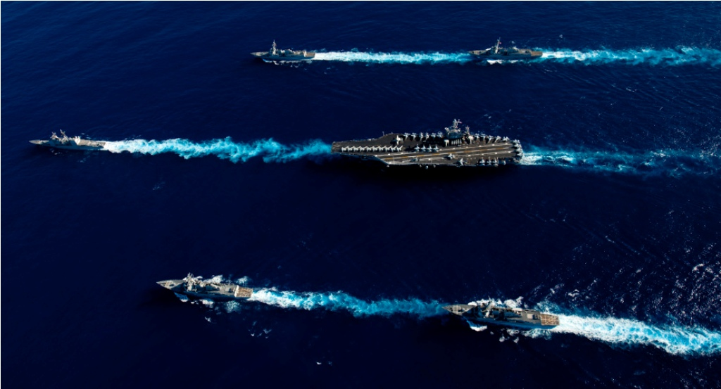

USS John C. Stennis CVBG

* CVN-74 John C. Stennis (FLAG)
  + CVWR 30
    - VF-301 Devils Disciples F-14D
    - VF-302 Stallions F-14D
    - VFA-303 Golden Hawks F/A-18C
    - VFA-305 Lobos F/A-18C
    - VA-52 Knightriders A-6F
    - VAQ-309 Axemen EA-6B
    - VAW-88 Cotton Pickers E-2C
    - VS-31 Topcats S-3B
    - HS-85 Golden Gators SH-60F, HH-60H
    - VQ-5(El) Sea Shadows ES-3A
  + CG-73 Port Royal (Builders trials at war start)
  + CG-72 Villa Gulf
  + CG-61 Monterey
  + DD-997 Hayler
  + DD-986 Harry W. Hill
  + FFG-54 Klakring
  + FFG-43 Ford

Notes

1. VS-31, ‘Topcats’ will join the air wing from CVW-2 from CV-64 Constellation.