NATO/US Navy/US Navy CVBGs

CVBG Kitty Hawk (CV-63)

USS Kitty Hawk, or Battle Cat was commissioned in 1961, six months ahead of her sister ship the Constellation, and completed a 3-year long Service Life Extension Program (SLEP) in August of 1990 which prepared her for another 20 years of sailing. When war breaks out she is tied up at San Diego going through a period of routine maintenance. She will deploy to the western Pacific to join the other carriers of the Pacific Fleet by the end of February.

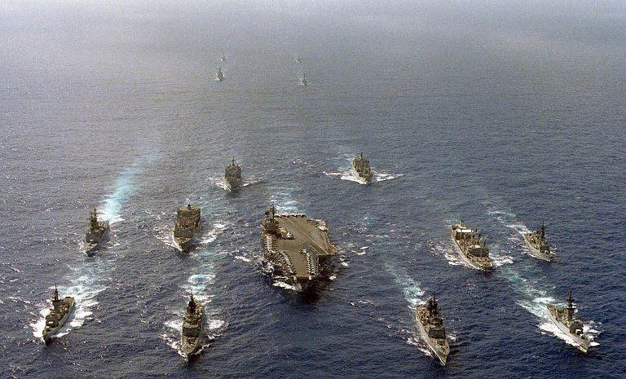

CVBG Kitty Hawk

* CV-63 Kitty Hawk (FLAG)
  + CVW 15
    - VF-74 Be-Devilers F-14B
    - VF-84 Jolly Rogers F-14B
    - VFA-27 Royal Maces F/A-18A
    - VFA-97 Warhawks F/A-18A
    - VAQ-134 Garudas EA-6B
    - VAW-114 Hormel Hogs E-2C
    - VS-37 Sawbucks S-3B
    - HS-4 Black Knights SH-60F, HH-60H
    - VQ-5(El) Sea Shadows ES-3A
  + CGN-35 Truxton
  + CG-54 Antietam
  + CG-71 Cape St. George
  + DD-973 John Young
  + DD-985 Cushing
  + FFG-31 Stark
  + FFG-34 Aubrey Fitch