**[USS Ranger (CV-61)](https://en.wikipedia.org/wiki/USS_Ranger_(CV-61))**

*USS Ranger*, was commissioned in 1957 as the third of four Forrestal class carriers and through her long life she doesn’t complete a Service Life Extension Program (SLEP), only a Complex overhaul in 1985/85. She was nicknamed ‘Top Gun’ after parts of that movie was filmed on board. Due for de-commissioning after the Gulf War, she was saved from the scrapers when heightened tensions caused an adjustment to that plan. Instead she followed *CV-41 Midway* into the Reserve fleet when that carrier was moved to inactive reserve in early 92. Since that time she’s been tied up with a skeleton crew, but will activate again at the start of the war. In late March she will sail for the Western Pacific in direct support of the USMC 3rd Marine Amphibious Force, and then the Indian Ocean to relieve her sister ship *CV-60 Saratoga*, allowing ‘Sara’ some badly needed and overdue maintenance time.

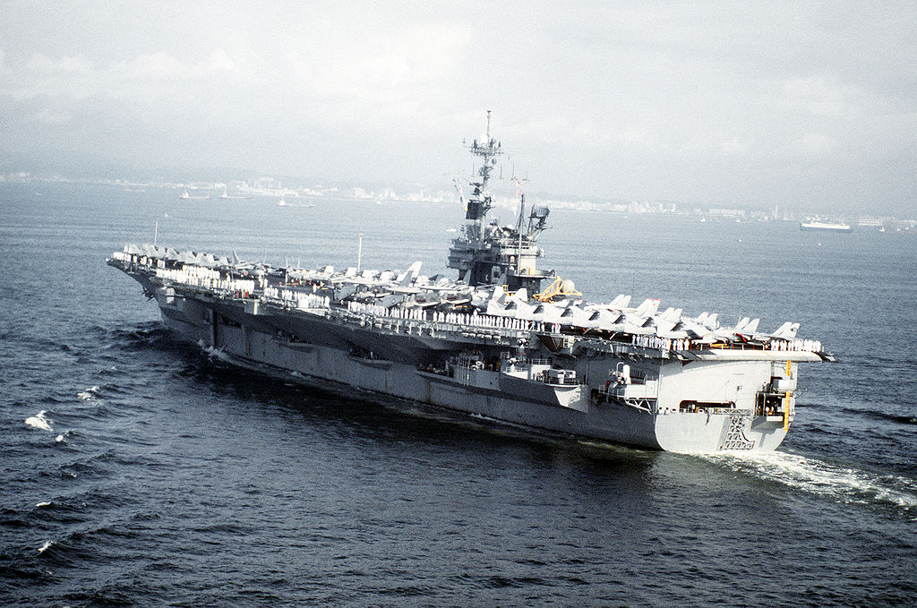

USS Ranger

CV-61 Ranger

* + USMC/USN Composite wing (April – Jul 94)
    - VF-191 Satan's Kittens F-14A
    - VMFA-232 Red Devils F/A-18D
    - VMFA-121 Green Knights F/A-18C (N)
    - VMFA-225 Vikings F/A-18D
    - VA-155 Silver Foxes A-6E SWIP
    - VMAQ-4 Seahawks EA-6B
    - VAW-127 Seabats E-2C
    - VS-21 Redtails S-3B
    - HS-17 Neptune's Raiders SH-3H
  + In July 94 when CV-60 Saratoga is relieved, partial cross decking with CVW-17 will take place when the USMC Sqns are able to establish on land bases.
  + Escorts as needed