**[CVBG Saratoga (CV-66)](https://en.wikipedia.org/wiki/USS_Saratoga_(CV-60))**

*USS Saratoga*, or ‘**Sara**’ was commissioned in 1956 as the second of four Forrestal class carriers, she completed a 3-year Service Life Extension Program (SLEP) in February of 1983, the first ship to do so, preparing her for another 15-20 years of sailing. Although she spent most of her service life in the Mediterranean, she is now based in San Diego and in the middle of an eight-month deployment to the Indian Ocean Persian/Gulf region. At the start of the war, she was on patrol in the Arabian Sea and would soon find herself alone in that region as other carriers were pulled to the Mediterranean or the Pacific. Due to the reduced threat in the Indian Ocean region there was quite a bit of turmoil with Saratoga’s escorts. She is due for some badly needed maintenance starting late summer in San Diego and is relieved by *USS Ranger*.

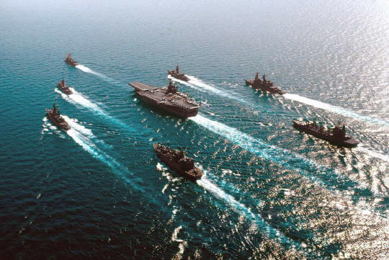

CVBG Saratoga

* CV-60 Saratoga (FLAG)
  + CVW 5
    - VF-83 Rampagers F-14B
    - VFA-81 Sunliners F/A-18C
    - VFA-82 Marauders F/A-18C
    - VFA-151 Chargers F/A-18C
    - VA-35 Black Panthers A-6E SWIP
    - VAQ-132 Scorpions EA-6B
    - VAW-125 Tigertails E-2C
    - VS-30 Diamondcutters S-3B
    - HS-9 Sea Griffins SH-3H
    - VQ-6(El) Black Ravens ES-3A
* CG 24 Reeves (Detached to Lincoln CVBG 18 Feb)
* CG 33 Fox
* CGN-39 Texas (Attached from independent Ops 20 Feb)
* CG-58 Philippine Sea (Attached from Lincoln CVBG 16 Feb)
* CG 64 Gettysburg (Detached to Nimitz CVBG 14 Feb)
* DD 892 Nicholson
* DDG 996 Chandler (Detached to Med 22 Feb)
* DD-976 Merrill (Attached from independent Ops 15 Feb)
* FFG-53 Hawes