**[CVBG Theodore Roosevelt (CVN-71)](https://en.wikipedia.org/wiki/USS_Theodore_Roosevelt_(CVN-71))**

The *USS Theodore Roosevelt* or ‘**Big Stick**’ is finishing up a four month Scheduled ‘Selected Restricted Availability’ (SRA) maintenance period at Norfolk.  She was planning to put to sea again in late February of 94 but hostilities hastened that departure slightly.  She and her Battle Group will move north with the amphibious units during the last week of February.

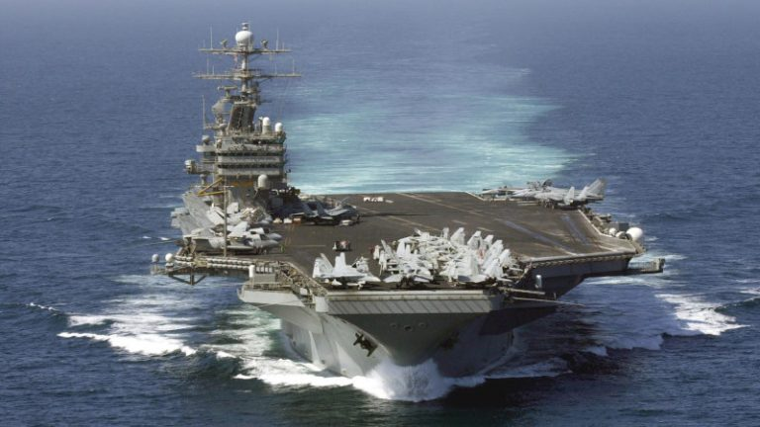

CVBG Theodore Roosevelt

* CVN-71 Theodore Roosevelt (FLAG)
  + CVW 8
    - VF-41 Black Aces F-14A
    - VF-114 Aardvarks F-14A
    - VFA-15 Valions F/A-18C
    - VFA-87 Golden Warriors F/A-18C(N)
    - VMFA-533 Hawks F/A-18D (Until 25 Feb)
    - VA-145 Swordsmen A-6E (From 27 Feb)
    - VAQ-141 Shadowhawks EA-6B
    - VAQ-209 Star Warriors EA-6B (Until 2 Mar)
    - VS-24 Scouts S-3B
    - VAW-121 Bear Aces E-2C
    - VQ-6 (El) Black Ravens ES-3A
    - HS-3 Tridents SH-60F & HH60H
  + CG-20 Richmond K Turner
  + CG-60 Normandy
  + CG-66 Hue City
  + DDG-55 Stout
  + DDG-995 Scott
  + FFG-50 Taylor
  + FFG-58 Samuel B Roberts
  + FFH-330 Halifax (CAN)