**USN DD/DDG**

In Northern Fury the US Navy fields 67 Destroyers (DD) and Guided Missile Destroyers (DDG), 29 more than they historically did, but this number is deceptive. Of these, 25 represents ships not retired and 16 of these older ships are undergoing refit at the start of the Northern Fury campaign.  The remaining increase are 4 Arleigh Burk class ships being commissioned 6-8 months early.  Therefore, the substantive increase at the start of Northern Fury is 13 Destroyers. The decision to maintain the older ships was a contentious one, many would rather they be scrapped and put the maintenance and overall time and money into more new ships, and the personnel cost of manning the ships could be better spent on training. However, in a series of rapid fire rulings by Congress, keeping the older ships was cheaper and quicker than building new, so navy planners got to work, glad that the short sighted ‘peace dividend’ mania that swept through the west in the post Cold War days was behind them.

[**Charles F. Adams** **Class**](http://destroyerhistory.org/coldwar/charlesfadamsclass/): The 23 ships of this class were commissioned in the early 1960s, and served a long and useful life as ASW escort ships with a decent Anti Air Warfare (AAW) capability. Although upgraded over time to carry the RIM-66 Standard SAM with better sensors, the main drawback of these ships is the lack of a helicopter. Historically only 3 of this class received a complete New Threat Upgrade (NTU) but in Northern Fury 12 more will complete this upgrade in the next 18 months. These ships are useful in secondary roles and would have great difficulty in a high threat area. Eight more Adams class DDGs are in Ready Reserve but will require a refit before they see service again.

|  |  |  |  |  |  |  |
| --- | --- | --- | --- | --- | --- | --- |
| Class | Pennant | Name | Historic | NF | Task | Remarks |
| Charles F Adams | DDG-8 | [Lynde McCormick](https://en.wikipedia.org/wiki/USS_Lynde_McCormick_(DDG-8)) | Sunk as Tgt | Refit |  | Compl Aug-94 |
|  | DDG-10 | [Sampson](https://en.wikipedia.org/wiki/USS_Sampson_(DDG-10)) | Scrapped | Refit |  | Compl Apr-95 |
|  | DDG-12 | [Robison](https://en.wikipedia.org/wiki/USS_Robison_(DDG-12)) | Scrapped | Refit |  | Compl Dec-94 |
|  | DDG-13 | [Hoel](https://en.wikipedia.org/wiki/USS_Hoel_(DDG-13)) | Converted | Refit |  | Compl Feb-95 |
|  | DDG-14 | [Buchanan](https://en.wikipedia.org/wiki/USS_Buchanan_(DDG-14)) | Sunk as Tgt | Refit |  | Compl Jan-95 |
|  | DDG-15 | [Berkeley](https://en.wikipedia.org/wiki/USS_Berkeley_(DDG-15)) | Sold to Greece | Refit |  | Compl Mar-95 |
|  | DDG-16 | [Joseph Strauss](https://en.wikipedia.org/wiki/USS_Joseph_Strauss_(DDG-16)) | Sold to Greece | Refit |  | Compl May-95 |
|  | DDG-17 | [Conyngham](https://en.wikipedia.org/wiki/USS_Conyngham_(DDG-17)) | Scrapped | Refit |  | Compl Jun-94 |
|  | DDG-18 | [Semmes](https://en.wikipedia.org/wiki/USS_Semmes_(DDG-18)) | Sold to Greece | Refit |  | Compl Nov-94 |
|  | DDG-19 | [Tattnall](https://en.wikipedia.org/wiki/USS_Tattnall_(DDG-19)) | Scrapped | NTU | Caribbean |  |
|  | DDG-20 | [Goldsborough](https://en.wikipedia.org/wiki/USS_Goldsborough_(DDG-20)) | Sold to Aus | NTU | Convoy |  |
|  | DDG-21 | [Cochrane](https://en.wikipedia.org/wiki/USS_Cochrane_(DDG-21)) | Scrapped | Refit |  | Compl Feb-94 |
|  | DDG-22 | [Benjamin Stoddert](https://en.wikipedia.org/wiki/USS_Benjamin_Stoddert_(DDG-22)) | Scrapped | NTU | Convoy |  |
|  | DDG-23 | [Richard E. Byrd](https://en.wikipedia.org/wiki/USS_Richard_E._Byrd_(DDG-23)) | Sold to Greece | Refit |  | Compl Jun-95 |
|  | DDG-24 | [Waddell](https://en.wikipedia.org/wiki/USS_Waddell_(DDG-24)) | Sold to Greece | Refit |  | Compl Oct-94 |

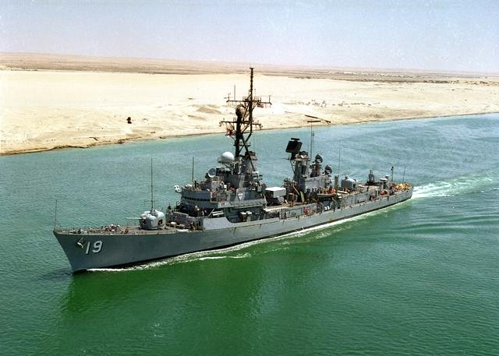

[**Farragut Class**](http://destroyerhistory.org/coldwar/farragutclass/): The 10 ships of this class were all launched between 1959-61 as AAW escorts to protect the fast aircraft carrier battel groups (CVBG). The Farragut class has a dual arm Mk 10 SAM launcher and with the NTU were able to fire medium range Standard missiles, the NTU upgrade also adds 8 Harpoon SSMs. Historically only USS Mahan (**DDG-42**) received the complete NTU improvement but in Northern Fury all ships of this class were retained and refit. To date 6 have completed the NTU and the remaining 4 ships will complete their refit later in 1994.

|  |  |  |  |  |  |  |  |
| --- | --- | --- | --- | --- | --- | --- | --- |
| Class | Pennant | Name | Historic | NF | Home Port | Task | Remarks |
| Farragut | DDG-37 | [Farragut](https://en.wikipedia.org/wiki/USS_Farragut_(DDG-37)) | Decom 89 | Refit |  |  | Compl Sep-94 |
|  | DDG-38 | [Luce](https://en.wikipedia.org/wiki/USS_Luce_(DDG-38)) | Decom 91 | Refit |  |  | Compl Jul-94 |
|  | DDG-39 | [Macdonough](https://en.wikipedia.org/wiki/USS_Macdonough_(DDG-39)) | Decom 92 | Refit |  | Convoy | Compl Mar-94 |
|  | DDG-40 | [Coontz](https://en.wikipedia.org/wiki/USS_Coontz_(DDG-40)) | Decom 89 | Refit |  | Convoy | Compl Feb-94 |
|  | DDG-41 | [King](https://en.wikipedia.org/wiki/USS_King_(DDG-41)) | Decom 91 | NTU | Mayport | Caribbean |  |
|  | DDG-42 | [Mahan](https://en.wikipedia.org/wiki/USS_Mahan_(DDG-42)) | Decom 93 | NTU | Norfolk | Convoy |  |
|  | DDG-43 | [Dahlgren](https://en.wikipedia.org/wiki/USS_Dahlgren_(DDG-43)) | Decom 92 | NTU | Rota | Med Amphibs |  |
|  | DDG-44 | [William V. Pratt](https://en.wikipedia.org/wiki/USS_William_V._Pratt_(DDG-44)) | Decom 91 | NTU | Norfolk | Convoy |  |
|  | DDG-45 | [Dewey](https://en.wikipedia.org/wiki/USS_Dewey_(DDG-45)) | Decom 90 | NTU | Rota | Mediterranean |  |
|  | DDG-46 | [Preble](https://en.wikipedia.org/wiki/USS_Preble_(DDG-46)) | Decom 91 | NTU | Norfolk | Convoy |  |

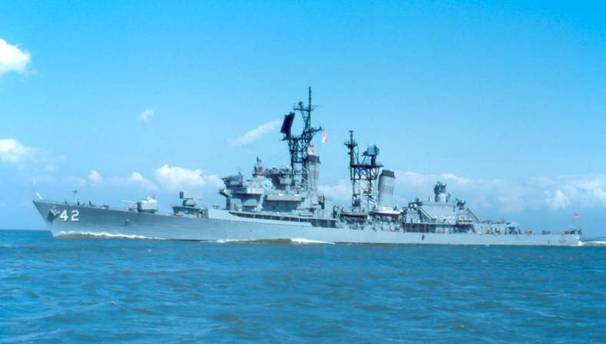

[**Kidd Class**](http://destroyerhistory.org/coldwar/kiddclass/)**:** The four Kidd Class DDGs, based on the Spruance design, were originally destined for Iran as part of a six ship transfer which was canceled when the Shah was deposed by a hard line anti-US government. These four were completed and delivered to the USN in 1981-82. The ships took an excellent design from the Spruance and made it better (and heavier) by adding missile launchers capable of firing both SAMs and ASROC ASW torpedoes as well as many other improvements. In the late 1980s the Kidds’ received their NTU greatly enhancing the AAW capabilities and will serve another 20 years as they did historically.

|  |  |  |  |  |  |
| --- | --- | --- | --- | --- | --- |
| Class | Pennant | Name | Home Port | Task | Remarks |
| Kidd | DDG-993 | [Kidd](https://en.wikipedia.org/wiki/USS_Kidd_(DDG-993)) | Norfolk | Kennedy CVBG |  |
|  | DDG-994 | [Callaghan](https://en.wikipedia.org/wiki/USS_Callaghan_(DDG-994)) | Yokosuka | Independence CVBG |  |
|  | DDG-995 | [Scott](https://en.wikipedia.org/wiki/USS_Scott_(DDG-995)) | Norfolk | Roosevelt CVBG |  |
|  | DDG-996 | [Chandler](https://en.wikipedia.org/wiki/USS_Chandler_(DDG-996)) | San Diego | Saratoga CVBG |  |

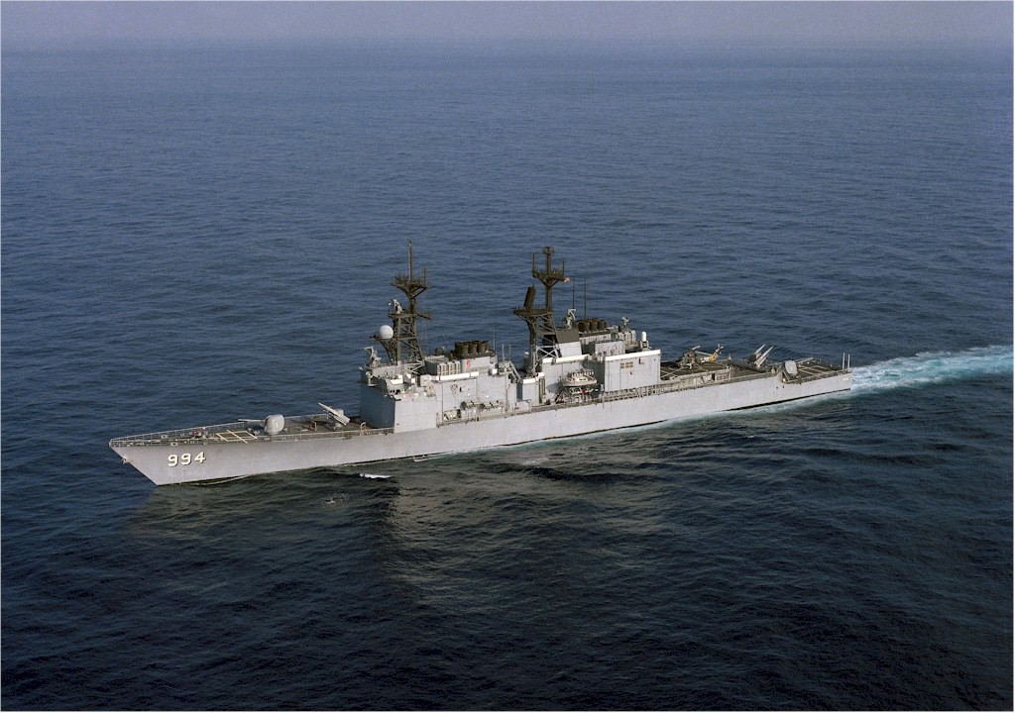

[**Spruance Class:**](http://destroyerhistory.org/coldwar/spruanceclass/) These ships were designed from the ground up to defeat the latest Soviet submarines and defend US CVBGs. This meant that they were big and fast ships, able to keep pace with a nuclear powered aircraft carrier in heavy seas. Because of their size they were easily modified throughout their life as threats changed or technology became available. All 31 ships carry two SH-60B Seahawk ASW helicopters and 24 of the 31 ships in the class had a major upgrade adding a 61-cell Vertical Launch Missile System (VLS). Ten of the VLS ships also received a 21 cell Rolling Airframe Missile (**RAM**) system. However, as the threat evolved once again and there was an urgent need for ASW escorts and a shortage of dry-dock space (needed to refit older ships) the last seven ships will not be upgraded to carry the VLS but will remain ASW DDs and undergo shorter mid-life refits than the others.

|  |  |  |  |  |  |
| --- | --- | --- | --- | --- | --- |
| Class | Pennant | Name | Home Port | Task | Remarks |
| Spruance | DD-963 | [Spruance](https://en.wikipedia.org/wiki/USS_Spruance_(DD-963)) | Norfolk | Tied up |  |
|  | DD-964 | [Paul F. Foster](https://en.wikipedia.org/wiki/USS_Paul_F._Foster_(DD-964)) | Norfolk | Carl Vinson CVBG |  |
|  | DD-965 | [Kinkaid](https://en.wikipedia.org/wiki/USS_Kinkaid_(DD-965)) | San Diego | Constellation CVBG |  |
|  | DD-966 | [Hewitt](https://en.wikipedia.org/wiki/USS_Hewitt_(DD-966)) | San Diego | Washington CVBG |  |
|  | DD-967 | [Elliot](https://en.wikipedia.org/wiki/USS_Elliot_(DD-967)) | San Diego | Independent in PG | VLS+RAM |
|  | DD-968 | [Arthur W. Radford](https://en.wikipedia.org/wiki/USS_Arthur_W._Radford_(DD-968)) | Norfolk | Amphib Escort |  |
|  | DD-969 | [Peterson](https://en.wikipedia.org/wiki/USS_Peterson_(DD-969)) | San Diego | Independent in PG |  |
|  | DD-970 | [Caron](https://en.wikipedia.org/wiki/USS_Caron_(DD-970)) | Norfolk | Amphib Escort |  |
|  | DD-971 | [David R. Ray](https://en.wikipedia.org/wiki/USS_David_R._Ray_(DD-971)) | Norfolk | Eisenhower CVBG |  |
|  | DD-972 | [Oldendorf](https://en.wikipedia.org/wiki/USS_Oldendorf_(DD-972)) | Yokosuka | Indian Ocean | VLS+RAM |
|  | DD-973 | [John Young](https://en.wikipedia.org/wiki/USS_John_Young_(DD-973)) | San Diego | Kitty Hawk CVBG | VLS+RAM |
|  | DD-974 | [Comte de Grasse](https://en.wikipedia.org/wiki/USS_Comte_de_Grasse_(DD-974)) | Norfolk | Amphib Escort | Non VLS |
|  | DD-975 | [O'Brien](https://en.wikipedia.org/wiki/USS_O%27Brien_(DD-975)) | Yokosuka | Independence CVBG |  |
|  | DD-976 | [Merrill](https://en.wikipedia.org/wiki/USS_Merrill_(DD-976)) | San Diego | Saratoga CVBG | Non VLS |
|  | DD-977 | [Briscoe](https://en.wikipedia.org/wiki/USS_Briscoe_(DD-977)) | San Diego | Nimitz CVBG | VLS+RAM |
|  | DD-978 | [Stump](https://en.wikipedia.org/wiki/USS_Stump_(DD-978)) | Norfolk | Tied up |  |
|  | DD-979 | [Conolly](https://en.wikipedia.org/wiki/USS_Conolly_(DD-979)) | Norfolk | Kennedy CVBG | Non VLS |
|  | DD-980 | [Moosbrugger](https://en.wikipedia.org/wiki/USS_Moosbrugger_(DD-980)) | Norfolk | STANAVFORLANT |  |
|  | DD-981 | [John Hancock](https://en.wikipedia.org/wiki/USS_John_Hancock_(DD-981)) | San Diego | Lincoln CVBG |  |
|  | DD-982 | [Nicholson](https://en.wikipedia.org/wiki/USS_Nicholson_(DD-982)) | San Diego | Saratoga CVBG | VLS+RAM |
|  | DD-983 | [John Rodgers](https://en.wikipedia.org/wiki/USS_John_Rodgers_(DD-983)) | Norfolk | TG 84 | Non VLS |
|  | DD-984 | [Leftwich](https://en.wikipedia.org/wiki/USS_Leftwich_(DD-984)) | San Diego | Nimitz CVBG | Non VLS |
|  | DD-985 | [Cushing](https://en.wikipedia.org/wiki/USS_Cushing_(DD-985)) | San Diego | Kitty Hawk CVBG | VLS+RAM |
|  | DD-986 | [Harry W. Hill](https://en.wikipedia.org/wiki/USS_Harry_W._Hill_(DD-986)) | San Diego | Refit - May 94 | Non VLS |
|  | DD-987 | [O'Bannon](https://en.wikipedia.org/wiki/USS_O%27Bannon_(DD-987)) | Norfolk | Enterprise CVBG | VLS+RAM |
|  | DD-988 | [Thorn](https://en.wikipedia.org/wiki/USS_Thorn_(DD-988)) | Norfolk | Enterprise CVBG | VLS+RAM |
|  | DD-989 | [Deyo](https://en.wikipedia.org/wiki/USS_Deyo_(DD-989)) | Norfolk | Amphib Escort Med |  |
|  | DD-990 | [Ingersoll](https://en.wikipedia.org/wiki/USS_Ingersoll_(DD-990)) | San Diego | Constellation CVBG | Non VLS |
|  | DD-991 | [Fife](https://en.wikipedia.org/wiki/USS_Fife_(DD-991)) | Yokosuka | Tied up | VLS+RAM |
|  | DD-992 | [Fletcher](https://en.wikipedia.org/wiki/USS_Fletcher_(DD-992)) | San Diego | Singapore | VLS+RAM |
|  | DD-997 | [Hayler](https://en.wikipedia.org/wiki/USS_Hayler_(DD-997)) | Norfolk | 2nd Flt Ready Shp |  |

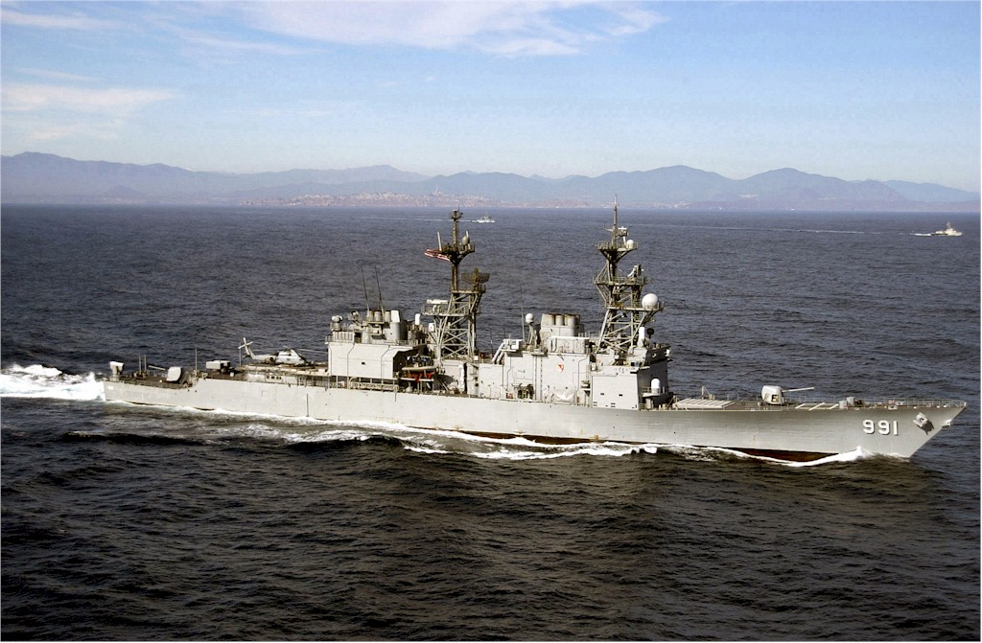

[**Arleigh Burke Class:**](http://destroyerhistory.org/arleighburkeclass/) This is a very advanced class of ship. History has shown that this class will grow to of 82 ships and replace all other escort types in the USN, and possibly the Cruisers as well by the 2020s. In 1994 however, the future is unclear but the need for ships is urgent; therefore, seven, vice the three historically have been completed.  There will be an additional 6 commissioned in late 94 or early 95. Known as the DDG-51 Class, all of the ships in service in Northern Fury are ‘Flight 1’ with the major disadvantage of lacking a hanger; so their ASW capability is negatively impacted if they are working alone. This class has a 90-cell VLS system able to fire any missile in the US inventory, making they very flexible, configuring the missile load as the task changes.

|  |  |  |  |  |  |  |
| --- | --- | --- | --- | --- | --- | --- |
| Class | Pennant | Name | Historic | Home Port | Task | Remarks |
| Arleigh Burke | DDG-51 | [Arleigh Burke](https://en.wikipedia.org/wiki/USS_Arleigh_Burke_(DDG-51)) |  | Norfolk | Eisenhower CVBG |  |
|  | DDG-52 | [Barry](https://en.wikipedia.org/wiki/USS_Barry_(DDG-52)) |  | San Diego | Washington CVBG |  |
|  | DDG-53 | [John Paul Jones](https://en.wikipedia.org/wiki/USS_John_Paul_Jones_(DDG-53)) |  | San Diego | Nimitz CVBG |  |
|  | DDG-54 | [Curtis Wilbur](https://en.wikipedia.org/wiki/USS_Curtis_Wilbur_(DDG-54)) | Mar-94 | San Diego | Lincoln CVBG | Compl Jul-93 |
|  | DDG-55 | [Stout](https://en.wikipedia.org/wiki/USS_Stout_(DDG-55)) | Aug-94 | Norfolk | Roosevelt CVBG | Compl Dec-93 |
|  | DDG-56 | [John S. McCain](https://en.wikipedia.org/wiki/USS_John_S._McCain_(DDG-56)) | Jul-94 | San Diego | Independent | Compl Nov-93 |
|  | DDG-57 | [Mitscher](https://en.wikipedia.org/wiki/USS_Mitscher_(DDG-57)) | Dec-94 | Norfolk | Carl Vinson CVBG | Compl Feb-94 |
|  | DDG-58 | [Laboon](https://en.wikipedia.org/wiki/USS_Laboon_(DDG-58)) | Mar-95 |  |  | Compl Sep-94 |
|  | DDG-59 | [Russell](https://en.wikipedia.org/wiki/USS_Russell_(DDG-59)) | May-95 |  |  | Compl Oct-94 |
|  | DDG-60 | [Paul Hamilton](https://en.wikipedia.org/wiki/USS_Paul_Hamilton_(DDG-60)) | May-95 |  |  | Compl Oct-94 |

