USN Repair Ships

In order to conduct operations across the globe, the USN needs a network of repair facilities both fixed and afloat to keep its ships operational. These Repair ships or ‘Tenders’ conduct routine maintenance, repair and support to ships at anchor and can augment a ports facilities or conduct repairs at austere anchorages.

**AD: Destroyer Tenders:**

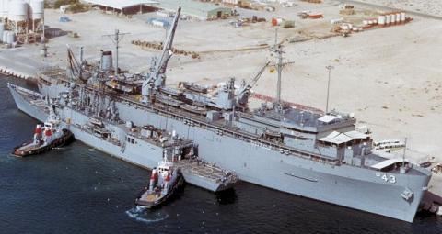These ships are vital to the general maintenance of surface ships up to CG size and can service several simultaneously. The oldest of the three remaining [Dixie](https://en.wikipedia.org/wiki/Dixie-class_destroyer_tender) class [USS Prairie](https://en.wikipedia.org/wiki/USS_Prairie_(AD-15)) was launched before the US entered World War Two, while her sisters served during the war, although historically retired in 93-94, as with many of the combat ships these venerable workhorses remain in service. Much more modern, the [Samuel Gompers](https://fas.org/man/dod-101/sys/ship/ad-37.htm) class was built in the early 60’s while the latest ships of the [Yellowstone](https://fas.org/man/dod-101/sys/ship/ad-41.htm) class were commissioned in the 80’s. All have received extensive upgrades and refits to enable their ability to repair modern ships.

|  |  |  |  |  |  |
| --- | --- | --- | --- | --- | --- |
| Class | Pennant | Name | Fleet | Home Port | Task |
| Dixie | AD-15 | [USS Prairie](https://en.wikipedia.org/wiki/USS_Prairie_(AD-15)) | Pacific | Pearl Hbr | Manila |
|  | AD-17 | [USS Sierra](https://en.wikipedia.org/wiki/USS_Sierra_(AD-18)) | Atlantic | Norfolk | Tied Up |
|  | AD-19 | [USS Yosemite](https://en.wikipedia.org/wiki/USS_Yosemite_(AD-19)) | Atlantic | Norfolk | New Orleans |
| Samuel Gompers | AD-37 | [USS Samuel Gompers](https://en.wikipedia.org/wiki/USS_Samuel_Gompers_(AD-37)) | Pacific | San Diego | Naples |
|  | AD-38 | [USS Puget Sound](https://en.wikipedia.org/wiki/USS_Puget_Sound_(AD-38)) | Atlantic | Norfolk | Diego Garcia |
| Yellowstone | AD-41 | [Yellowstone](https://en.wikipedia.org/wiki/USS_Yellowstone_(AD-41)) | Atlantic | Norfolk | Scotland |
|  | AD-42 | [Acadia](https://en.wikipedia.org/wiki/USS_Acadia_(AD-42)) | Pacific | San Diego | Bahrain |
|  | AD-43 | [Cape Cod](https://en.wikipedia.org/wiki/USS_Cape_Cod_(AD-43)) | Pacific | San Diego | Guam |
|  | AD-44 | [Shenandoah](https://en.wikipedia.org/wiki/USS_Shenandoah_(AD-44)) | Atlantic | Norfolk | Tied up |

**AS: Submarine Tenders:**

These ships are similar to Destroyer Tenders but their tooling and equipment is configured for maintenance and repair of submarines. The three remaining [Fulton](https://en.wikipedia.org/wiki/Fulton-class_submarine_tender) class are all veterans of World War Two and, like the Dixies, were not retired in the early 90’s. Four more classes provide support to 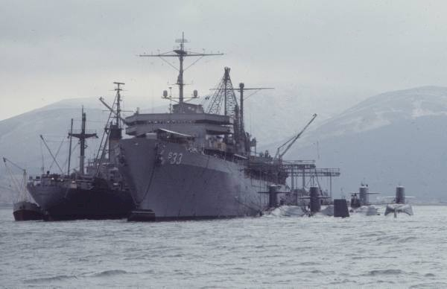submarines around the world, the [Hunley](https://fas.org/nuke/guide/usa/slbm/as-31.htm) class from the early 60’s, [Simon Lake](https://fas.org/nuke/guide/usa/slbm/as-31.htm) class from the mid 60’s, [L.Y. Spear](https://fas.org/man/dod-101/sys/ship/as-36.htm) class from the early 70’s, and the Emory S. Land class from the early 80’s.

|  |  |  |  |  |  |
| --- | --- | --- | --- | --- | --- |
| Class | Pennant | Name | Fleet | Home Port | Task |
| Fulton | AS-11 | [Fulton](https://en.wikipedia.org/wiki/USS_Fulton_(AS-11)) | Atlantic | Norfolk | Scotland |
|  | AS-18 | [Orion](https://en.wikipedia.org/wiki/USS_Orion_(AS-18)) | Atlantic | Norfolk | Tied Up |
|  | AS-19 | [Proteus](https://en.wikipedia.org/wiki/USS_Proteus_(AS-19)) | Pacific | Bremerton | Japan |
| Hunley | AS-31 | [Hunley](https://en.wikipedia.org/wiki/USS_Hunley_(AS-31)) | Atlantic | Norfolk | Scotland |
|  | AS-32 | [Holland](https://en.wikipedia.org/wiki/USS_Holland_(AS-32)) | Atlantic | Norfolk | Rota Spain |
| Simon Lake | AS-33 | [Simon Lake](https://en.wikipedia.org/wiki/USS_Simon_Lake) | Atlantic | Norfolk | La Mddalena It |
|  | AS-34 | [Canopus](https://en.wikipedia.org/wiki/USS_Canopus_(AS-34)) | Atlantic | Charleston | Tied Up |
| L.Y Spear | AS-36 | [L.Y. Spear](https://en.wikipedia.org/wiki/USS_L._Y._Spear_(AS-36)) | Atlantic | Norfolk | Tied Up |
|  | AS-37 | [Dixon](https://en.wikipedia.org/wiki/USS_Dixon_(AS-37)) | Pacific | San Diego | Tied Up |
| Emory S. Land | AS-39 | [Emory S. Land](https://en.wikipedia.org/wiki/USS_Emory_S._Land_(AS-39)) | Atlantic | Norfolk | Tied Up |
|  | AS-40 | [Frank Cable](https://en.wikipedia.org/wiki/USS_Frank_Cable_(AS-40)) | Pacific | Guam | Tied Up |
|  | AS-41 | [McKee](https://en.wikipedia.org/wiki/USS_McKee_(AS-41)) | Pacific | San Diego | Tied Up |

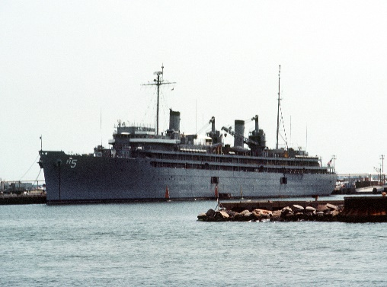**AR: Repair Ship:**

The four World War Two veterans of the [Vulcan](https://fas.org/man/dod-101/sys/ship/ar-5.htm) class are capable of a wide range of repairs to any ship in the USN. They have been put into the ready reserve fleet and will take several weeks to bring up to active status.

|  |  |  |  |  |
| --- | --- | --- | --- | --- |
| Pennant | Name | Fleet | Home Port | Status |
| AR-5 | [Vulcan](https://en.wikipedia.org/wiki/USS_Vulcan_(AR-5)) | Atlantic | Norfolk | Mothballed |
| AR-6 | [Ajax](https://en.wikipedia.org/wiki/USS_Ajax_(AR-6)) | Pacific | San Diego | Mothballed |
| AR-7 | [Hector](https://en.wikipedia.org/wiki/USS_Hector_(AR-7)) | Pacific | Portland | Mothballed |
| AR-8 | [Jason](https://en.wikipedia.org/wiki/USS_Jason_(AR-8)) | Pacific | San Diego | Mothballed |

There are literally dozens of smaller support and repair ships in the USN which will not be listed here. These include the 10 ARS (Salvage and Repair) of the [Bolster](https://fas.org/man/dod-101/sys/ship/ars-38.htm) and [Safeguard](https://fas.org/man/dod-101/sys/ship/ars-50.htm) classes, six ASR (Submarine Rescue Ships) of the [Chanticleer](https://fas.org/man/dod-101/sys/ship/asr-7.htm) and [Pigeon](https://fas.org/man/dod-101/sys/ship/asr-21.htm), the seven ATF (Ocean Going Tugs) of the [Powhatan](https://fas.org/man/dod-101/sys/ship/tatf-166.htm) class, the five ATS (Salvage Ships) of the [Edenton](https://fas.org/man/dod-101/sys/ship/ats-1.htm) class, the three ARC (Cable Repair Ships) of the [Neptune](https://en.wikipedia.org/wiki/USNS_Neptune_(ARC-2)) and [Zeus](https://en.wikipedia.org/wiki/USNS_Zeus_(T-ARC-7)) class, and more.