**Norway** 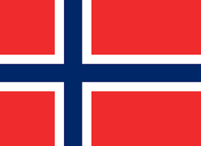

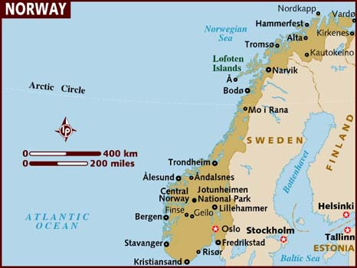

**Norway:** Norway is one of the 12 original members of the NATO alliance and was initially the only one to share a boarder directly with the Soviet Union. Turkey now shares that distinction since it joined in 1952. With a population hovering around 5 million people and having a long and vulnerable coastline, Norway is dependent on NATO's collective defence assurances for its survival. Even though a small country economically, Norway routinely spends over 3% of its GDP on defence, 50% more than NATO requires.

NATO realized the critical vulnerability of its northern flank and made provision for rapid deployment to Norway. AMF (ACE [Allied Command Europe] Mobile Force) deployment and pre-positioned equipment was exercised annually. STANAVFORLANT (Standing Allied Naval Force Atlantic) was also routinely deployed to Norwegian waters. Regular training by British Royal Marines and US Marine Corps units on Norwegian territory familiarized many involved with the intricacies of fighting on Norway's rugged terrain. Finally, NATO E-3A AWACs aircraft were almost continually stationed in Norway at Orland Air base

Norway's military is small but highly trained and well equipped to utilize the advantage of terrain to counteract its disadvantage of geography.