**Portugal** 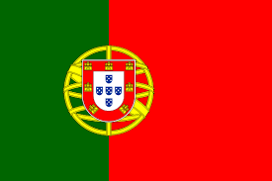

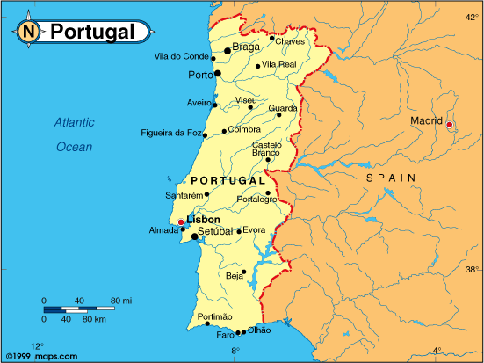

**Portugal:** One of the 12 founding members of NATO, Portugal with a population of 10 million and a low GDP was also the poorest by most measurements. Ultra-ideological policies, a transition from colonialism to socialism and then finally to a liberal democracy, all left the economy in a state of turmoil requiring the International Monetary Fund (IMF) to step in with stabilization programs in the 70's and again in the 80's. After joining the European Economic Community (EEC) in 1986, the economy improved substantially.

The troubled political and economic situation did not leave much room for military development. Although one of the smaller forces in NATO, Portugal maintains several key bases, critical for security of trans- Atlantic commerce, particularly Lejas in the Azors but also the Cape Verde Islands and Madeira. Germany also uses the Portuguese base of Baja for its air combat training, and the HQ for Commander - in- Chief Iberian Atlantic (CINCIBERLANT) is located just west of Lisbon at Oeiras.