***HMS Illustrious* CVG**

*HMS Illustrious (Lusty)* has spent the past three months on patrol in the Mediterranean, first enforcing the no-fly zone over Bosnia and conducting sea interdiction in the Adriatic, then conducting an exercise in the Eastern Med of Cyprus with the American Marine Expeditionary Unit stationed there. She was on her way home when the Soviets struck, and although not involved in the fighting on day one, but will receive her baptism of fire on the second day of the war as she sails west towards Malta on her way home to undergo a 4-month refit.

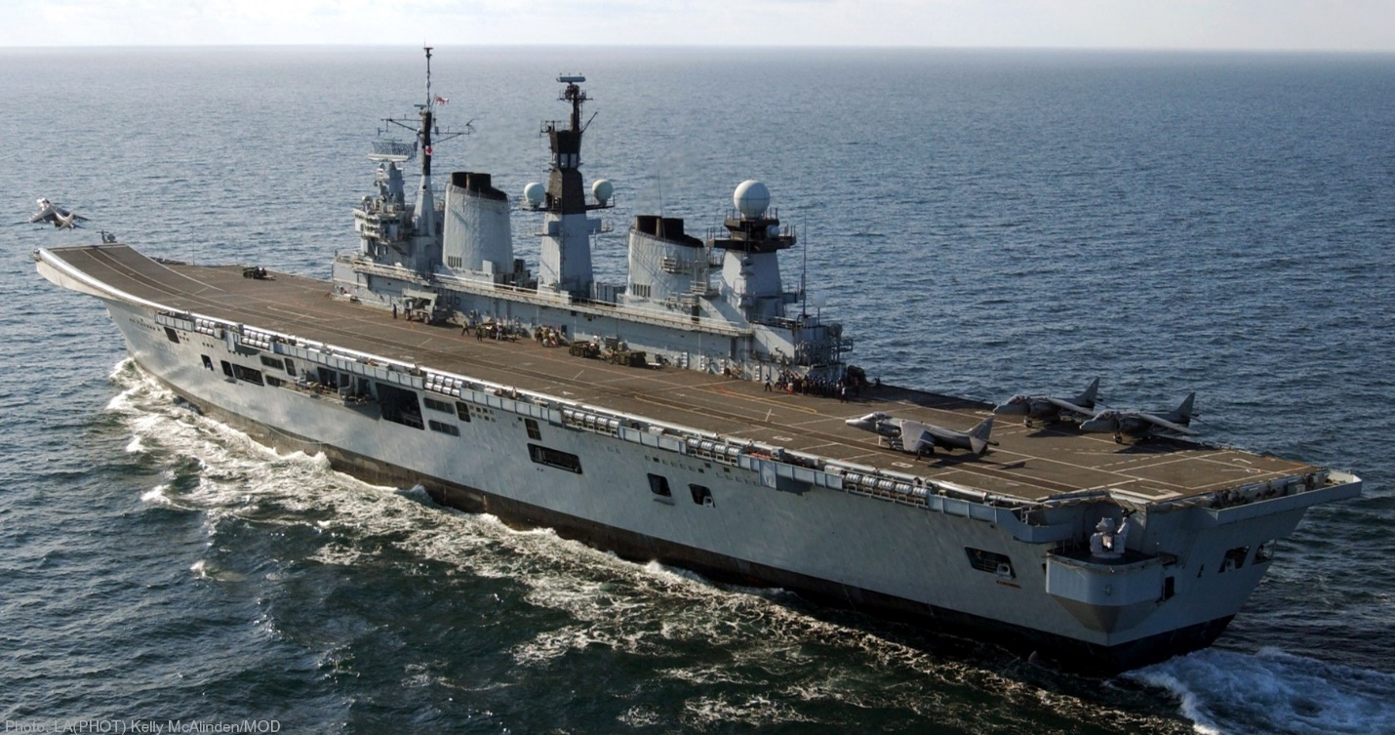

* R 06 HMS Illustrious
  + 802 NAS 8x Sea Harrier FA.2
  + 802 NAS 6x Harrier GR.7 (from 1 Sqn RAF for Training with USMC)
  + 820 NAS 6x Sea King HAS.6
  + 849B NAS 2x Sea King AEW.2A
  + 772A NAS 2x Sea King HAR.3
* D 88 HMS Glasgow (Type 42 Batch 1)
  + 815 NAS 1x Lynx HAS.3
* D 97 HMS Edinburgh (Type 42 Batch 3)
  + 847 NAS 1x Lynx HAS.3(GM)
* F 85 HMS Cumberland (Type 22 Batch 3)
  + 815 NAS 2x Lynx HAS.3
* F 89 HMS Battleaxe (Type 22 Batch 1)
  + 847 NAS 2x Lynx HAS.3(GM)
* F 92 HMS Boxer (Type 22 Batch 2)
  + 815 NAS 2x Lynx HAS.3
* F 234 HMS Iron Duke (Type 23)
  + 825 NAS 1x Lynx HAS.8

