**United Kingdom** 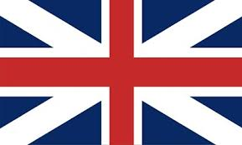

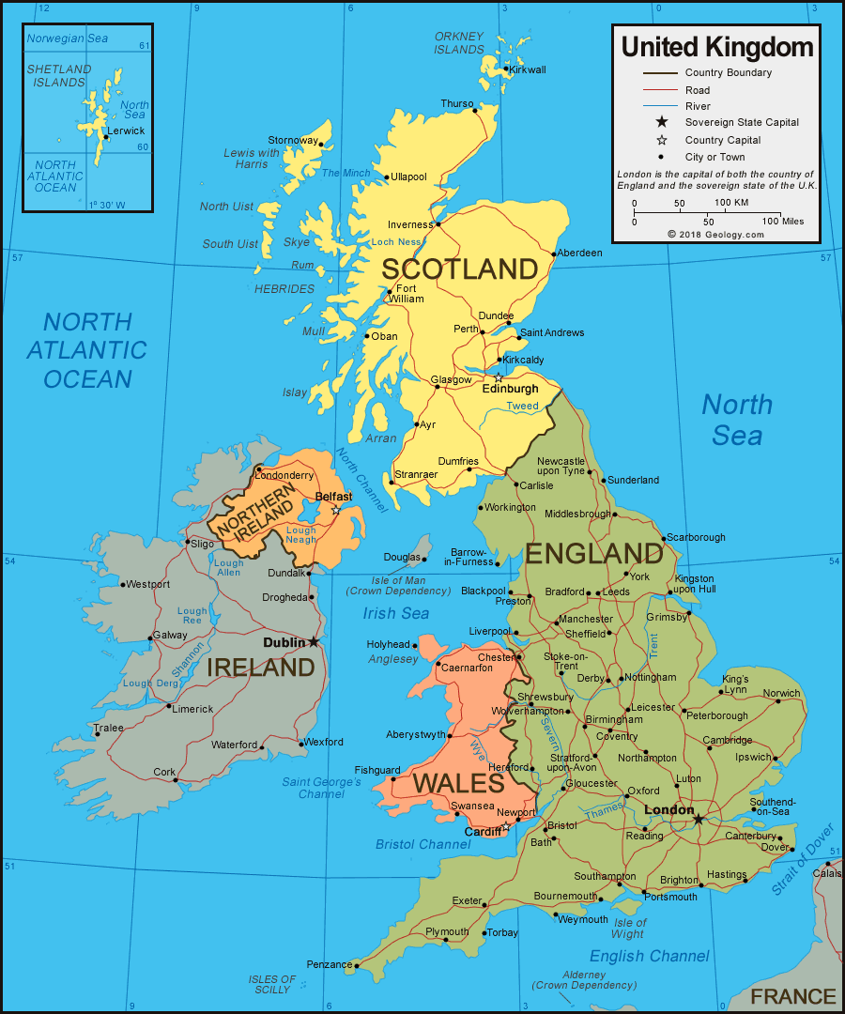

**United Kingdom:** The UK is one of the founding members of NATO and is arguably the second most important military power behind the US. This status is arguable because Germany, Turkey and Italy, not to mention France have become increasingly important while the UK military forces have shrunk considerably since the formation of the Alliance. For a better understanding of the entities that make up the UK, you may wish to watch this humorous but accurate [video](https://www.youtube.com/watch?v=rNu8XDBSn10). In 1994 the British military had reduced to about 250,000 personnel, but was technologically advanced and highly proficient.

Territorial commitments, disputes and agreements are too numerous to mention but the UK has global commitments which it struggles to maintain. However, despite the difficulties since 1982 the British forces have fought and won in the Falklands, the Gulf War, Yugoslavia and Bosnia, along with a continuing commitment to Northern Ireland, Belize, Brunei, Hong Kong, Kenya, Cyprus and Gibraltar.