***HMS Invincible* CVG**

*HMS Invincible (Vince)* had completed a minor refit in late 1993 and was conducting fleet training with several RN ships and submarines in the Celtic Sea between Wales and Ireland when the war started. She immediately returned to Portsmouth to replenish and put to sea again within 24 hours, still awaiting orders. Her first task of the war would be an intimidating one, to stop the Soviet advance south of the Shetland and Faro islands into the Atlantic. During the first three days of the war however she had gained a formidable Battle Group, including a slightly over crowded air group.

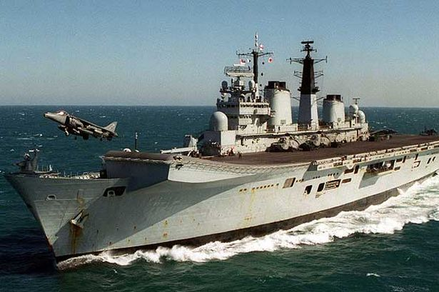

* R 05 HMS Invincible
  + 800 NAS 14x Sea Harrier FA.2
  + 824 NAS 6x Sea King HAS.6
  + 849A NAS 2x Sea King AEW.2A
  + 771B NAS 2x Sea King HAR.3
* D 86 HMS Birmingham (Type 42 Batch 1)
  + 847 NAS 1x Lynx HAS.3(GM)
* D 89 HMS Exeter (Type 42 Batch 2)
  + 815 NAS 1x Lynx HAS.3
* D 96 HMS Gloucester (Type 42 Batch 3)
  + 847 NAS 1x Lynx HAS.3(GM)
* F 86 HMS Campbeltown (Type 22 Batch 3)
  + 815 NAS 2x Lynx HAS.3
* F 95 HMS London (Type 22 Batch 2)
  + 815 NAS 2x Lynx HAS.3
* F 96 HMS Sheffield (Type 22 Batch 2)
  + 815 NAS 2x Lynx HAS.3
* F 235 HMS Monmouth (Type 23)
  + 847 NAS 2x Lynx HAS.3(GM)

