**USAF Training aircraft**

[**T-41 Mescalero**](https://fas.org/man/dod-101/sys/ac/t-41.htm)

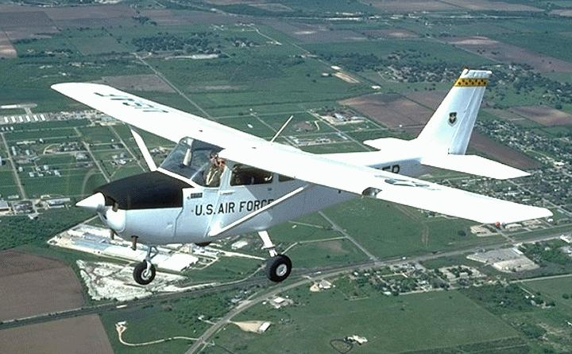This military version of the Cessna 172 was used by the USAF to determine a student’s suitability for further flight training. This was called the Flight Screening Program (FSP), and was conducted by a contracted company at Hondo Airfield, Texas. Each officer candidate would spend 14 hours of flight training in the T-41 prior to being accepted into flight school. The program was conducted under the auspices of 12 Air Training Wing at Randolph AFB. About 200 aircraft were engaged in this task at any time as well as another 50 more powerful T-41C held at the Air Force Academy in Colorado. The T-41-Cs were to provide officer candidates at the Academy a further 21 hours of flight training under a similar contract arrangement. The Army also operated another 255 T-41B in training and liaison duties.

**Note**: Neither the T-3 or the T-6 were available at the time of Northern Fury.

[**T-37B Tweet**](https://fas.org/man/dod-101/sys/ac/t-37.htm)

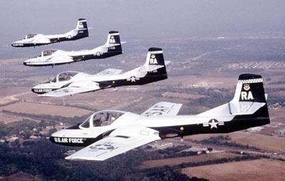The T-37 is the basic jet trainer used by the USAF and many other air forces. The main function of the aircraft is to train pilots and navigators in the fundamentals of flight, navigation, instrumentation, night and formation flying. This aircraft introduces students to the handling and characteristics of jet aircraft before they move into either the T-38 or the T-1A. Over 1,000 were produced for the USAF and about 580 remain in service in 1994, all are T-37B and used by 12 Flight Training Squadrons (FTS). The heavily modified T-37C can be armed and is in use by various air forces around the world as was the A-37 Super Tweet used extensively by the USAF in Viet Nam.

|  |  |  |  |  |  |  |
| --- | --- | --- | --- | --- | --- | --- |
| Sqn | Name | Wing | Location | No. | Type | Remarks |
| 8th FTS | Eight Ballers | 71st | Vance AFB, OK | 48 | T-37B |  |
| 25th FTS | Shooters | 71st | Vance AFB, OK | 48 | T-37B |  |
| 33rd FTS | Dragons | 71st | Vance AFB, OK | 48 | T-37B |  |
| 35th FTS | Pretvels | 64th | Reese AFB, TX | 48 | T-37B |  |
| 37th FTS | Bengal Tigers | 14th | Columbus AFB, MI | 48 | T-37B |  |
| 41st FTS | Flying Buzzsaws | 14th | Columbus AFB, MI | 48 | T-37B |  |
| 43rd FTS | Phoenix | 14th | Columbus AFB, MI | 48 | T-37B |  |
| 84th FTS | Panthers | 47th | Lackland AFB, TX | 48 | T-37B |  |
| 85th FTS | Tigers | 47th | Lackland AFB, TX | 48 | T-37B |  |
| 89th FTS | Banshees | 80th | Sheppard AFB, TX | 48 | T-37B |  |
| 455 FTS | Hawks | 323rd | Mather AFB, CA | 48 | T-37B |  |
| 559th FTS | Billy Goats | 12th | Randolph AFB, TX | 48 | T-37B | Instructor training |

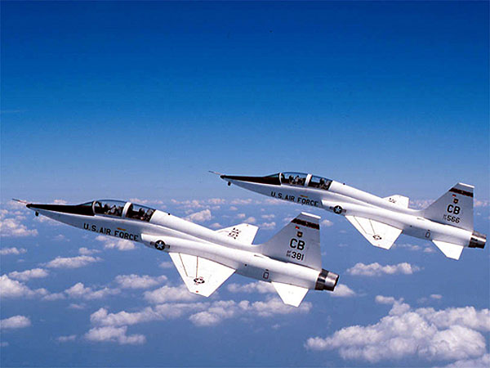[**T-38 Talon**](https://fas.org/man/dod-101/sys/ac/t-38.htm)

The Talon is an advanced jet trainer and students move onto this aircraft from the T-37 if they are going into fighters, strike or bomber aircraft. Many air forces use the T-38 in the training role, and several NATO countries train their pilots in the US both on this aircraft and on the T-37 through the NATO Joint Jet Pilot training program hosted at Sheppard AFB. Some of the T-38s are modified to the AT-38B standard with external weapons mounts in order to train pilots in weapons release. The Test Pilot School at Edwards AFB uses the T-38 to qualify its students, and all commands in the USAF as well as NASA use this versatile aircraft for various roles. Over 1,100 Talons were produced for the USAF and in 1994 there are about 600 remaining in service, with around 500 available for flight training.

|  |  |  |  |  |  |  |
| --- | --- | --- | --- | --- | --- | --- |
| Sqn | Name | Wing | Location | No. | Type | Remarks |
| 5th FTS | Spittin’ Kittens | 71st | Vance AFB, OK | 40 | T-38 |  |
| 26th FTS | Tigers | 71st | Vance AFB, OK | 40 | T-38 |  |
| 49th FTS | Black Knights | 14th | Columbus AFB, MI | 40 | T-38 |  |
| 50th FTS | Strikin' Snakes | 14th | Columbus AFB, MI | 40 | T-38 |  |
| 54th FTS | Peregrines | 64th | Reese AFB, TX | 40 | T-38 |  |
| 87th FTS | Red Bulls | 47th | Lackland AFB, TX | 40 | T-38 |  |
| 88th FTS | Lucky Devils | 80th | Sheppard AFB, TX | 40 | T-38 |  |
| 90th FTS | Boxing Bears | 80th | Sheppard AFB, TX | 40 | T-38 |  |
| 97th FTS | Devil Cats | 82nd | Williams AFB, AZ | 40 | T-38 |  |
| 434th FTS | Red Devils | 43rd | Holloman AFB, NM | 40 | T-38 |  |
| 435th FTS | Black Eagles | 43rd | Holloman AFB, NM | 40 | T-38 |  |
| 560th FTS | Chargin Cheetahs | 12th | Randolph AFB, TX | 40 | T-38 | Instructor training |

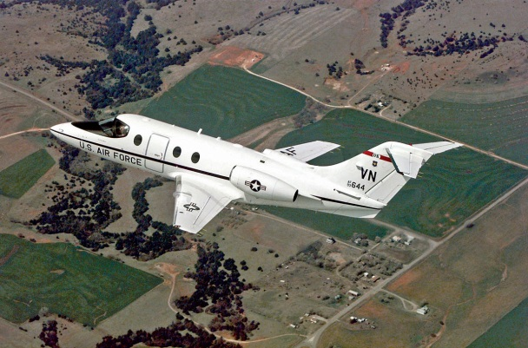[**T-1A Jayhawk**](https://fas.org/man/dod-101/sys/ac/t-1.htm)

The Jayhawk came into the USAF in 1992 and began training pilots for the airlift and tanker fleets in early 1993. Both US Navy and USMC pilots requiring multi-engine jet qualifications are trained by the USAF on these same squadrons. Programed for 180 aircraft, about 80 had been delivered by the end of 1993. New aircraft are arriving at a rate of two per month and will be distributed evenly until the training squadrons reach a strength of 36 each.

|  |  |  |  |  |  |  |
| --- | --- | --- | --- | --- | --- | --- |
| Sqn | Name | Wing | Location | No. | Type | Remarks |
| 3rd FTS | Peugeots | 71st | Vance AFB, OK | 16 | T-1A |  |
| 48th FTS | Alley Cats | 14th | Columbus AFB, MI | 16 | T-1A |  |
| 52nd FTS | Gators | 64th | Reese AFB, TX | 16 | T-1A |  |
| 86th FTS | Lobos | 47th | Lackland AFB, TX | 16 | T-1A |  |
| 99th FTS | Tuskegee Airmen | 82nd | Williams AFB, AZ | 16 | T-1A | Instructor Training |

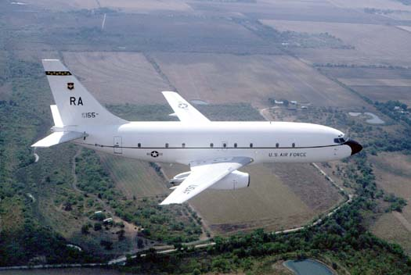[**T-43**](https://fas.org/man/dod-101/sys/ac/t-43.htm)

The T-43 is a modified Boeing 737 used primarily for navigation training and prepared navigators and other crew for duty in strategic and tactical platforms such as Looking Glass, E-3 Sentry or J-STARS. Of the 15 aircraft in the inventory 12 are used by 562nd ‘Gators’ and 563rd ‘Ace of Spades’ Squadrons as part of 12th Air Training Wing at Randolph AFB, Texas. The remaining three are used for general transport duties.

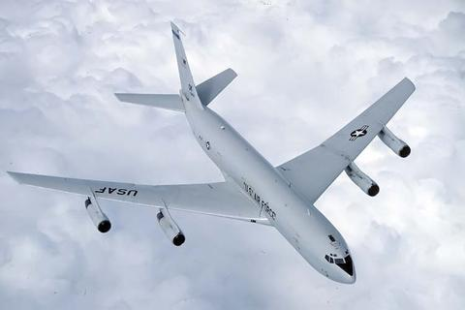[**TC-18E**](https://en.wikipedia.org/wiki/Boeing_C-137_Stratoliner)

Two second hand Boeing 707s with the TC-18E designation are used for training of E-3 pilot and crews. They are operated out of Tinker AFB, Oklahoma by the 552d Operations Group.

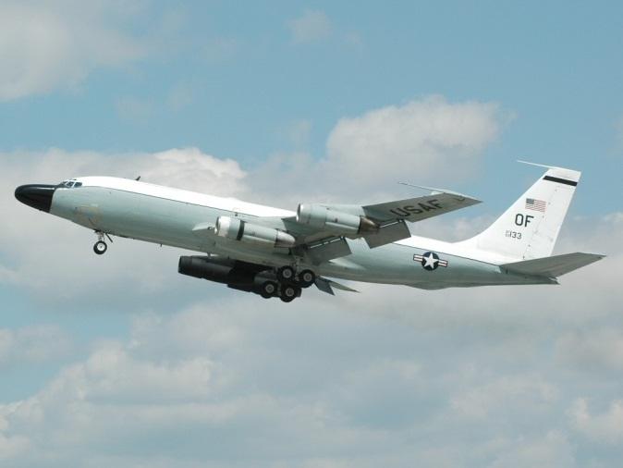

[**TC-135**](https://en.wikipedia.org/wiki/Boeing_RC-135#TC-135)

Three aircraft designed to provide training to RC-135 Rivet Joint and Cobra Ball aircrew. They are operated by 338th Combat Training Squadron at Offutt AFB, Nebraska.

**U-2TR-1B**

Training versions of the U-2 Strategic Reconnaissance aircraft, operated by the 9th Strategic Reconnaissance Wing at Beale AFB, California. Four of the original five aircraft exist and they are modified and updated to the latest versions.

