**United States** 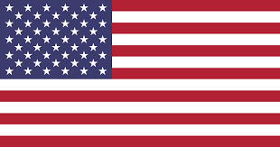

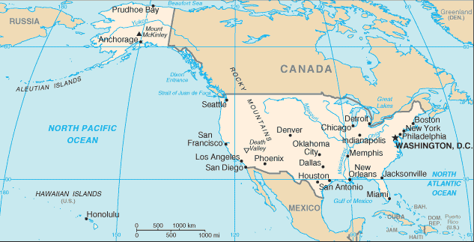

**United States:** The US is one of the founding members of NATO and is undoubtedly the important military power in the alliance. Although there was significant discussion over military reductions following the unification of Germany, the hard line resurgence in the USSR quickly stymied that discussion. Internationally, the US has been arguing for maintenance of Cold War commitments while many governments are more interested in the ‘Peace Dividend’ that was promised in the late ‘80s. The divergence of a hawkish response to a resurgent USSR versus isolationist voices complaining about lack of foreign spending has given rise to some ugly political situations in Washington.

The US military has undergone some reorganization, minor reductions and adjustments but has largely maintained its Cold War capabilities. The Reagan era ‘600 Ship Navy’ is still an aspiration and very close to becoming a reality, although there are 16 Aircraft Carriers on the roster, only 13 of these are fully capable with air wings and available escorts. The US Air Force historically suffered significant cuts and base closures resulting from three rounds of BRAC (Base Realignment and Closure Commission) reviews, for the most part these do not occur. The Army has had a confusing and frustrating few years; the planned downsizing of forces in Europe after the Gulf War did, to a large extent happen, but at the same time structures in the US were bolstered and plans remain to reinforce forces in Germany.

Global commitments have generally grown over the past few years. Instead of focusing primarily on Europe, the results of the Gulf War have left significant military commitments in the Middle East and Indian Ocean area, as well as evolving problems in Central America and Africa. Although large – the US Military is stretched quite thin.