NATO/US Navy/Amphibious Forces/Amphibious Groups/II MEF

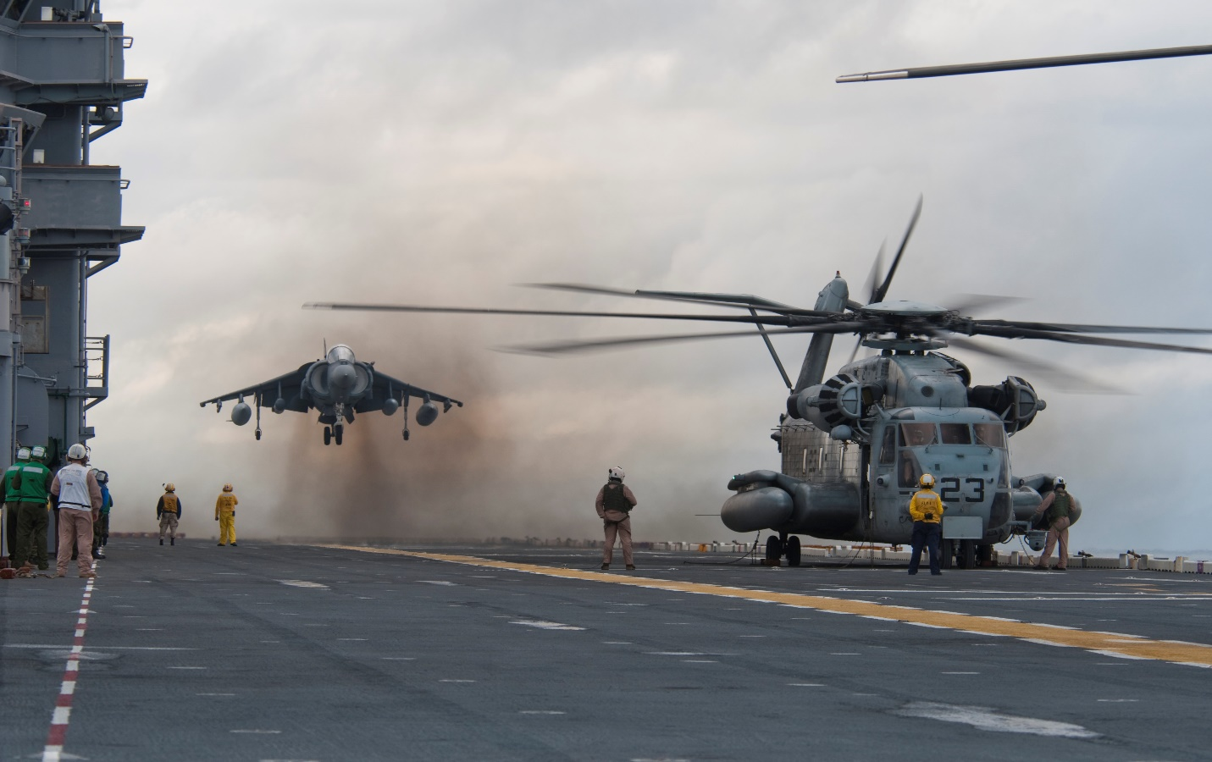

As 2nd Fleet gains air and sea dominance in the North Atlantic the significant problem of Iceland remains. To tackle this II Marine Expeditionary Force (MEF) is formed base on 2nd Marine Division and is configured as follows:

* **CE**: II MEF HQ Group
  + 2nd Force Reconnaissance Coy
  + 3rd Force Reconnaissance Coy (4 Mar Div)
  + 4th Combat Engr Bn (4 Mar Div Follow on Force)
  + 2nd Intelligence Bn (partially embarked)
  + 2nd Law Enforcement Bn (follow on force)
  + 2nd Radio Bn (follow on force)
  + 8th Communications Bn
  + 2nd Air Naval Gunfire Liaison Company (ANGLICO)
* **GCE**: 2nd Marine Division (minus 2nd Mar Regt, plus reinforcements)
  + 6th Mar Regt
  + 8th Mar Regt
  + 10th Mar Regt (Arty)
  + 2nd Assault Amphibian Bn
  + 2nd Combat Engr Bn
  + 2nd Light Armored Infantry Bn
  + 2nd Reconnaissance Bn
  + 2nd Tank Bn
  + 4th Tank Bn (4 Mar Div)
  + 2nd Logistics Bn
* **ACE**: 2nd Marine Air Wing (MAW)
  + Marine Air Group (MAG) 14
    - VMA-223 Bulldogs 22x AV-8B Harrier II
    - VMA-231 Ace of Spades 22x AV-8B Harrier II+
    - VMA-331(-) Bumblebees 16x AV-8B Harrier II+
    - VMA-542 Flying Tigers 22x AV-8B Harrier II
    - VMO-1 Yazoo 22x OV-10D
    - VMAQ-2 Panthers 5x EA-6B
    - VMAQ-3 Moon Dogs 5x EA-6B
    - VMGR-252 Otis 10x KC-130F, 14x KC-130R
  + MAG 26 (-)
    - HMM-162 Golden Eagles 12x CH-46E
    - HMM-261 Raging Bulls 12x CH-46E
    - HMM-263 Thunder Eagles 12x CH-46E
    - HMM-265 Blue Knights 12x CH-46E
    - HMM-266 Ftg Griffons 12x CH-46E
  + MAG 29
    - HMLA-167 Warriors 14x AH-1W, 12x UH-1N
    - HMLA-269 Gunrunners 14x AH-1W, 12x UH-1N
    - HMLA-467(-) Sabers 8x AH-1W, 8x UH-1N
    - HMH-362 Ugly Angles 16x CH-53D
    - HMH-366 Hammerheads 16x CH-53E
    - HMH-461(-) Ironhorse 12x CH-53E
    - HMH-464 Condors 18x CH-53E
  + MAG 31
    - VMFA-122 Werewolves 12x F/A-18A
    - VMFA-251 Thunderbolts 12x F/A-18A
    - VMFA-312 Checkerboards 12x F/A-18D
    - VMFA-332 Polka Dots 12x F/A-18D
    - VMFA-533 Hawks 12x F/A-18D
  + Marine Air Control Group 28
* **LCE**: 2nd Marine Logistics Group
  + Combat Logistics Regiment 2
  + Combat Logistics Regiment 25
  + 2nd Medical Bn
  + 4th Medical Bn (4 Mar Div)
  + 2nd Dental Bn (Follow on force)
  + 8th Engineer Support Bn

There are over 100 ships involved in the initial assault making this the most significant operation of the war so far and is controlled directly by Comd 2nd Fleet afloat.

* Command:
  + TG Mount Whitney
* Covering Force:
  + CVBG Carl Vinson
  + CVBG Eisenhower
* Support Force:
  + CVBG Theodore Roosevelt
  + TG Missouri
  + TG Wisconsin
* Screening Force:
  + TG Hayler
* Amphibious Force:
  + 6th Mar Regt
    - TG Wasp
    - TG Charleston
  + 8th Mar Regt
    - TG Bataan
    - TG Mobile
  + 2 Mar Div
    - TG Guadalcanal

