NATO/US Navy/Amphibious Forces/Amphibious Groups/II MEF/TG Bataan

TG Bataan is transporting the combat elements of 8th Marine Regiment.

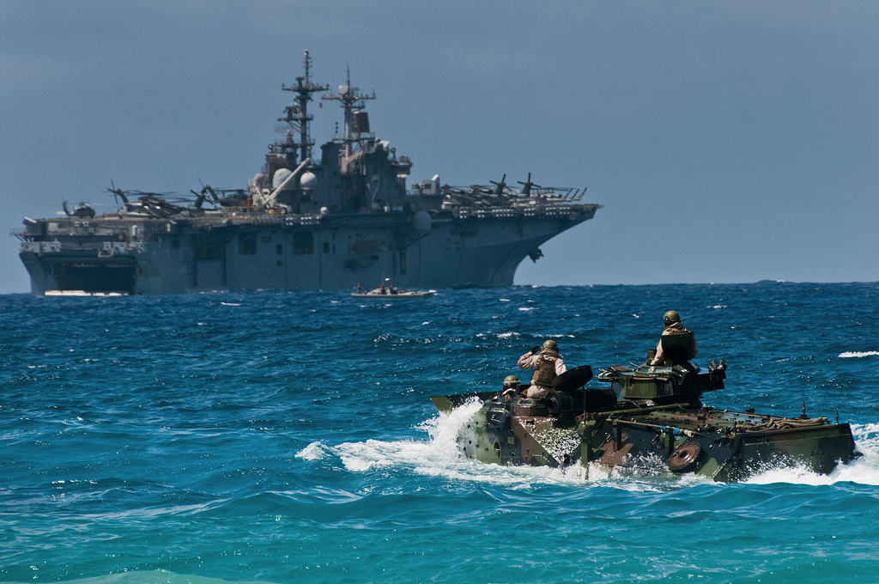

TG Bataan

* LHD-5 USS Bataan
  + VMA-223 – 10x AV-8B
  + VMA-331 – 12x AV-8B+
  + HMLA-167 – 8x AH-1W, 4x UH-1N
  + Elm HMM-261 – 4x CH-46E
  + Elm HMH-461 – 4x CH-53E
  + Elm HM-14 – 2x MH-53E
* LHA-2 USS Saipan
  + Elm VMA-223– 8x AV-8B
  + Elm VMA-331 – 4x AV-8B+
  + VMM-266 – 12x CH-46E
  + Elm HMLA-467 – 6x AH-1W
  + HMH-464 – 16x CH-53E
* LPH-12 USS Inchon
  + Elm VMA-223– 4x AV-8B
  + Elm HMLA-167 – 4x AH-1W, 4x UH-1N
  + HMM-261 – 8x CH-46E
  + HMH-461 – 10x CH-53
* CG-72 USS Vella Gulf
  + Elm HSL-40 – 2x SH-60B
* LPD-4 USS Austin
* LPD-15 USS Ponce
* LSD-37 USS Portland
* LSD-38 USS Pensacola
  + Elm HMH-362 – 2x CH-53D
* LSD-50 USS Carter Hall
  + Elem HMH-464 – 2x SH-53E
* DD-968 USS Arthur W. Radford
  + Elm HSL-60 – 2x SH-60B
* FFG-54 USS Ford
  + Elm HSL-48 – 2x SH-60B

