NATO/US Navy/Amphibious Forces/Amphibious Groups/II MEF/TG Charleston

TG Charleston is transporting the support elements of 6th Marine Regiment and consists mainly of slower ships.

TG Charleston

* LKA-113 Charleston
* LST-1192 Spartanburg County
* LST-1193 Fairfax County
* LST-1194 La Moure County
* LST-1196 Harlan County
* T-AOT 172 Sealift Atlantic
* FF-1189 Jesse L. Brown
  + Elm HSL-38 – 1x SH-2F

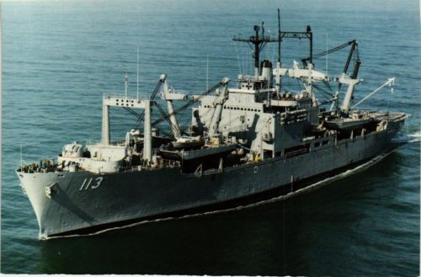

LKA-113 USNS Charleston