NATO/US Navy/Amphibious Forces/Amphibious Groups/II MEF/TG Guadalcanal

TG Guadalcanal is transporting the Divisional troops for 2nd Marine Div.

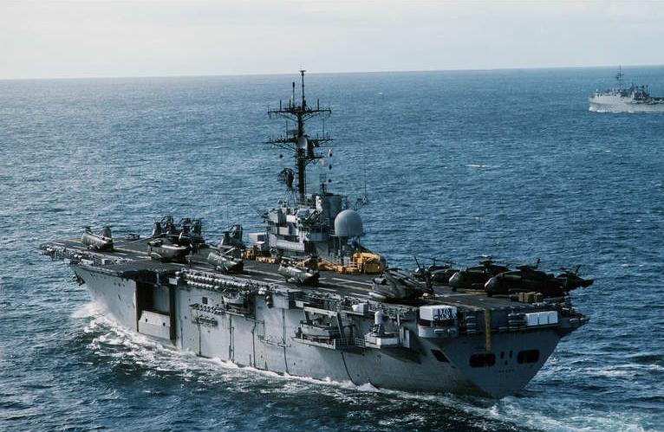

TG Guadalcanal

* LPH-7 USS Guadalcanal
  + HMM-265 – 12x CH-46E
  + Elm HMH-461 – 4x CH-53E
  + Elm HMLA-467 – 2x AH-1W, 8x UH-1N
* LPH-9 USS Guam
  + HMH-366 – 16x CH-53E
  + Elm HMLA-167 – 4x AH-1W, 4x UH-1N
  + Elm HMM-264 – 8x CH-46E
  + Elm HMLA-269 – 8x UH-1N
* CG-19 USS Dale
* DD-974 USS Comte de Grasse
  + Elm HSL-60 – 2x SH-60B
* FFG-5 USS Richard L. Page
  + Elm HSL-38 – 1x SH-2F
* LKA- 116 St. Louis
* T-AK 3005 Sgt. Matej Kocak
* T-AK 3006 PFC E.A. Obregon
* T-AK 3007 Maj S.W. Pless
* T-AK 3008 Lt John P. Bobo
* T-AOT 1121 Gus W. Darnell
* T-AVB 3 Wright

