NATO/US Navy/Naval Aviation/A-6

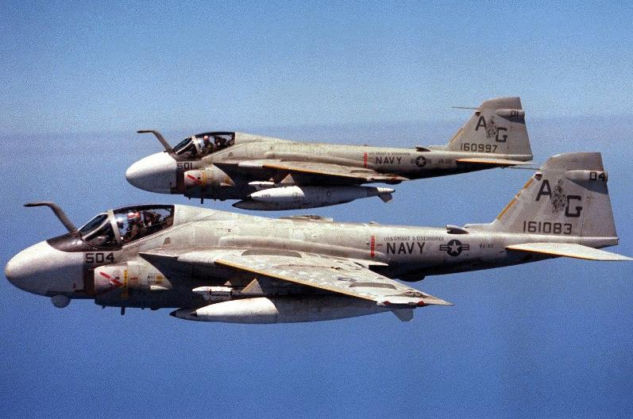

***A-6 Intruder***

The A-6 family of aircraft were venerable workhorses within the USN. Introduced in the mid 1960’s, over half of the 445 A-6E’s were rebuilt from the original airframes. In the Northern Fury world two key decisions were made:

1. The A-6 *Intruder*, as a single role airframe would be retired early. This decision was made in 1989 and was linked to the increased production of the F/A-18 Hornets. Therefore; conversion of the A-6E TRAM (Target Recognition and Attack Multi-Sensor) to the A-6E SWIP (System Weapons Improvement Program) was canceled with only half the fleet converted; and, all A-6E SWIP would be placed in preservation storage by the middle of 1994.  All USMC Squadrons had already converted to the Hornet and only 2 Squadrons remain in the Fleet: VA-176 ‘Thunderbolts’ in CVW-6 on the USS Enterprise, and VA-115 ‘Eagles’ in CVW-5 on the USS Independence based in Japan. The remainder are processing through the three readiness Squadrons into storage.
2. Realizing somewhat belatedly that the threat from the Soviet bloc was increasing. Congress authorized the purchase of 100 new build A-6F *Intruder II*, which had; vastly improved avionics and sensors, a ‘non-afterburner version of the same engine the F/A-18 used, more hard points for weapons and the ability to use the Aim-120 AMRAAM air to air missile.  These 100 aircraft would outfit 6 squadrons, plus training and evaluation units, and be assigned as required to CVW’s or land establishments. The first two Squadrons (VF-52 ‘Knightriders’, and VF-55 ‘Warhorses’) were receiving their aircraft and undergoing type training at the outbreak of the war.

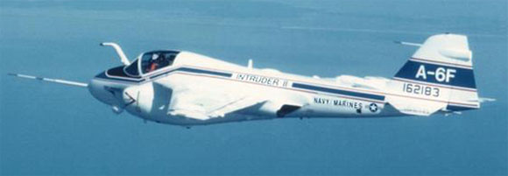

The Tanker version, designed specifically for air to air refueling, the KA-6D had also been retired, but because these aircraft were so heavily used during their lifetime, they were unrecoverable and would not be re-commissioned.

In the early days of the conflict the pentagon would partially reverse the first decision, rebuilding 6 Squadrons of A-6E SWIP and fielding them initially with 8 aircraft each. As airframes become available these – and the two Sqns in the fleet which have 10 aircraft each, will be bulked up to 12 each.  Combined with the 6 A-6F squadrons, the fleet will maintain a total of 14 Attack (VA) squadrons, with a possibility of forming 4 additional USMC (VMA) Squadrons by the end of 1994.

The remaining aircraft of the Intruder family was the most specialized.  The EA-6B *Prowler*, was the fleet Electronic Warfare aircraft. The systems were so effective that the USAF was using 16 of them to complement their fleet of EW aircraft. Each CVW had a Squadron of 5 Prowlers and the USMC had an additional 4 Squadrons.  Slow rate production (4/yr) was restarted in 1992 with the first aircraft coming off the line in July or Aug of 1994.

|  |  |  |  |  |  |
| --- | --- | --- | --- | --- | --- |
| Sqn | Name | CVW | No. | Type | Remarks |
| VA-176 | Thunderbolts | A-6E | 10 | CAW-6 | USS Enterprise |
| VA-115 | Eagles | A-6E | 10 | CVW-5 | USS Independence |
| VA-42 | Green Pawns | A-6E | 20 | FRS | NAS Oceana |
| VA-128 | Golden Intruders | A-6E | 36 | FRS | NAS Whidbey Island |
| VA-155 | Silver Foxes | A-6E | 16 | FRS | NAS Whidbey Island |

