NATO/US Navy/US Navy CVBGs

CVBG Abraham Lincoln (CVN-72)

CVN-72 deployed to the Pacific Fleet as planned in 1991 to join CVN-68 Nimitz. When war starts she is in the process of deploying to the Indian Ocean, Persian Gulf to replace the Nimitz. Deploying before Christmas 93 she conducted an exercise with CV-62 Independence and CV-63 Kitty Hawk (just returning from the Persian Gulf) off of the Philippines in Jan which was followed by a port visit to Sydney Australia at the beginning of February. She is en route to the Indian Ocean at war start but will be almost immediately recalled to the Pacific to help stabilize maters there.

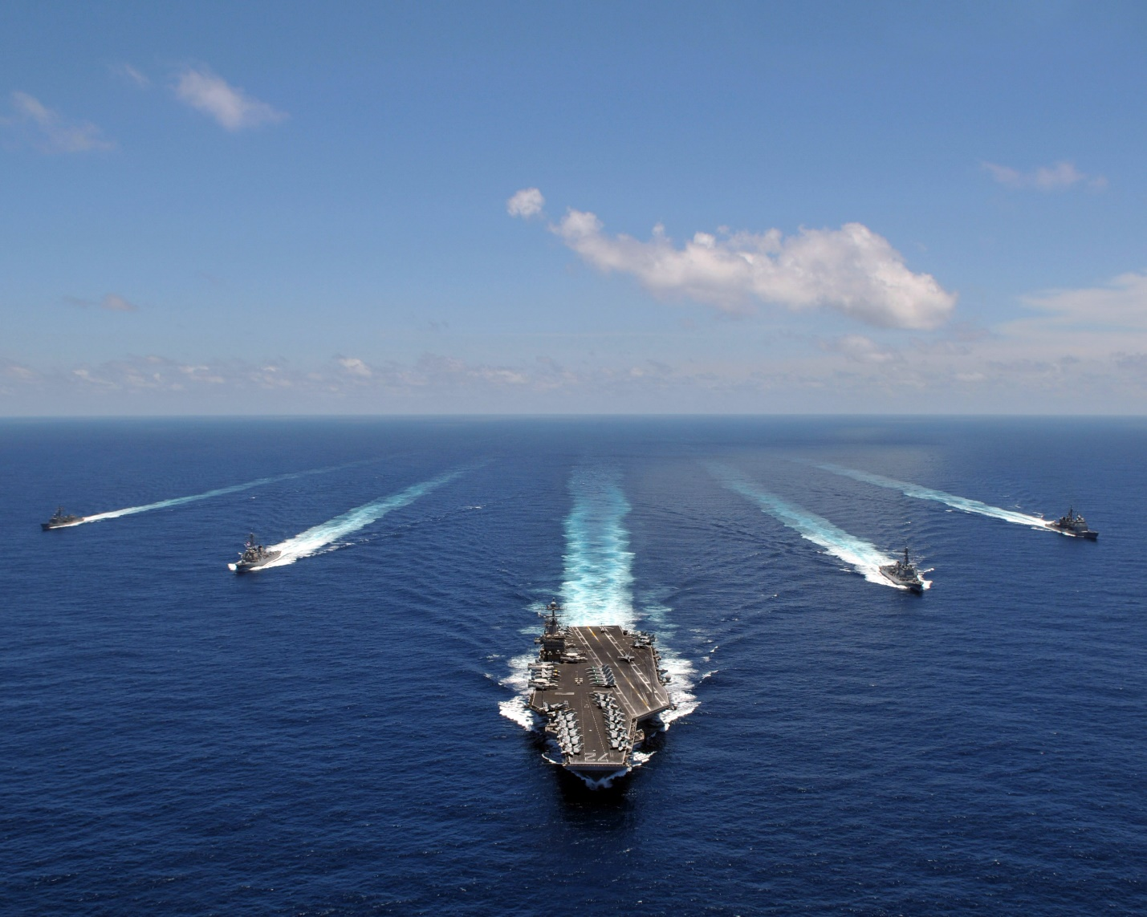

USS Abraham Lincoln CVBG

* CVN-72 Abraham Lincoln (FLAG)
  + CVW 11
    - VF-213 Black Lions F-14A
    - VF-102 Diamondbacks F-14A
    - VFA-22 Fighting Redcocks F/A-18C (N)
    - VFA-94 Mighty Shrikes F/A-18C (N)
    - VFMA-314 Black Knights F/A-18A
    - VA-95 Green Lizards A-6E SWIP (From 1 March)
    - VAQ-135 Black Ravens EA-6B
    - VAW-117 Wallbangers E-2C
    - VS-29 Dragonfires S-3B
    - HS-6 Indians SH-60F, HH-60H
    - VQ-5(El) Sea Shadows ES-3A
  + CG-51 Thomas S. Gates
  + CG-30 Horne
  + CG-24 Reeves
  + DDG-54 Curtis Wilber
  + DD-981 John Hancock
  + FFG-51 Gary
  + FFG-32 John L. Hall

Notes

1. VA-95, deploys when the Navy reactivates 6x A-6E Sqns (only 8 AC)