NATO/US Navy/US Navy CVBGs

CVBG John C. Stennis (CVN-74)

CVN-74 is currently completing construction and is being rushed into service. She will put to sea for builder’s trials in Mar 94 and acceptance trials in early April. Commissioning will be on 10 April 94 when she will conduct rapid qualification of all her systems and transit to the North Sea at the end of April. Her air group, based on the Reserve Air wing for the West Coast (CVWR-30), is conducting carrier qualification on CV-64 Constellation which is in the process of reconstituting its air group off the west coast.

The Stennis is destined for the West Coast fleet but will conduct operations in the North Atlantic for two months prior to heading back into dry-dock for a month in July and transiting to San Diego in August. Her Battle Group will form as required near the end of April and until then will conduct other tasks.

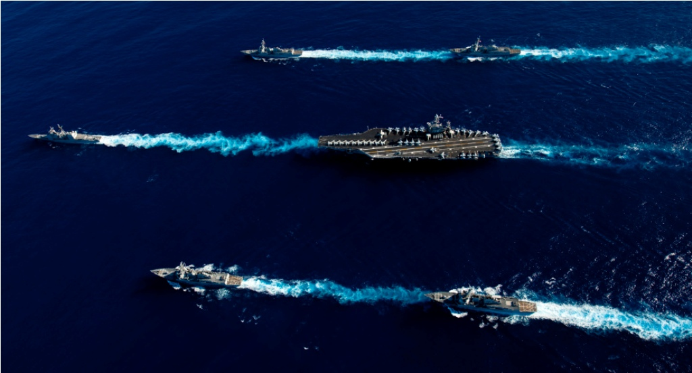

USS John C. Stennis CVBG

* CVN-74 John C. Stennis (FLAG)
  + CVWR 30
    - VF-301 Devils Disciples F-14D
    - VF-302 Stallions F-14D
    - VFA-303 Golden Hawks F/A-18C
    - VFA-305 Lobos F/A-18C
    - VA-52 Knightriders A-6F
    - VAQ-309 Axemen EA-6B
    - VAW-88 Cotton Pickers E-2C
    - VS-31 Topcats S-3B
    - HS-85 Golden Gators SH-60F, HH-60H
    - VQ-5(El) Sea Shadows ES-3A
  + CG-73 Port Royal (Builders trials at war start)
  + CG-72 Villa Gulf
  + CG-61 Monterey
  + DD-997 Hayler
  + DD-986 Harry W. Hill
  + FFG-54 Klakring
  + FFG-43 Ford

Notes

1. VS-31, ‘Topcats’ will join the air wing from CVW-2 when CV-64 Constellation withdraws.