NATO/US Navy/US Navy CVBGs

CVBG Nimitz (CVN-68)

The USS Nimitz is the lead ship of her class, the largest most ships afloat in any navy, ever. Nicknamed ‘Old Salt’ she has already been active in the US Navy for 19 years by the time war starts in February 1994. Based in San Diego as part of 3rd Fleet, she is just completing a six-month tour of duty in the Indian Ocean, Persian Gulf area. She will immediately be tasked with conducting a contested passage into the Mediterranean and beyond that into the North Atlantic to work with her East Coast sister ships.

The change in role from peacetime patrol to wartime power projection means quite a shift in the Battle Group early in the conflict.

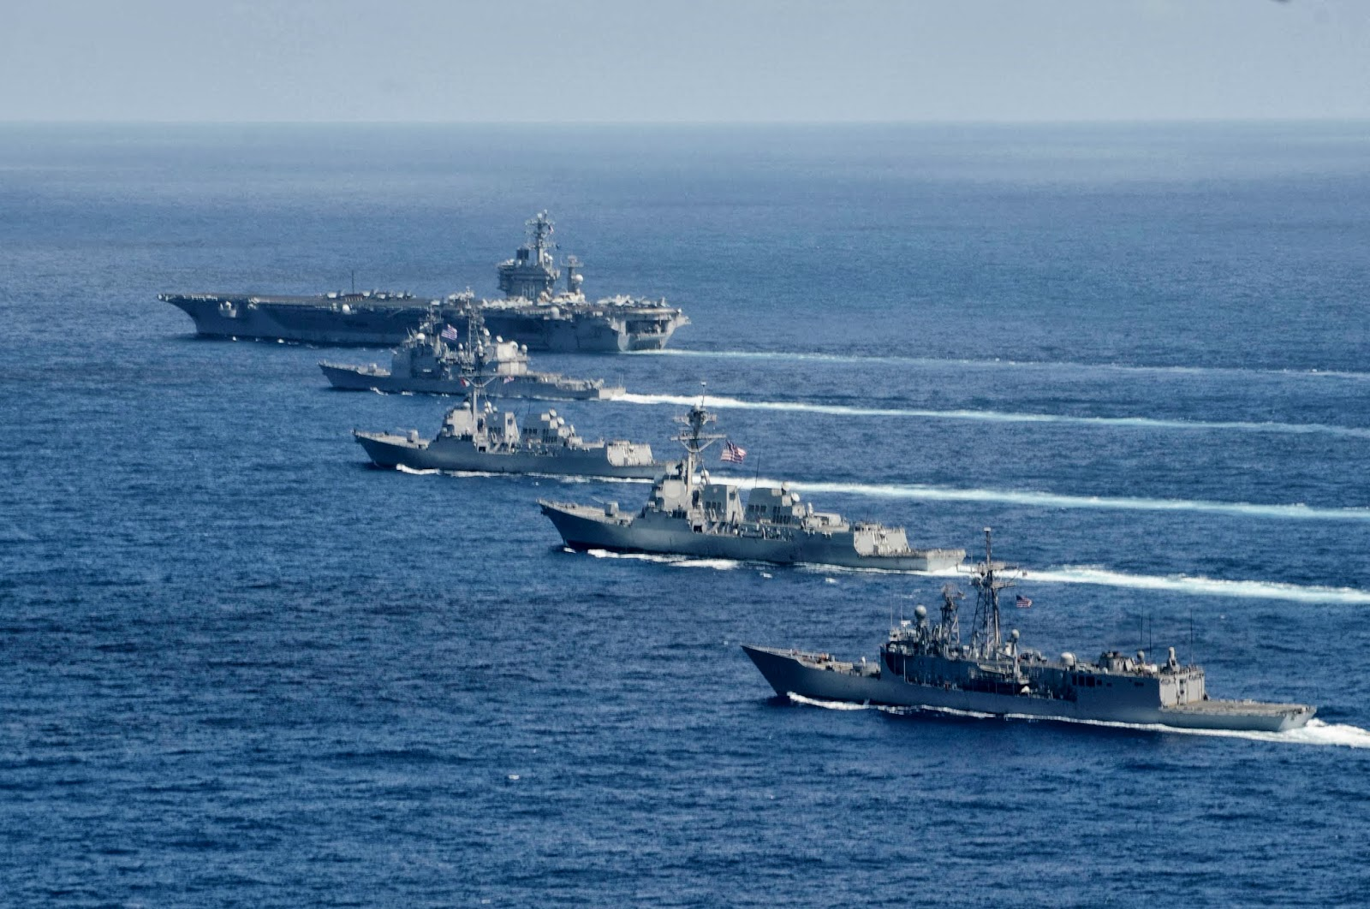

USS Nimitz CVBG

* CVN-68 Nimitz (FLAG)
  + CVW 9
    - VF-24 Fighting Renegades F-14A
    - VF-211 Checkmates F-14A
    - VFA-146 Blue Diamonds F/A-18C (N)
    - VFA-147 Argonauts F/A-18C (N)
    - VA-165 Boomers A-6E SWIP (From 28 Feb)
    - VAQ-138 Yellow Jackets EA-6B
    - VAW-112 Golden Hawks E-2C
    - VS-33 Screwbirds S-3B
    - HS-2 Golden Falcons SH-60F, HH-60H
  + CG-18 Warden (at war start)
  + CG-28 Wainwright (reinforcement)
  + CG-64 Gettysburg (reinforcement)
  + DD-977 Briscoe (at war start)
  + DD-984 Leftwich (reinforcement)
  + DDG-53 John Paul Jones (at war start)
  + FFG-29 Stephen W Groves (at war start)
  + FFG-41 McClusky (reinforcement)
  + AO-177 Cimarron (reinforcement)

Notes

1. VA-165, deploys when the Navy reactivates 6x A-6E Sqns (only 8 AC)