**USN Attack Submarines (SSN)**

An SSN has many names, at its core it is simply a nuclear powered general purpose submarine, Americans call them ‘Attack Submarines’, the Royal Navy knows them as ‘Fleet Submarines’, the Soviets call them ‘Cruisers’ and in many ways they have replaced that traditional surface class in key roles. It is sometimes easier to classify an SSN by what it isn’t; it is not able to fire ballistic missiles, this is reserved for SSBNs; it’s primary weapon is not a missile, that would be an SSGN (none in US service in 1994); and it is not commonly use as a research vessel, although testing new equipment is routine. Another distinction that is mere semantics is the term ‘Hunter Killer’ which, is a popular phrase but is more properly reserved for small diesel powered boats classified as SSK. Since the USN doesn’t operate SSKs and its entire submarine fleet is nuclear powered that distinction is not useful. In Northern Fury the US Navy has 97 of the 100 attack boats called for in the Reagan ‘600 ship navy’ plan, but also has retained 12 specialist submarines based on SSN hulls. Two key decisions have been made specific to the Northern Fury world: 1) Older subs will be maintained to balance the fleet at 100 Attack boats plus 8-10 specialist hulls; and 2) The Seawolf class will not be canceled and will build as planned out to the 29 hulls projected, perhaps beyond. Seawolf will replace older boats over time and the special mission roles will transfer to the Flight 1 Los Angelis class.

In many ways the unique derivatives of the fleet submarine, developed largely in the ‘80s, were not foreseen or even technically feasible when the Reagan plan was drawn up. Special Forces delivery, communications eavesdropping and gathering electronic intelligence has always been a function of submarines but the USN took these activities to a far higher level than previously envisaged, and these developments are too valuable to squander. Therefore, although the boats dedicated to these tasks are capable of acting as attack submarines and are classified as SSN, in Northern Fury the USN will retain them in excess of the main fleet of attack boats.

[**Permit Class**](https://en.wikipedia.org/wiki/Permit-class_submarine): Five of the 14 boats in this class are still in service, three of them beyond their historical life. The remaining hulls were commissioned in the late 1960s and three of them (*Flasher, Greenling* and *Gato*) have a longer hull, larger sail and were built with a ‘SUBSAFE’ standards based on the lessons learned from the loss of *USS Thresher*, the original class lead. *USS Haddock* was built with a larger sail and retrofitted with many other improvements while *Guardfish* was rebuilt to SUBSAFE standards. These two boats are slated for retirement later in 1994 when the 3rd and 4th of the Seawolf class are commissioned. Even though these boats are approaching 30 years old, they are still very capable and potent platforms, but are not quiet enough nor do they have the sonar capabilities to challenge modern Soviet boats. In secondary roles confronted with most other situations however, they are still very valuable assets.

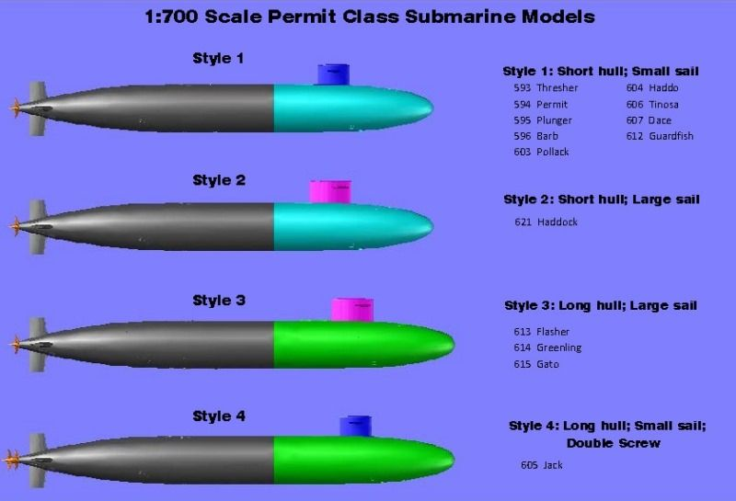

|  |  |  |  |  |  |  |  |
| --- | --- | --- | --- | --- | --- | --- | --- |
| Class | Pennant | Name | Historic | Flt | Home Port | Task | Remarks |
| Permit | SSN-612 | Guardfish | Retired 92 | Pacific | San Diego |  | SUBSAFE rebuild |
|  | SSN-613 | Flasher | Retired 92 | Pacific | San Diego | Patrol Philippians | SUBSAFE build |
|  | SSN-614 | Greenling | Retired 94 | Atlantic | Portsmouth | Patrol Caribbean | SUBSAFE build |
|  | SSN-615 | Gato | Retired 96 | Atlantic | New London |  | SUBSAFE build |
|  | SSN-621 | Haddock | Retired 93 | Pacific | Vallejo |  | SUBSAFE retrofit |

[**Sturgeon Class**](https://fas.org/man/dod-101/sys/ship/ssn-637.htm): All 28 boats of this class remain in service. Not included in this number are the nine ‘Long Hull Sturgeon’ boats referred to as the Archerfish class below, or the two experimental boats which were based on this class: *USS Narwhal*, still in service and detailed below; and *Glenard P. Lipscomb* which has been retired. The Sturgeons were longer improved versions of the Permit class, they also had a larger sail and more sensors. They had the same four torpedo tubes as the Permit class but carried more reloads and could fire Harpoon missiles, Tomahawk land attack or anti-ship missiles, SUBROC anti-submarine missiles or standard Mk-48 ADCAP torpedoes. A midlife upgrade improved the hull mounted sonar and added a towed array sonar as well as many other electronics upgrades.

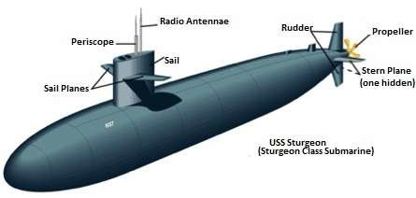

|  |  |  |  |  |  |  |  |
| --- | --- | --- | --- | --- | --- | --- | --- |
| Class | Pennant | Name | Historic | Flt | Home Port | Task | Remarks |
| Sturgeon | SSN-637 | Sturgeon | Retired 94 | Atlantic | Charleston |  |  |
|  | SSN-638 | Whale |  | Atlantic | Groton |  |  |
|  | SSN-639 | Tautog |  | Pacific | Pearl Harbor | Patrol South Pacific |  |
|  | SSN-646 | Grayling |  | Atlantic | Charleston |  |  |
|  | SSN 647 | Pogy |  | Pacific | San Diego | Refit |  |
|  | SSN-648 | Aspro |  | Pacific | Pearl Harbor |  |  |
|  | SSN-649 | Sunfish |  | Atlantic | Charleston |  |  |
|  | SSN-650 | Pargo |  | Pacific | Bremerton |  |  |
|  | SSN-651 | Queenfish | Retired 92 | Pacific | Pearl Harbor | Patrol Japan |  |
|  | SSN-652 | Puffer |  | Pacific | Pearl Harbor |  |  |
|  | SSN-653 | Ray | Retired 93 | Atlantic | Charleston |  |  |
|  | SSN 660 | Sand Lance |  | Atlantic | Groton | Refit |  |
|  | SSN-661 | Lapon |  | Atlantic | Norfolk |  |  |
|  | SSN-662 | Gurnard |  | Pacific | San Diego | Patrol Philippians |  |
|  | SSN-663 | Hammerhead |  | Pacific | Vallejo |  |  |
|  | SSN-664 | Sea Devil | Retired 91 | Atlantic | Charleston |  |  |
|  | SSN-665 | Guitarro | Retired 92 | Pacific | San Diego | Patrol North Pacific |  |
|  | SSN 666 | Hawkbill |  | Pacific | Pearl Harbor |  |  |
|  | SSN-667 | Bergall |  | Atlantic | New London |  |  |
|  | SSN-668 | Spadefish |  | Atlantic | Norfolk | Patrol Caribbean |  |
|  | SSN-669 | Seahorse |  | Atlantic | Charleston | Patrol South Atlantic |  |
|  | SSN-670 | Finback |  | Atlantic | Norfolk | Patrol Mediterranean |  |
|  | SSN-672 | Pintado |  | Pacific | San Diego |  |  |
|  | SSN-673 | Flying Fish |  | Pacific | Bremerton | Refit |  |
|  | SSN 674 | Trepang |  | Atlantic | Groton | Patrol Caribbean |  |
|  | SSN-675 | Bluefish |  | Atlantic | Norfolk |  |  |
|  | SSN 676 | Billfish |  | Atlantic | Groton | Patrol Scotland |  |
|  | SSN-677 | Drum |  | Pacific | San Diego |  |  |

[**USS Narwal (SSN 671)**](https://fas.org/man/dod-101/sys/ship/ssn-671.htm)**:** The Narwal was a testbed for an advanced propulsion system designed to minimize or hide noise from water circulation, a constant requirement in nuclear power plants. The new design made her the quietest submarine of her time and proved the system for employment on the forthcoming Los Angeles and Ohio class boats. More important for the Northern Fury campaign however was her role in the fleet as a Special Mission electronic intelligence gathering platform, a task she performs throughout the campaign. At the start of the campaign she is resident at her homeport of Charleston South Carolina.

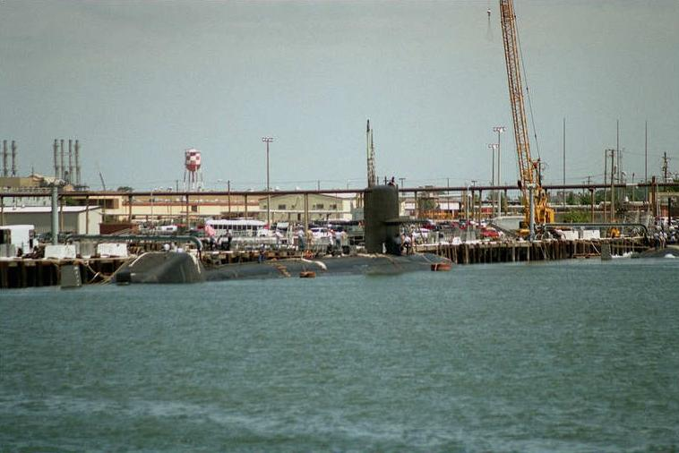

[**Archerfish Class**](https://en.wikipedia.org/wiki/Sturgeon-class_submarine): The nine boats of this class are often considered Sturgeon class but have a lengthened hull to provide more space for accommodation and improved electronic equipment. The additional space allowed for a much easier transition to [Special Mission boats](http://www.hisutton.com/Sturgeon_SSN.html), as all of these hulls have been repurposed to do. In addition to other factors, USS Batfish was the trials boat for a super quiet surface coating which was later included on Los Angeles and other submarine designs. Although their missions varied and these boats underwent some unique overhauls two main functions emerged:

* [Cable Tap](https://en.wikipedia.org/wiki/Operation_Ivy_Bells): [*Parche*](http://www.hisutton.com/USS_Parche.html) in the Pacific and *L. Mendel Rivers* in the Atlantic were extended by 100’ and outfitted for deep water research and recovery using divers and a special deployable ‘sled’ to tap underwater communications cables. The modifications are all very secret and these comments are highly speculative but there is some evidence to support these activities. Since Northern Fury is fiction, it is not too big of a leap to include these capabilities. There is some doubt if *L. Mendel Rivers* was modified, but it was used as a DDS submarine and there is a good chance that *Richard B. Russell* was equipped this way, but she is on the wrong coast.
* [DDS](https://fas.org/man/dod-101/sys/ship/docs/990100-drydeck.htm): [Dry Deck Shelters](https://fas.org/man/dod-101/sys/ship/dds.htm) are installable chambers that allow Special Forces personnel and equipment to easily depart from the submarine while submerged. These have the capacity to hold an underwater ‘[SDV’](https://en.wikipedia.org/wiki/SEAL_Delivery_Vehicle) Swimmer Delivery Vehicle and up to 20 divers able to conduct a mass summer exit from the sub.

|  |  |  |  |  |  |  |  |
| --- | --- | --- | --- | --- | --- | --- | --- |
| Class | Pennant | Name | Historic | Flt | Home Port | Task | Remarks |
| Archerfish | SSN-678 | Archerfish |  | Atlantic | Groton | DDS |  |
|  | SSN-679 | Silversides | Retired 94 | Pacific | Bremerton | DDS |  |
|  | SSN-680 | William H. Bates |  | Pacific | Pearl Harbor | DDS |  |
|  | SSN 681 | Batfish |  | Atlantic | Groton | DDS/Super quiet |  |
|  | SSN-682 | Tunny |  | Pacific | Pearl Harbor | DDS |  |
|  | SSN-683 | Parche |  | Pacific | San Diego | Cable Tap |  |
|  | SSN-684 | Cavalla |  | Pacific | Pearl Harbor | DDS |  |
|  | SSN 686 | L. Mendel Rivers |  | Atlantic | Norfolk | Cable Tap |  |
|  | SSN-687 | Richard B. Russell | Retired 94 | Pacific | Vallejo | DDS |  |

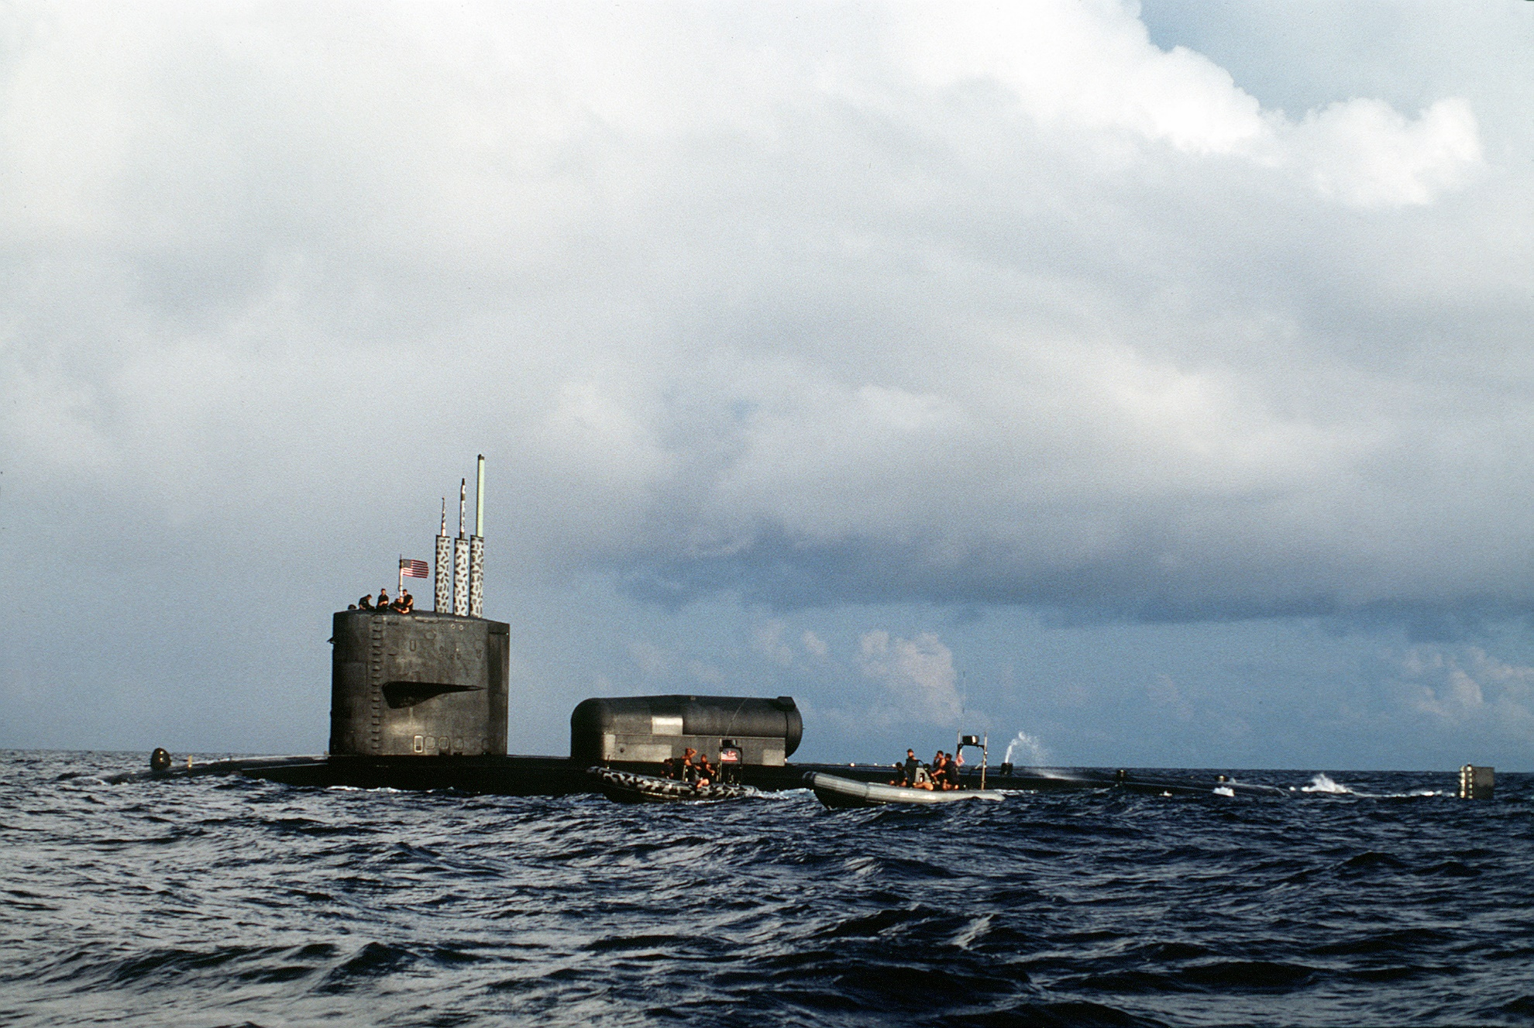

[**Benjamin Franklin Class SSN**](https://fas.org/man/dod-101/sys/ship/ssn-640.htm): These two former SSBNs were converted into Special Mission SSNs in the early 1990s. Large, quiet and equipped with plenty of space for mission planning and Special Forces accommodation these boats have twin DDS and a capacity for about 50-70 Special Forces personnel.

|  |  |  |  |  |  |  |
| --- | --- | --- | --- | --- | --- | --- |
| Class | Pennant | Name | Flt | Home Port | Task | Remarks |
| Benjamin Franklin | SSN-645 | [James K Polk](https://www.ussjameskpolk.org/history-of-the-uss-james-k-polk-ssbnssn-645/) | Atlantic | Norfolk | 2xDDS | Conversion completed Feb 94 vice March |
|  | SSN-642 | [Kamehameha](https://www.navysite.de/ssbn/ssbn642.htm) | Pacific | Pear Harbor | 2xDDS |  |

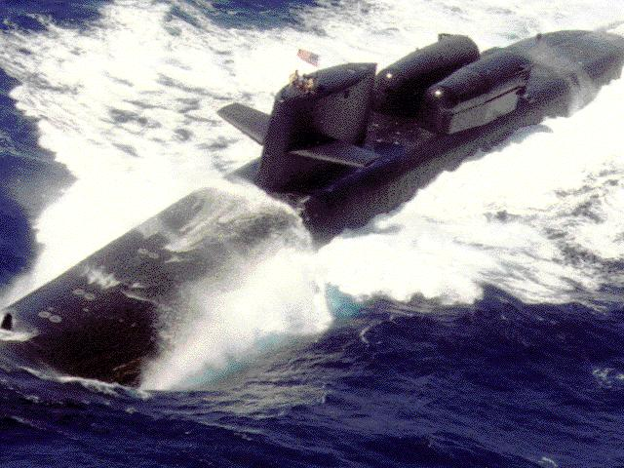

[**Los Angeles (Type 688)**](https://fas.org/man/dod-101/sys/ship/ssn-688.htm)**:** All 62 of the Los Angeles class are in service for Northern Fury, this is about two years faster than real life but the assumption is that a somewhat accelerated program would have been adopted for the last five years of production. In reality there are at least three distinct sub-classes and several variations within the production of this series:

* SSNs 688-718 - Original Los Angeles class – 31 boats
* SSNs 719-725 + 750 - Have 12 vertical launch tubes (VLS) for the Tomahawk cruise missile, and an upgraded reactor core.
* SSNs 751-773 - The final 23 hulls are referred to as "688I" (for improved) with better sonar and under ice capability and the 12 VLS tubes

These boats are the workhorses of the Northern Fury campaign, they are quiet, powerful and have excellent sensors. There were several controversies involved in the design, such as sacrificing dive depth for higher speed, however no clear unclassified understanding of the real measurements exists so a general statement that these are fast and capable boats with very few rivals will have to suffice.

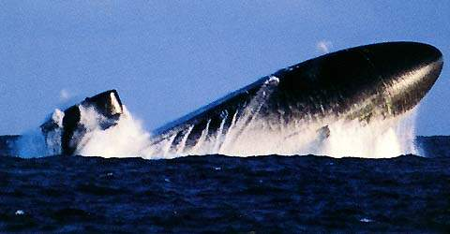

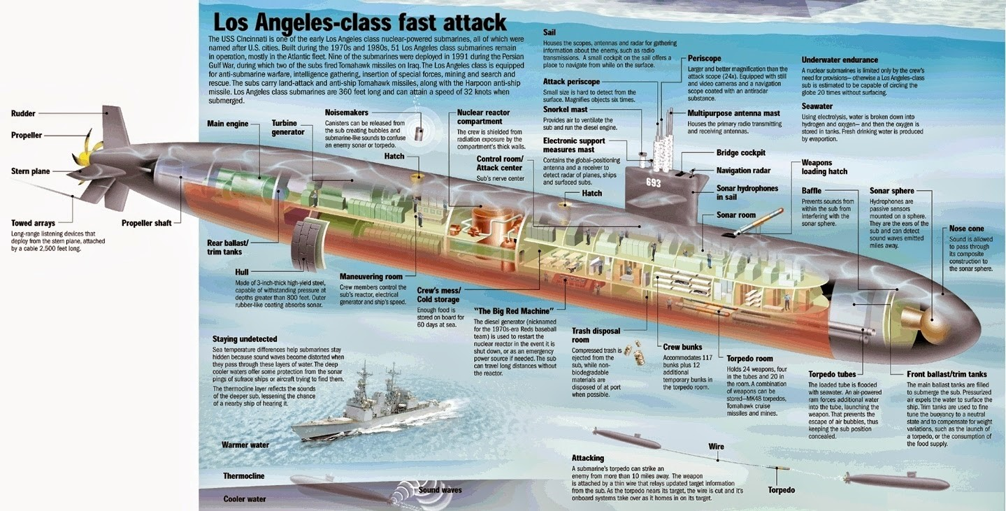

|  |  |  |  |  |  |  |
| --- | --- | --- | --- | --- | --- | --- |
| Class | Pennant | Name | Flt | Home Port | Task | Remarks |
| Los Angeles | SSN 688 | Los Angeles | Pacific | Pearl Harbor |  |  |
|  | SSN-689 | Baton Rouge | Atlantic | Norfolk |  | Repaired soon after collision |
|  | SSN 690 | Philadelphia | Atlantic | Groton |  |  |
|  | SSN 691 | Memphis | Atlantic | Groton | Med |  |
|  | SSN-692 | Omaha | Pacific | Pearl Harbor |  |  |
|  | SSN-693 | Cincinnati | Atlantic | Norfolk |  |  |
|  | SSN-694 | Groton | Atlantic | Groton |  |  |
|  | SSN-695 | Birmingham | Pacific | Pearl Harbor |  |  |
|  | SSN-696 | New York City | Atlantic | Norfolk | X-Ray Stn | Change of historic home port |
|  | SSN 697 | Indianapolis | Pacific | Pearl Harbor | Refueling | Dry dock |
|  | SSN 698 | Bremerton | Pacific | Pearl Harbor |  |  |
|  | SSN 699 | Jacksonville | Atlantic | Norfolk |  |  |
|  | SSN 700 | Dallas | Atlantic | Groton |  |  |
|  | SSN 701 | La Jolla | Pacific | Pearl Harbor |  |  |
|  | SSN-702 | Phoenix | Atlantic | Norfolk |  |  |
|  | SSN 703 | Boston | Atlantic | Groton |  |  |
|  | SSN 704 | Baltimore | Atlantic | Groton | X-Ray Stn |  |
|  | SSN 705 | City Of Corpus Christi | Pacific | Guam |  |  |
|  | SSN 706 | Albuquerque | Atlantic | Groton |  |  |
|  | SSN 707 | Portsmouth | Atlantic | San Diego |  | Change of historic home port |
|  | SSN 708 | Minneapolis-St. Paul | Pacific | Pearl Harbor |  | Change of historic home port |
|  | SSN 709 | Hyman G. Rickover | Atlantic | Norfolk |  |  |
|  | SSN 710 | Augusta | Atlantic | Groton |  |  |
|  | SSN 711 | San Francisco | Pacific | Guam |  |  |
|  | SSN 712 | Atlanta | Atlantic | Norfolk | Scottland |  |
|  | SSN 713 | Houston | Pacific | San Diego |  |  |
|  | SSN 714 | Norfolk | Atlantic | Norfolk | Med |  |
|  | SSN 715 | Buffalo | Pacific | Pearl Harbor |  |  |
|  | SSN 716 | Salt Lake City | Pacific | San Diego |  |  |
|  | SSN 717 | Olympia | Pacific | Pearl Harbor |  |  |
|  | SSN 718 | Honolulu | Pacific | Pearl Harbor |  |  |
| Providence VLS | SSN 719 | Providence | Atlantic | Groton |  |  |
|  | SSN 720 | Pittsburgh | Atlantic | Groton |  |  |
|  | SSN 721 | Chicago | Atlantic | Groton |  | Change of historic home port |
|  | SSN 722 | Key West | Pacific | Pearl Harbor |  |  |
|  | SSN 723 | Oklahoma City | Pacific | Norfolk |  |  |
|  | SSN 724 | Louisville | Pacific | Pearl Harbor |  |  |
|  | SSN 725 | Helena | Pacific | San Diego |  |  |
|  | SSN 750 | Newport News | Atlantic | Norfolk |  |  |
| San Juan (688I) | SSN 751 | San Juan | Atlantic | Groton |  | Change of historic home port |
|  | SSN 752 | Pasadena | Pacific | Pearl Harbor |  |  |
|  | SSN 753 | Albany | Atlantic | Norfolk |  |  |
|  | SSN 754 | Topeka | Pacific | Pearl Harbor |  |  |
|  | SSN 755 | Miami | Atlantic | Groton |  |  |
|  | SSN 756 | Scranton | Atlantic | Norfolk |  |  |
|  | SSN 757 | Alexandria | Atlantic | Groton |  |  |
|  | SSN 758 | Asheville | Pacific | Pearl Harbor |  |  |
|  | SSN 759 | Jefferson City | Pacific | San Diego |  |  |
|  | SSN 760 | Annapolis | Atlantic | Groton |  |  |
|  | SSN 761 | Springfield | Pacific | Guam |  | Change of historic home port |
|  | SSN 762 | Columbus | Pacific | Pearl Harbor |  |  |
|  | SSN 763 | Santa Fe | Pacific | Pearl Harbor |  |  |
|  | SSN 764 | Boise | Atlantic | Norfolk | X-Ray Stn |  |
|  | SSN 765 | Montpelier | Atlantic | Norfolk |  |  |
|  | SSN 766 | Charlotte | Pacific | Pearl Harbor |  |  |
|  | SSN 767 | Hampton | Atlantic | Norfolk |  |  |
|  | SSN 768 | Hartford | Atlantic | Groton |  |  |
|  | SSN 769 | Toledo | Atlantic | Groton |  |  |
|  | SSN 770 | Tucson | Pacific | Pearl Harbor |  |  |
|  | SSN 771 | Columbia | Pacific | Pearl Harbor |  |  |
|  | SSN 772 | Greenville | Pacific | Pearl Harbor |  |  |
|  | SSN 773 | Cheyenne | Pacific | Pearl Harbor |  |  |

[**Seawolf Class**](http://www.military-today.com/navy/seawolf_class.htm)**:** Arguably the most advanced submarine on the planet, the Seawolf class. Know as the fastest submarine in the US fleet and the quietest submarine in the world, estimated at 10 times quitter than an Improved Los Angeles boat, with twice as many torpedo tubes. Sensors, electronic countermeasures, accommodation, weapon storage and essentially all other systems are a major improvement over the 688 class. With this improvement comes a high cost, these were projected as being the most expensive submarines ever built, at about $3 Billion dollars each they were three times the price of a 688 boat as well. Historically the program was cancelled after the first three were built and there were significant delays caused by funding shortfalls. In Northern Fury the first two are already in service while the next two are launched and fitting out for commissioning later in the year. The plan to build all 29 is being carried forward and there is discussion of even more. Note that the 3rd of the class *USS Jimmy Carter* was completed as an SSN and not as the redesigned as a Special Mission boat as she was historically. The Virginia class was not designed or constructed.

|  |  |  |  |  |  |  |  |
| --- | --- | --- | --- | --- | --- | --- | --- |
| Class | Pennant | Name | Historic | Flt | Home Port | Task | Remarks |
| Seawolf | SSN-21 | Seawolf | 1997 | Atlantic | Groton |  | Commissioned 1993 |
|  | SSN-22 | Connecticut | 1998 | Atlantic | Groton | X-Ray Stn | Commissioned 1993 |
|  | SSN-23 | Jimmy Carter | 2001 | Atlantic | Bangor |  | Aug 1994 |
|  | SSN-24 | Virginia | Canceled | Atlantic | Bangor |  | Dec 1994 |

