**Bulgarian People’s Army (BKA)**

The Bulgarian Army was organized along Soviet lines and tasked with operating in the Southern Group of Forces (SGF). The army was highly trained and had some very good equipment but consisted largely of conscript forces. The primary task of the BKA was to field a FRONT (1st Balkan) of three Combined Arms Armies (CAA), then take a Soviet and a Romanian Front under command and expel any NATO forces from its assigned area.

The three CAAs consisted of a mix of Motor Rifle Divisions (MRD), Tank Brigades TB) and supporting arms, these formations, like their Soviet equivalent have varying states of readiness:

* Category A-divisions which have 80% or more of their full strength
* Category B-those with between 30% and 50%
* Category C-those with between 5% and 10%

Category A formations could be ready to move in the matter of a few hours or less, while Category B would be ready in about 72 hours and Category C would take about 60 days.

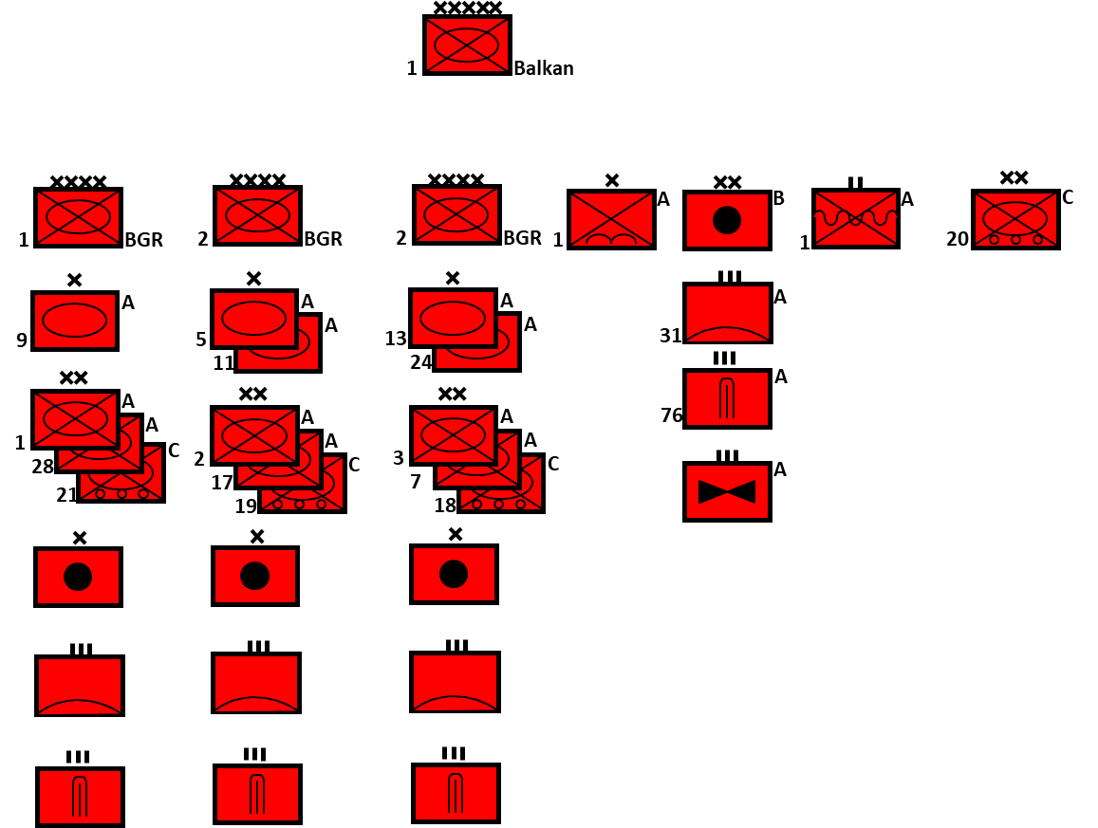

Four of Category A MRDs were equipped along standard Soviet lines with a mix of equipment. Details of the structure can be found [here](http://www.bits.de/NRANEU/others/amd-us-archive/fm100-2-3%2891%29.pdf). Two of the Category A and the four Category C Divisions are not standard, they have 4x Motor Rifle Regiments (MRR) as opposed to the normal three, but no Tank Regiment (TR). The Category C Divisions have older equipment.

Four of the five TBs also followed the standard organization; however, 9th TB was stationed near the capital and was organized quite differently. 9th TB has 3x Tank Bns each of 49 tanks (as opposed to 3x 31 tank Bns) plus 2x Infantry Bns which each have 10 tanks and an independent Tank Coy of 13 – a total of 182 tanks or twice the number of a standard TB.

The Airborne Bde does not have BMDs but is on very high readiness. The Naval Infantry Bn is largely used for garrisoning naval bases.

Equipment is mixed and depends the division or brigade in question. The table below outlines the wide variety available and since nothing is ever thrown away, if it is not in use, it’s in reserve or storage.

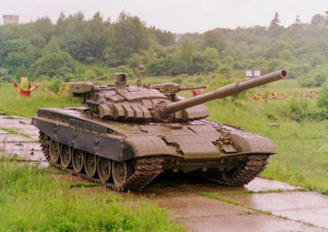

|  |  |  |  |  |
| --- | --- | --- | --- | --- |
| MBT | T-72 | T-72A/AK | 100 | Improvement on the base model with laser range finder(LRF) and improved Fire Control System (FCS) |
|  |  | T-72B | 90? | Better protection, FCS & LRF. New gun and ATGM (Anti-Tank Guided Missile) |
|  |  | T-72M1 | 240 | Czech version of the T-72A for export |
|  | T-62 | T-62MD | 250 | Improved armor, up to 200 others converted to support vehicles or bunkers. In reserve. |
|  | T-54/55 | T-54 | 900 | Soviet built with some Romanian upgraded versions |
|  |  | T-55 | 465 | Soviet built |
|  |  | T-55AM2 | 436 | Czech upgrade |
|  | T-34 | T-34/85 | ~400 | All in storage |
|  |  | Bunkers | 140 | Some with 100mm T-62 gun turrets |
|  | PT-76 |  | 250 | Amphibious tanks, mostly in reserve |
| IFV | BMP-23 | BMP-23 | 172 | Local design |
|  |  | BMP-23D | ? | Improved with ATGM |
|  |  | BRM-23 | ? | Recon vehicle |
|  | BMP-1P |  | 100 |  |
| APC | BTR-60 | Various | 781 |  |
|  | MTLB | Various | 1100 | Including many specialist vehicles |
|  | BTR-50 |  | 700 | Reserve |
| Armd Cars | BRDM-2 |  | 74 | Reconnaissance |
| Artillery | 100mm | BS-3 | 16 |  |
|  | 120mm | 2S12 | 356 | On MTLB chassis, locally produced |
|  |  | 2S11 | 359 | BTR-70 chassis |
|  |  | A-19 | 25 |  |
|  | 122mm | 2S1 | 750 | locally produced |
|  |  | M-30 | 500 |  |
|  | 130mm | M-46 | 72 |  |
|  | 152mm | 2S3 | 18 |  |
|  |  | D-20 | 150 | Towed |
|  | MLRS | BM-21 | 392 |  |
|  |  | RM-51 | 24 | Czech version of BM-13 |
| AT Guns | 85mm | D-44 | 200 |  |
|  | 100mm | SU-100 | 68 | In reserve |
|  |  | MT12 | 200 |  |
| SSMs |  | Frog-7 | 24 |  |
|  |  | Scud-B | 67 |  |
|  |  | SS-23 | 24 |  |
| AAA | 23mm | ZSU-232 | 300 | Locally produced |
|  |  | ZSU-23/4 | 30 |  |
|  | 57mm | ZSU-57/2 | 100 |  |
|  |  | S-60 | 16 |  |
|  | 76mm | M1938 | ? |  |
|  | 100mm | KS-19 | ? |  |
| SAMs | SA-3 | Goa | 34 | 750 missiles |
|  | SA-4 | Ganef | 30 | 150 missiles |
|  | SA-5 | Gammon | 26 |  |
|  | SA-6 | Gainful | 20+ | 750 missiles |
|  | SA-8 | Gecko | 24 | 780 missiles |
|  | SA-9 | Gaskin | 50 | 750 missiles |
|  | SA-13 | Gopher | 20 | 500 missiles locally produced |
| MANPADs | SA-7 | Grail | ? | 6700 missiles locally produced |
|  | SA-14 | Gremlin | ? | 250 missiles |
|  | SA-16 | Gimlet | ? | 200 missiles |
|  | SA-18 | Grouse | ? |  |
| IRBMs | SS-21 | Scarab-A | 18 | 28 HE Warheads |
|  |  | Scarab-B | ? | 8 Cluster munitions Warheads |

More detail can be found here: <https://www.scribd.com/doc/184374791/The-Bulgarian-Military>

This Wiki has some good detail as well: <https://en.wikipedia.org/wiki/Structure_of_the_Bulgarian_People%27s_Army_1989#1st_Army>

