**Bulgaria** 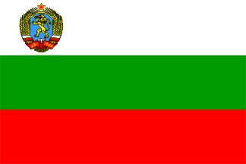

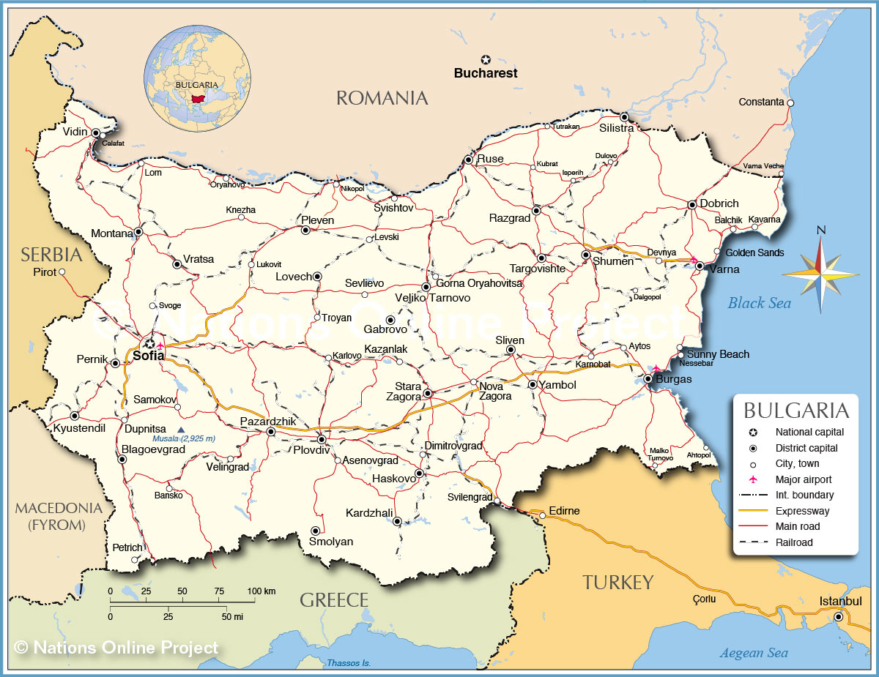

**Bulgaria** is one of the five remaining countries forming the Warsaw Pact but largely stays because of a fear that instability in the former Yugoslavia will spill over its borders. The Soviets have provided some military and economic assistance which influences some elements in Bulgaria, but once the staunchest ally, now of any member, its loyalty to the Soviets is the weakest.

The Bulgarian People’s Army (BKA) forms the bulk of the defence forces with a small coastal navy designed to assist the Soviet Black Sea Fleet in securing the approaches to the Bosporus, and a moderately sized air force of about 300 combat aircraft.