**Bulgarian Military Sea Fleet**

The Bulgarian navy, or Military Sea Fleet, is relatively small with limited capabilities, its main role is to support the Soviet Black Sea Fleet in times of crisis. As the smallest element of the Bulgarian military, the fleet was usually the last to receive funding, new equipment or government interest.

Based in two locations; Varna, and Atia, the fleet consists mostly of Anti-Submarine Warfare (ASW) vessels and minesweepers, as well as a limited number of amphibious and support ships. The major units are four frigates, three of them and the four submarines are all obsolete. The Bulgarian Navy is meant to operate in the Black Sea only and is materially unable to venture beyond that effectively.

**Frigates**

[**Koni Class**](https://en.wikipedia.org/wiki/Koni-class_frigate) ***BGS Smeli (F-11)***, formerly the Soviet ***SKR-825 Delfin***, was transferred to the Bulgarian Navy in 1989 when the Soviets felt that the old Riga class should retire. Not very large or modern, this ship still represents a significant improvement in capability for Bulgaria. The 4K33 "Osa-M" Surface to Air Missile (SAM) launcher (NATO designation SA-N-4 Gecko) has 20 reloads giving the ship a moderate missile umbrella out to about 13Km. The ASW suite is decent and the ship carries 2x 76mm guns as well as 2x 30mm cannons which act as a last ditch Close in Weapons System (CIWS).

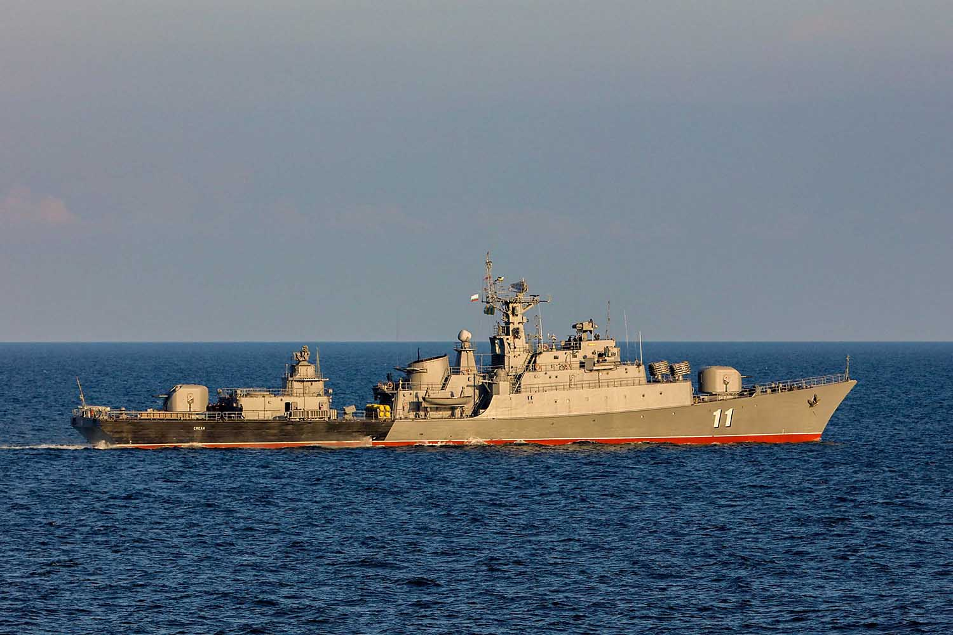

[**Riga Class**](http://russianships.info/eng/warships/project_50.htm)Two of the three ships of this class are laid up in preservation by the start of Northern Fury. The third, ***BGS Bodri (F-13)***, was modernized and was still in commission, although historically it to was supposed to retire in late 1993. The Bodri, has four SAM launchers for the 9K32 Strela-2 missile, (NATO designation SA-7 Grail) a Man Portable Air Defence System (MANPADS) with 16 missiles, and 2 CIWS 30mm cannons. The main weapon systems are the 3x100mm guns and some very dated ASW equipment. All three are located at Varna and it’s possible that at least one other has been modernized. Should the two older ships be activated it will take between six weeks and three months of work and one would need a new pennant number while the other would need a new name.

|  |  |  |  |  |
| --- | --- | --- | --- | --- |
| Class | Pennant | Name | Status | Remarks |
| Riga | F-11 | Derzki | Laid up |  |
|  | F-12 | Smeli | Laid up |  |
|  | F-13 | Bodri | Active | Modernized |

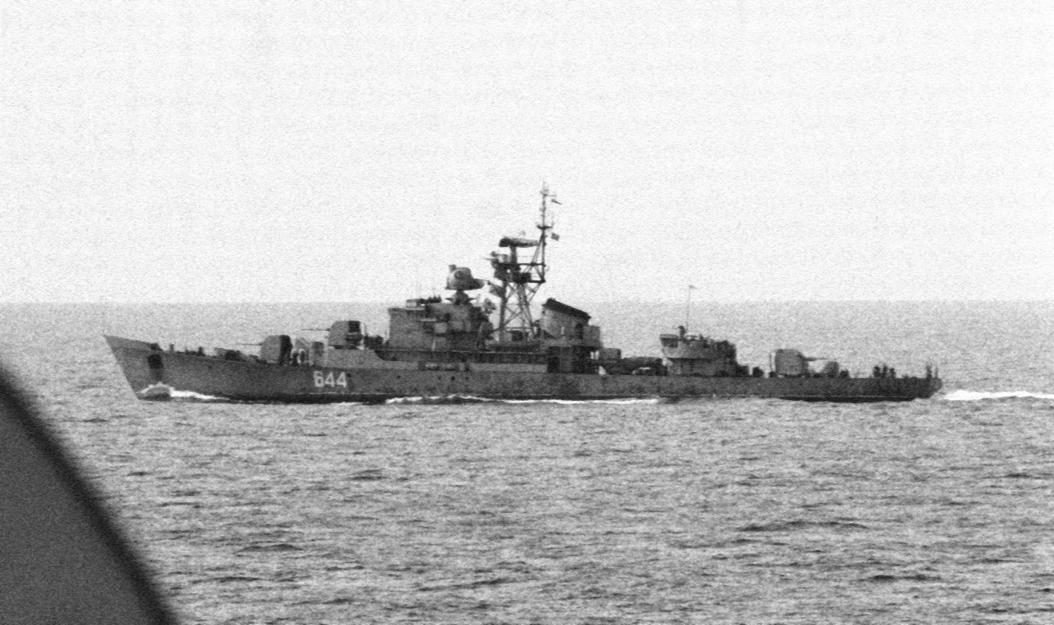

**Missile Boats**

[**Tarantul Class**](http://russianships.info/eng/warfareboats/project_12411.htm)The Bulgarian Navy received one of this class in 1992 from the Soviet Back Sea Fleet. With 4x P-15M (S-N-2C) Styx, Surface to Surface Missiles (SSM) and high speed (42 Knts), this is a potent little ship, weighing in at 495 tons. The ***BGS Malniya (P-101)*** is based at Atia.

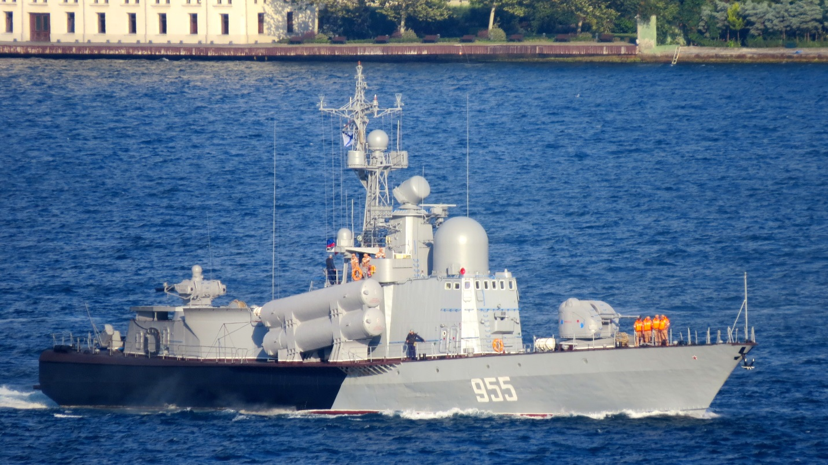

[**Osa Class**](http://russianships.info/eng/warfareboats/project_205.htm)The Bulgarian Navy took delivery of three Osa I and three Osa II boats in 1985, although RKA-10 Uragan arrived in 1981 as a training ship under Soviet control. The main improvement between the two sub classes is a modernized version of the P-15 (S-N-2C) Styx SSM. All are based at Atia.

|  |  |  |  |  |
| --- | --- | --- | --- | --- |
| Class | Pennant | Name | Status | Remarks |
| Osa I | RKA-10 | Uragan | Active | Pr. 205 |
|  | RKA-11 | Svetkavitca | Active |  |
|  | RKA-12 | Tayfun | Active |  |
| Osa II | RKA-20 | Smerch | Active | Pr. 205U |
|  | RKA-21 | Grum | Active |  |
|  | RKA-22 | Burya | Active |  |

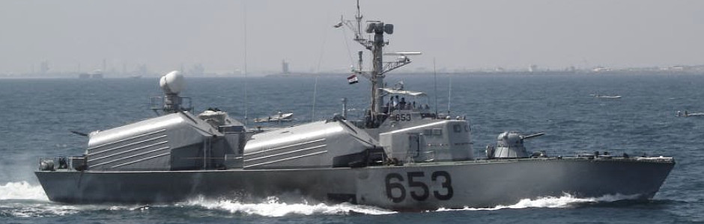

**ASW Corvettes**

[**Poti Class**](http://russianships.info/eng/warships/project_204.htm)These rugged little ships arrived in Bulgaria during the early 1980s, they are kept quite busy providing excellent service and have a good ASW suite in a small package. The Bulgarian Navy operated six of these ships.

|  |  |  |  |  |
| --- | --- | --- | --- | --- |
| Class | Pennant | Name | Status | Remarks |
|  | PLK-41 | Letjashhi | Active | Atia |
|  | PLK-42 | Bditelni | Active | Atia |
|  | PLK-43 | Naporisti | Active | Atia |
|  | PLK-44 | Khrabri | Active | Atia |
|  | PLK-45 | Strogi | Active | Varna |
|  | PLK-46 | Bezstrashni | Active | Varna |

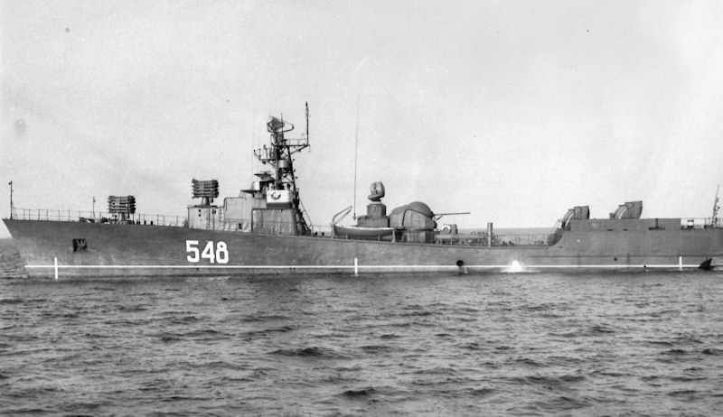

[**Pauk Class**](http://russianships.info/eng/warships/project_12412.htm)These two ships, based on the Tarantul class hull were transferred from the Soviet Black Sea Fleet in 1989 and 1992. They are more modern with improved weapons and sensors but do the same job as the Poti class.

|  |  |  |  |  |
| --- | --- | --- | --- | --- |
| Class | Pennant | Name | Status | Remarks |
|  | PLK-13 | Reshitelni | Active | Varna |
|  | PLK-14 | Bodri | Active | Varna |

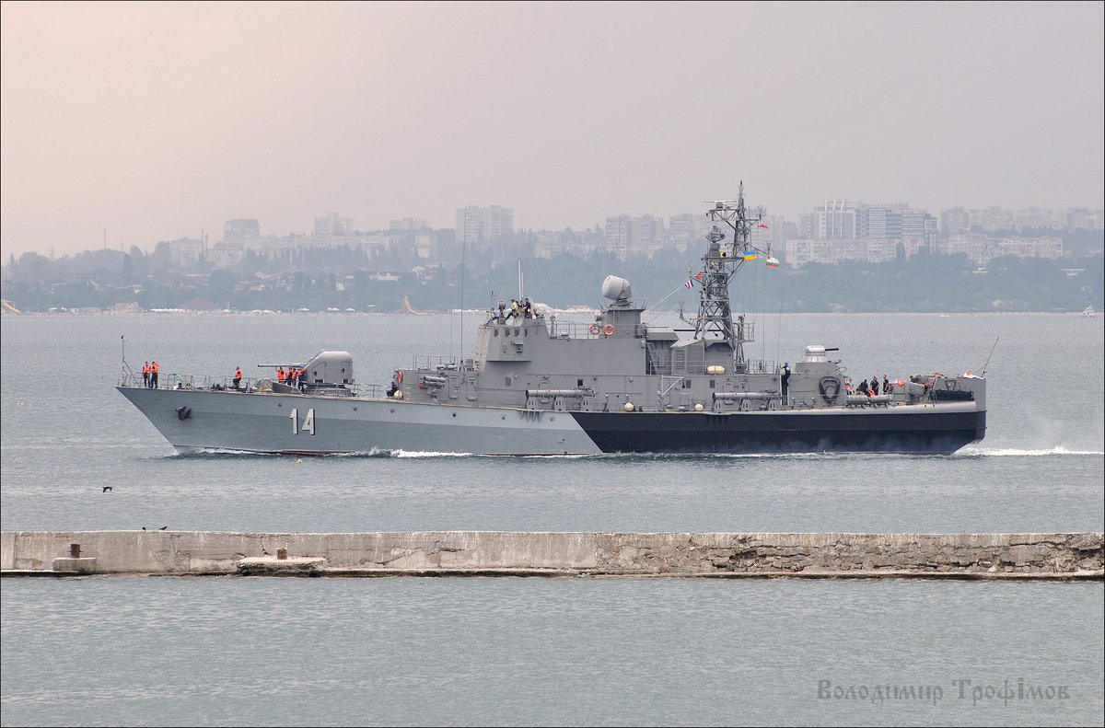

**Torpedo Boats**

[**Shershen Class**](http://russianships.info/eng/warfareboats/project_206.htm)By 1994 these six boats wereobsolete and historically were in various levels of readiness. In Northern Fury they are all in reserve status and will require a week or so to put to sea.

|  |  |  |  |  |
| --- | --- | --- | --- | --- |
| Class | Pennant | Name | Status | Remarks |
| Shershen | TKA-24 | Orel | Reserve |  |
|  | TKA-25 | Yastreb | Reserve |  |
|  | TKA-26 | Albatros | Reserve |  |
|  | TKA-27 | Yaguar | Reserve |  |
|  | TKA-28 | Bars | Reserve |  |
|  | TKA-29 | Pantera | Reserve |  |

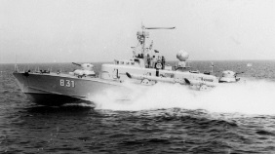

**Amphibious Ships**

[**Polnocny Class**](http://russianships.info/eng/warships/project_770.htm)The two ships of this class form the mainstay of the ‘Landing Ship’ Division. Each is able to lift a reinforced company sized unit of 10-12 armored vehicles or four tanks. All landing ships are based at Atia.

|  |  |  |  |  |
| --- | --- | --- | --- | --- |
| Class | Pennant | Name | Status | Remarks |
|  | L-701 | Sirius | Active |  |
|  | L-702 | Antares | Active |  |

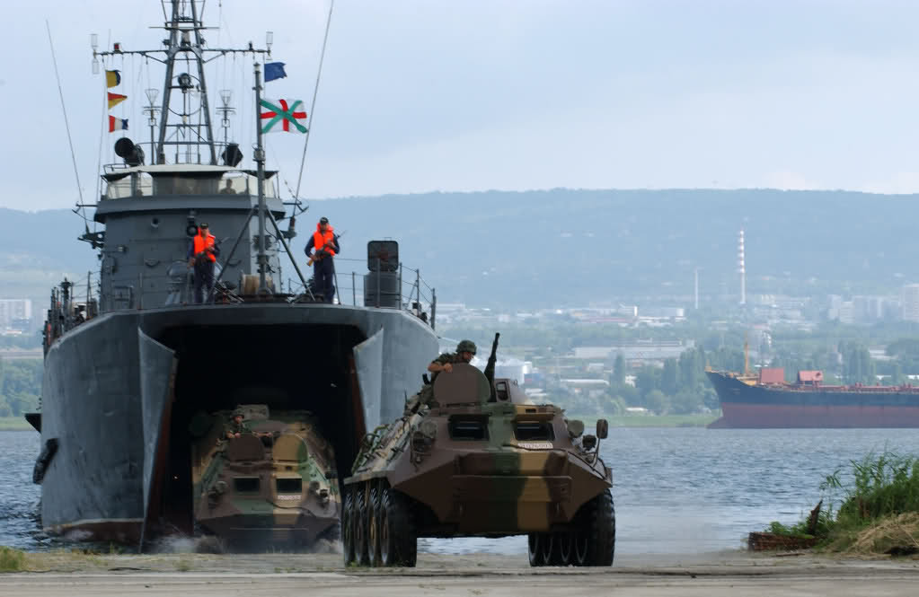

[**Vydra Class**](http://weaponsystems.net/weaponsystem/GG08+-+Vydra+class.html)These are small, rugged landing craft able to lift three tanks or four other armored vehicles and about 100 troops. Of the 24 originally in service, 4 have been converted to minelayers and one to a general stores ship. The 19 remaining operate with the two Polocny class to form the Landing Ship Division.

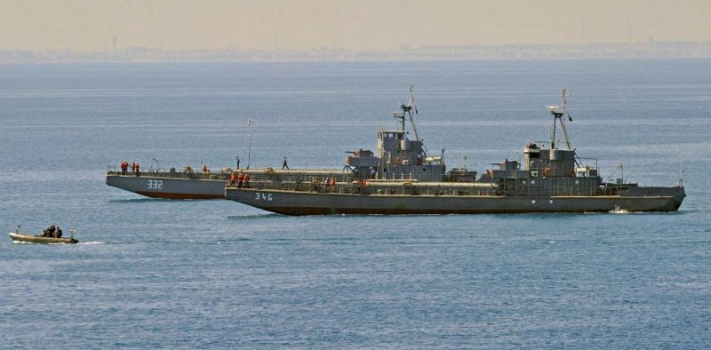

**Minesweepers**: Some 24 -30 minesweeping craft are in operation, based in both ports in roughly equal numbers.

* 6x [Vanya](https://en.wikipedia.org/wiki/Vanya-class_minesweeper) class
* 4x [Yevgenya](https://en.wikipedia.org/wiki/Yevgenya-class_minesweeper) class
* 4x [Sonya](https://en.wikipedia.org/wiki/Sonya-class_minesweeper) class
* 6x [Olya](http://russianships.info/eng/warships/project_1259.htm) class
* 4x converted [Vydra](http://russianships.info/eng/warships/project_106k.htm) Class
* Several others of various heritage, vintage and readiness

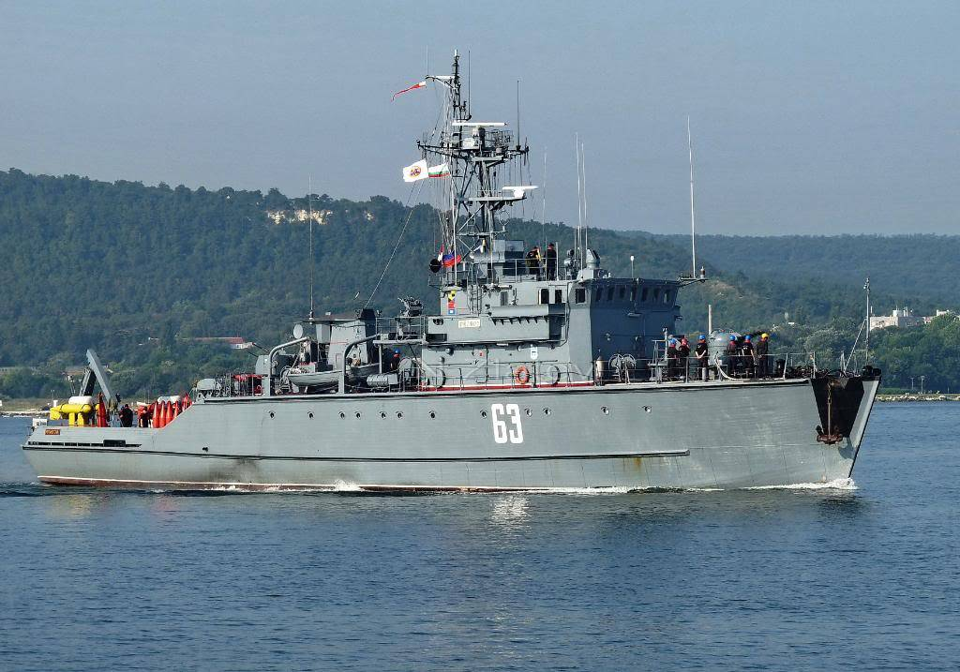

**Submarines**

[**Pobeda (Romeo) Class**](https://en.wikipedia.org/wiki/Romeo-class_submarine)These four boats are well past their prime, two have been decommissioned and will probably never sail again, the other two are limited in both dive depth and range from port.

|  |  |  |  |  |
| --- | --- | --- | --- | --- |
| Class | Pennant | Name | Status | Remarks |
| Romeo | S 81 | Pobeda | Decommissioned |  |
|  | S 82 | Viktoriya | Decommissioned |  |
|  | S 83 | Nadezhda |  |  |
|  | S 84 | Slava |  |  |

