**Serbian Air Forces**

The Serbian Air Force operates about 200 combat aircraft, 110 helicopters, 20 transport and about 70 training aircraft as well as dozens of air defence missile systems. In addition to being quite dated by 1994, the Serbian Air Force was operating under very strenuous conditions. The Yugoslav civil war had caused several units to displace from their long standing basis, and lose of pilots and staff due to national selection meant a drastic loss in experience. The imposition of NATO’s Operation Deny flight meant that air support of Serbian backed forces in Bosnia Herzegovina was severely curtailed, until this point however many pilots in the Serbian Air Force gained some limited combat experience.

**MiG-21**

The mainstay of the Serbian Air force is the MiG-21, well over half of the combat force is made up from a mix of older **MiG-21PFM** ‘Fishbed F’ and the much newer and more capable **MiG-21bis** ‘Fishbed-L’. In addition the hundred or so combat variants, Serbia maintained 24 training and 12 reconnaissance versions.

|  |  |  |  |  |
| --- | --- | --- | --- | --- |
| 129th Ftr Sqn | Batajmica | Mig-21bis | 12 |  |
|  |  | Mig-21MR | 12 |  |
| 252nd Trg Sqn | Batajmica | MiG-21UM | 24 |  |
| 83rd Ftr Bde | Pristina | MiG-21bis | 36 |  |
| 177th Ftr Regt | Batajmica | Mig-21bis | 36 |  |
| 204th Ftr Regt | Batajmica | MiG-21PFM | 36 | Many in reserve |

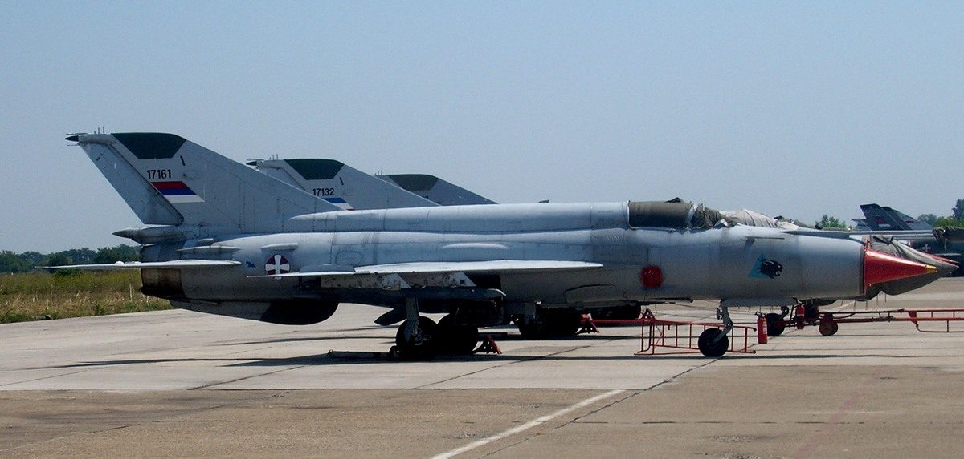

**J-22 Orao**

A local design in conjunction with Romania, the J-22 is light attack and reconnaissance aircraft primarily assigned to ground support tasks. A Squadron of 8 J-22s was left in Bosnia as part of the Republic of Serbska air force while the remainder were withdrawn to Serbia

|  |  |  |  |  |
| --- | --- | --- | --- | --- |
| 82nd Regt | Sjenica AB | J-22B | 22 |  |
| 98th Regt | Uzice Ponikve AB | J-22B | 12 |  |

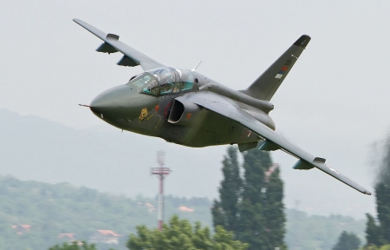

**MiG-29**

The **MiG-29A** arrived in Yugoslav service in the late ‘80s when they became the first European export customer for the type. A true multi-roll 4th generation aircraft able to match NATO air superiority fighters on a near one to one bases, the Fulcrum was very advanced, highly maneuverable, and quite rugged. These aircraft saw some limited combat prior to the 1993 imposition of the No-fly zone over Bosnia. They are used primarily in the Air Defence role.

|  |  |  |  |  |
| --- | --- | --- | --- | --- |
| 204th Ftr Regt | Batajmica AB | MiG-29B | 14 |  |
|  |  | MiG-29UB | 2 | Combat capable |

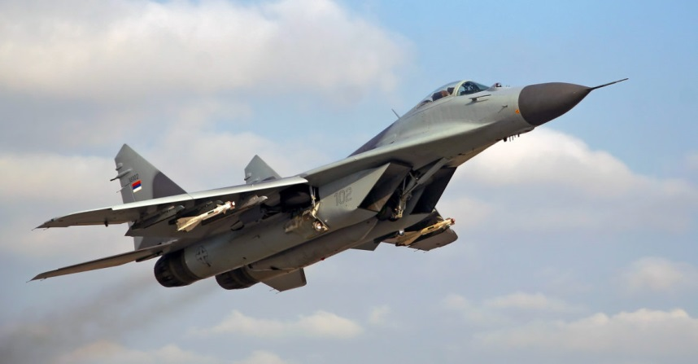

**G-4 Super Galeb**

Designed in Yugoslavia as a combat jet training aircraft, 79 were built for the Yugoslav Air Force between 1984 and 1991 while a further 6 were exported. During the civil wars these rugged and versatile aircraft were pressed into service in the ground attack role, 3 were shot down and several were destroyed on the ground. The Republic of Serbska holds 1 of these while the remainder withdrew to Serbia which currently operates 40 in two squdrons.

|  |  |  |  |  |
| --- | --- | --- | --- | --- |
| 252nd Sqn | Kraljevo AB | G-4M | 20 |  |
| 253rd Sqn | Sombor AB | G-4M | 20 |  |

