**Serbia** 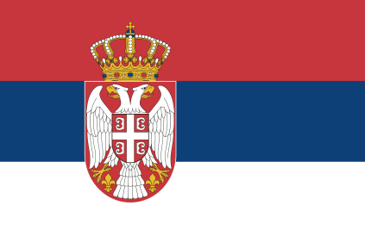

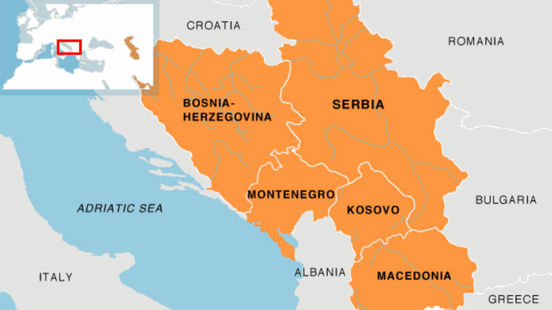

**Serbia** is the newest member of the Warsaw Pact and has gravitated into the Soviet sphere as the dissolution of the former Republic of Yugoslavia (FRY) partitioned the population and geography into an East-West divide. With Italy and Austria backing Slovenia, and the US and Germany funding and supporting Croatia, Serbia became isolated and reached out to the Soviet Union and its neighbors in Bulgaria, Romania and Hungary for assistance. They complied.

Timing is important. In Feb 1994, Montenegro, Kosovo and Macedonia are still firmly in Serbian hands. Bosnia is in the midst of a civil war and Serbia is firmly in the pro re-unification camp; supporting Bosnian Serbs against the Bosniaks, Croats and indirectly against western elements trying to resolve the issue. Western influence in the three Serbian provinces - Montenegro, Kosovo and Macedonia, is being actively countered with both funds and force.

The Serbian alignment with the Warsaw Pact has significantly tied western and NATO hands in this region. ***OPERATION DENY FLIGHT*** is starting to pick up steam and there is an agreement to provide air support to UNPROFOR (UN Protection Force) but the first air support mission historically did not happen until 10 April, 94. Also ***OPERATION MARITIME GUARD*** was integrated into EU activities forming ***OPERATION SHARP GUARD*** in June 1993. The maritime task is largely one of contraband interdiction, primarily smuggling by criminal elements into and out of Italy. Serbia’s new Warsaw Pact allies are making sure that Serbia is well equipped, and through them the Bosnian Serbs and other supporting factions. So the net effect of NATO operations is to support Serbia by denying its opponents the funds and weapons it needs to continue the Bosnian war.

At the outbreak of war a very interesting and delicate – from a NATO perspective – situation will exist in the Bulkans, remembering that Austria is ‘non-aligned’ and ostensibly neutral. Serbia and Croatia are also non-aligned and unlikely to commit to war quickly as they have no meaningful combat force. Bosnia is protected by a No-Fly zone, policed by ***OPERATION DENY FLIGHT.*** Forces committed to UNPROFOR, and the two NATO operations cannot engage in combat activities without violating a UN Security Council resolution, nor can they use bases or airspace in neutral countries to operate from without violating international law. This will all get sorted out but it will take hours, if not a couple days before western governments even get around to acting in this undeniably secondary front. If Serbia were to declare itself neutral, even for a few days, it would complicate the situation even further.