**Czechoslovakian Air Force**

The Czechoslovakian Air Force operates almost 800 aircraft including 140 helicopters, about 150 training aircraft, 30 transports and almost 500 combat aircraft. Over half of the combat aircraft however are MiG-21 which would have difficulty against NATOs front line fighter force. As compensation for the large number of troops remaining in Czechoslovakian territory the Soviets have augmented their brethren somewhat; in particular they have given the Czechs a squadron (12) of Su-27 multi role fighters, added another four (4) MiG-29s to the recent acquisition, exchanged a squadron of older MiG-23s for new MiG-23MLDs (12) and acquired some additional Su-22s and Su-25s. These additions go some of the way to upgrading the Czechoslovakian air defence forces, as does another addition on an S-300 battalion to replace one of the older S-75M units.

**Su-27**

Czechoslovakia is the first country outside the USSR to receive this very advanced 4th generation multi-role aircraft. In Northern Fury these aircraft were not sent to China in 1992, and instead the ‘SK’ or export variants were delivered to Czechoslovakia, negotiations with China are still ongoing but it is unlikely they will be concluded for some time. The transfer took place in early 1993 with flight training in the USSR, there are several Soviet pilots on staff with the Squadron to assist with advanced training and tactics but there are no two seat training aircraft available and pilots need to go to the Soviet Union for qualification and re-certification if needed. Although capable of air to ground missions, these aircraft are used primarily in the air defence role as part of the 11th Fighter Regiment along with the MiG-29s.

|  |  |  |  |  |  |
| --- | --- | --- | --- | --- | --- |
| 1st Sqn 11th Ftr Regt | 3rd AD Div | Žatec AB | SU-27SK | 12 | Limited air to ground munitions |

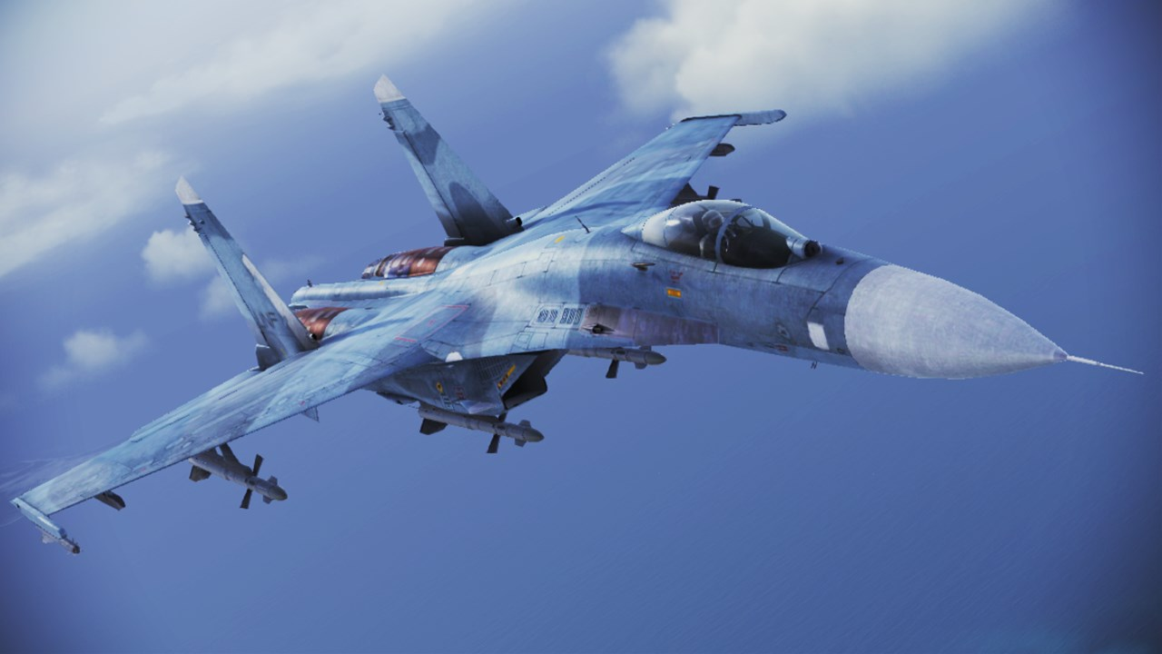

**MiG-29**

Originally 20 of these high performance multi-role aircraft were delivered by 1991; this number included two MiG-29UB 2-seat trainers. Since this time four more aircraft were delivered and they were consolidated into two squadrons of the 11th Fighter Regiment. Together with the Su-27s these aircraft represent a massive improvement in capability from the 1980’s and provide a real threat to NATO aircraft.

|  |  |  |  |  |  |
| --- | --- | --- | --- | --- | --- |
| 2nd Sqn 11th Ftr Regt | 3rd AD Div | Žatec AB | MiG-29A | 12 |  |
| 3rd Sqn 11th Ftr Regt | 3rd AD Div | Žatec AB | MiG-29A | 10 |  |
|  |  |  | MiG-29UB | 2 |  |

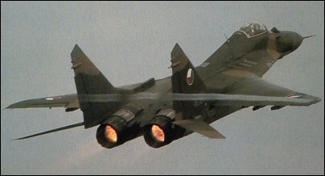

**MiG-23**

The Czechoslovakian air force has a mix of air superiority and ground support variants and has concentrated these aircraft into two units. Two Northern Fury events have augmented the Czech holding of this type. Originally there were 32 modern ‘BN’ (NATO name Flogger H) variants used for ground support and that remains extant; however, in the 1st Fighter Regiment there were 36 older ‘MF’ (Flogger B) air superiority fighters and about a dozen modern ‘ML’ (Flogger G) types. With the unification of Germany there were surplus MiGs-23s available which were more recent than those in use so a deal was cut where enough Flogger G’s were provided to outfit two squadrons while the other two squadrons stayed with the Flogger B’s. Finally in 1993, as part of the deal with the Soviet Union both of the Flogger B squadrons were to be updated to the very latest ‘MLD’ (Flogger K) in exchange for the older airframes, only one squadron has completed the exchange by the time Northern Fury starts.

|  |  |  |  |  |  |
| --- | --- | --- | --- | --- | --- |
| 1st Sqn 1st Ftr Regt | 3rd AD Div | České Budějovice | MiG-23MLD | 12 | Flogger K |
| 2nd Sqn 1st Ftr Regt | 3rd AD Div | České Budějovice | MiG-23MF | 12 | Flogger B |
| 3rd Sqn 1st Ftr Regt | 3rd AD Div | České Budějovice | MiG-23ML | 12 | Flogger G |
| 4th Sqn 1st Ftr Regt | 3rd AD Div | České Budějovice | MiG-23ML | 12 | Flogger G |
| 1st Sqn 28th Ftr/Bmbr Regt | 34th FB Div | Čáslav | MiG-23BN | 16 | Flogger H |
| 2nd Sqn 28th Ftr/Bmbr Regt | 34th FB Div | Čáslav | MiG-23BN | 16 | Flogger H |

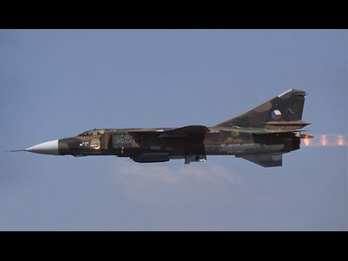

**MiG-21**

Over 260 MiG-21s remain in service in the Czechoslovakian air force, from the antique MiG-21F-13s (Fishbed C) still used in training through the second (Fishbed D & F) and third generation (Fishbed J) of these ubiquitous aircraft. The Czechoslovak uprising in 68 probably had something to do with none of the later types being in use, but those that are in service are used for all roles, training, reconnaissance, air superiority and ground attack, although these latter two roles would be quite risky against modern NATO fighters.

|  |  |  |  |  |  |
| --- | --- | --- | --- | --- | --- |
| 1st Sqn 4th Ftr Regt | 1st Ftr Div | Pardubice | MiG-21MF | 16 | Fishbed J |
| 2nd Sqn 4th  Ftr Regt | 1st Ftr Div | Pardubice | MiG-21MF | 16 | Fishbed J |
| 3rd Sqn 4th  Ftr Regt | 1st Ftr Div | Pardubice | MiG-21MF | 16 | Fishbed J |
| 1st Sqn 5th Ftr Regt | 1st Ftr Div | Dobřany | MiG-21MF | 16 | Fishbed J |
| 2nd Sqn 5th  Ftr Regt | 1st Ftr Div | Dobřany | MiG-21MF | 16 | Fishbed J |
| 3rd Sqn 5th Ftr Regt | 1st Ftr Div | Dobřany | MiG-21MA | 16 | Fishbed J |
| 1st Sqn 6th Ftr/Bmbr Regt | 34th FB Div | Přerov | MiG-21MF | 16 | Fishbed J |
| 1st Sqn 8th Ftr Regt | 2nd AD Div | Brno–Tuřany | MiG-21PF | 16 | Fishbed D |
| 2nd Sqn 8th Ftr Regt | 2nd AD Div | Brno–Tuřany | MiG-21PFM | 16 | Fishbed F |
| 3rd Sqn 8th Ftr Regt | 2nd AD Div | Brno–Tuřany | MiG-21PFM | 16 | Fishbed F |
| 1st Sqn 9th Ftr Regt | 1st Ftr Div | Bechyně | MiG-21PF | 16 | Fishbed D |
| 2nd Sqn 9th Ftr Regt | 1st Ftr Div | Bechyně | MiG-21PFM | 16 | Fishbed F |
| 3rd Sqn 9th Ftr Regt | 1st Ftr Div | Bechyně | MiG-21PFM | 16 | Fishbed F |
| 4rd Sqn 9th Ftr Regt | 1st Ftr Div | Bechyně | MiG-21PFM | 16 | Fishbed F |
| 1st Sqn 47th Air Recce Regt | 10th Air Army | Hradec Králové | Mig-21R | 24 | Fishbed H |
| 1st Trg Regt (4 Sqns) | Air Trg Wing | Přerov | MiG-21F-13 | 80 | Fishbed C |

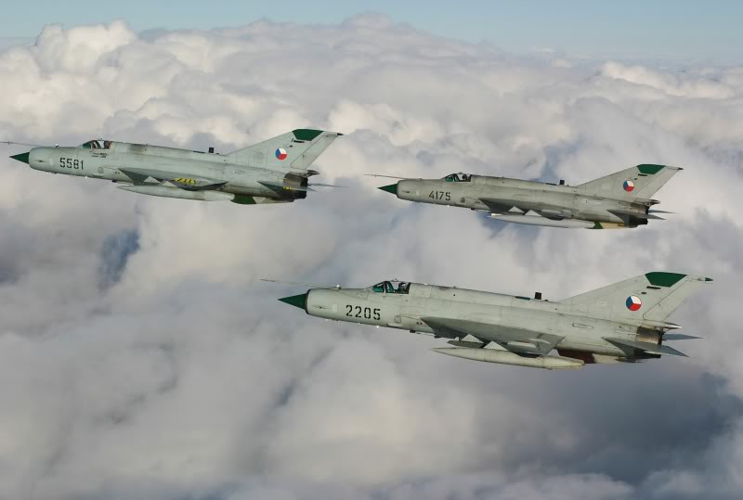

**Su-22**

Historically, Czechoslovakia acquired 49 Su-22M4 and 8 two seat Su-22UM3Ks in 1992, these are the very latest in this family of Fighter Bomber and in Northern Fury this acquisition has been increased to 65 single and 10 double seat versions. Negotiations are ongoing for an additional 32 airframes to replace the remaining MiG-21s in the 6th Fighter/Bomber Regt and round out a third squadron in the 20th Fighter/Bomber Regt. The trickle-down effect of this proposed acquisition is the retirement of the Fishbed D’s in the Force.

|  |  |  |  |  |  |
| --- | --- | --- | --- | --- | --- |
| 2nd Sqn 6th Ftr/Bmbr Regt | 34th FB Div | Přerov | Su-22M-4 | 14 | Fitter K |
|  |  |  | Su-22UM3K | 2 | Fitter G |
| 3rd Sqn 6th Ftr/Bmbr Regt | 34th FB Div | Přerov | Su-22M-4 | 14 | Fitter K |
|  |  |  | Su-22UM3K | 2 | Fitter G |
| 1st Sqn 20th Ftr/Bmbr Regt | 34th FB Div | Náměšť nad | Su-22M-4 | 14 | Fitter K |
|  |  |  | Su-22UM3K | 2 | Fitter G |
| 2nd Sqn 20th Ftr/Bmbr Regt | 34th FB Div | Náměšť nad | Su-22M-4 | 14 | Fitter K |
|  |  |  | Su-22UM3K | 2 | Fitter G |
| 2nd Sqn 47th Air Recce Regt | 10th Air Army | Hradec Králové | Su-22M-4 | 8 | Fitter K |
|  |  |  | Su-22UM3K | 2 | Fitter G |

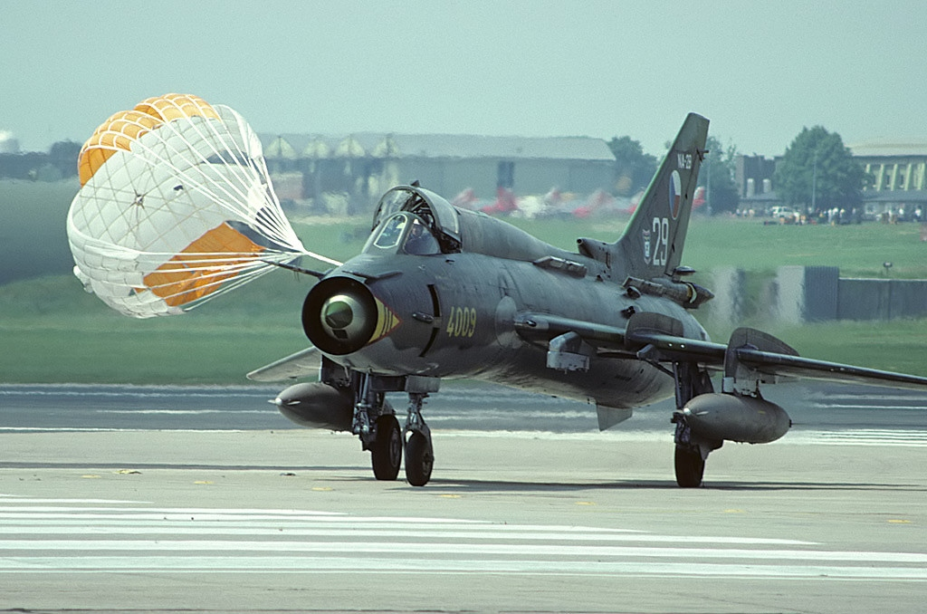

**Su-25**

To fulfill the close support ground attack function in close cooperation with army units, Czechoslovakia, as well as most other WP countries, acquired the Su-25, the Soviet equivalent to the American A-10 Warthog. In the late ‘80s the Soviets produced well over 1000 of these aircraft and 36 Su-25K were sent to the Czechs, plus two dual control trainers (Su-25UBK). In Northern fury Soviet production of the Su-25T was increased and some of the older Su-25Ks were distributed to WP countries, in this case an additional 12 were provided, adding a third squadron to the ORBAT.

|  |  |  |  |  |  |
| --- | --- | --- | --- | --- | --- |
| 1st Sqn 30th Grnd Atk Regt | 34th FB Div | Pardubice | Su-25K | 16 | Frogfoot |
| 2nd Sqn 30th Grnd Atk Regt | 34th FB Div | Pardubice | Su-25K | 16 | Frogfoot |
| 3rd Sqn 30th Grnd Atk Regt | 34th FB Div | Pardubice | Su-25K | 16 | Frogfoot |
| 30th Grnd Atk Regt | 34th FB Div | Pardubice | Su-25UBK | 2 | Frogfoot |

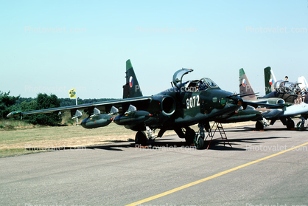

[**L-29 Delfin /L-39 Albatros**](http://www.airvectors.net/avl39.html)

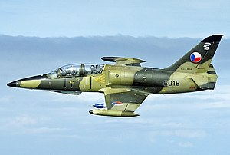These Czechoslovakian designed and produced aircraft became the standard training aircraft throughout the Warsaw Pact and beyond, with many going to African and Asian WP aligned countries. The L-39ZA was an improved design able to conduct advanced training, light conduct ground attack and reconnaissance. The next evolution of this aircraft was the L-39MS (the ‘M’ variant was not produced) which was produced starting in 1989, real life intervened causing production to cease early but in Northern Fury this doesn’t happen and 24 were produced for the Czechoslovak Air Force by the start of 1994 in addition to sales to Egypt, Tunisia and other WP countries.

|  |  |  |  |  |  |
| --- | --- | --- | --- | --- | --- |
| 2nd Trg Regt (2 Sqns) | Air Trg Wing | Košice | L-29 Delfin | 80 |  |
| 2nd Trg Regt (1 Sqns) | Air Trg Wing | Košice | L-39C | 39 |  |
| 2nd Trg Regt (1 Sqns) | Air Trg Wing | Košice | L-39ZA | 30 |  |
| 3rd Sqn 47th Air Recce Regt | 10th Air Army | Hradec Králové | L-39MS | 24 |  |

**Air Transport**

A wide range of transport aircraft is flown by the 1st Mixed Air Transport Regiment in Ostrava. This unit provides all general transport requirements for the air force and also the army.

|  |  |  |  |  |
| --- | --- | --- | --- | --- |
| Sqn | Type | NATO Name | Num |  |
| 1st Sqn | An-12 | Cub | 2 | Tactical Transport, Para drop capable, 60 troops |
| 1st Sqn | An-24 | Coke | 8 | Tactical Transport, Para drop capable, 44 troops |
| 1st Sqn | An-26 | Curl | 8 | Tactical Transport, Para drop capable, 40 troops |
| 2nd Sqn | An-30 | Clank | 2 | Development of An-24 for mapping and recon |
| 2nd Sqn | Yak-40 | Codling | 3 | Passenger Transport, 32 passengers |
| 2nd Sqn | Tu-134 | Crusty | 2 | Passenger Transport, 72 passengers |
| 2nd Sqn | Tu-154M | Careless | 4 | Passenger Transport, 180 passengers |
| 3rd Sqn | Mi-17 | Hip | 20 | General Transport Helicopter |

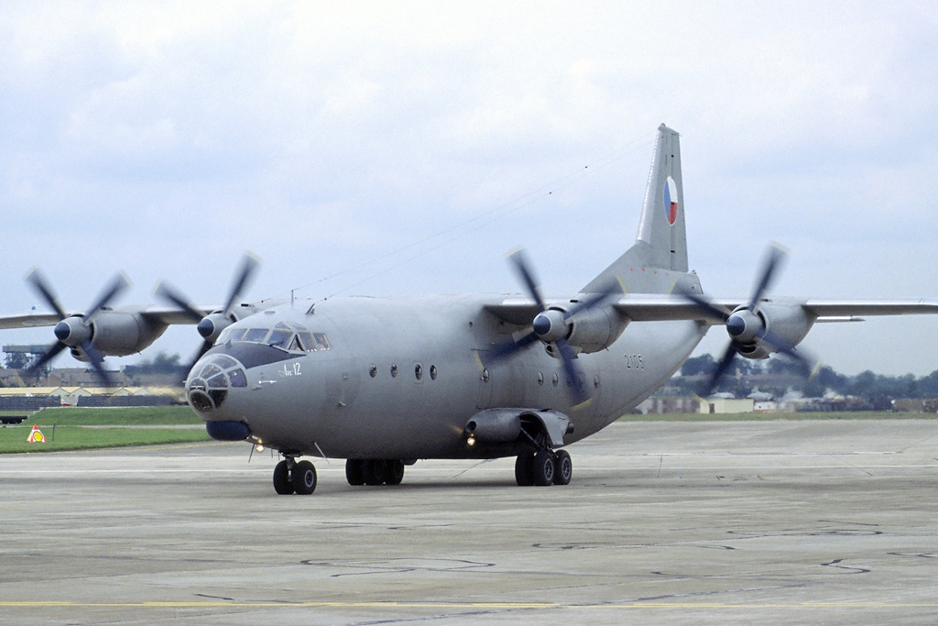

**Army Aviation**

With a mix of attack and transport helicopters controlled by the air force, these aircraft form two Helicopter Regiments provide immediate ready forces to 1st Army with the 11th Helicopter Regiment while 51st Regiment provides mobilization forces to the other two Armies as required.

|  |  |  |  |  |  |
| --- | --- | --- | --- | --- | --- |
| 1st Sqn 11th Heli Regt | 10th Air Army | Plzeň | Mi-24D | 24 | Hind D |
| 2nd Sqn 11th Heli Regt | 10th Air Army | Plzeň | Mi-24V | 20 | Hind E |
| 3rd Sqn 11th Heli Regt | 10th Air Army | Plzeň | Mi-17 | 20 | Hip-H |
| 1st Sqn 51th Heli Regt | 10th Air Army | Prostějov | Mi-8TBK | 20 | Hip-K Atk |
| 2nd Sqn 51th Heli Regt | 10th Air Army | Prostějov | Mi-24D | 24 | Hind D |
| 3rd Sqn 51th Heli Regt | 10th Air Army | Prostějov | Mi-17 | 20 | Hip-H |
| 3rd Trg Regt (2 Sqns) | Air Trg Wing | Piešťany | Mi-2 | 60 | Hopelight |

