**[Czechoslovak People’s Army](https://ipfs.io/ipfs/QmXoypizjW3WknFiJnKLwHCnL72vedxjQkDDP1mXWo6uco/wiki/Czechoslovak_People%27s_Army.html) (CVA)**

Historically the Czechoslovak Army divided in 1993 along with the rest of the country into two; the Czech and the Slovak armies, the ‘People’s’ was also dropped from the name in 1990. In Northern Fury, these changes do not occur and the army remains roughly as it was in 1989, although with slightly lower moral due to the virtual state of occupation existing in our storyline, but this is countered by some better equipment flowing from the former East Germany and additional training opportunities working with Soviet formations.

The CVA was one of the most ready armies in the Eastern Block. Like all WP armies it was organized along Soviet lines and integrated into Soviet military plans. The bulk of the army, those in the Western Military District were all fully manned and equipped. Structurally Western Military District will form a FRONT level HQ and either operate as an independent HQ reporting to the Soviet Central Group of Forces (CGF) an equal level Front HQ, or more likely remain as a national mobilization HQ. Certainly, 1st Army will be attached to CGF immediately and is ready to conduct offensive operations, 4th Army will follow within a week as it is at a very high state of readiness for Category B formations. Eastern Military District would mobilize in 2-4 weeks (very quick for Category C elements) and form an Army reinforced by a Soviet Division (30th Gds MRD), the two Tank Divisions (13th and 14th) are at a relatively high state of readiness so may be committed as reinforcements to 1st Army earlier than that.

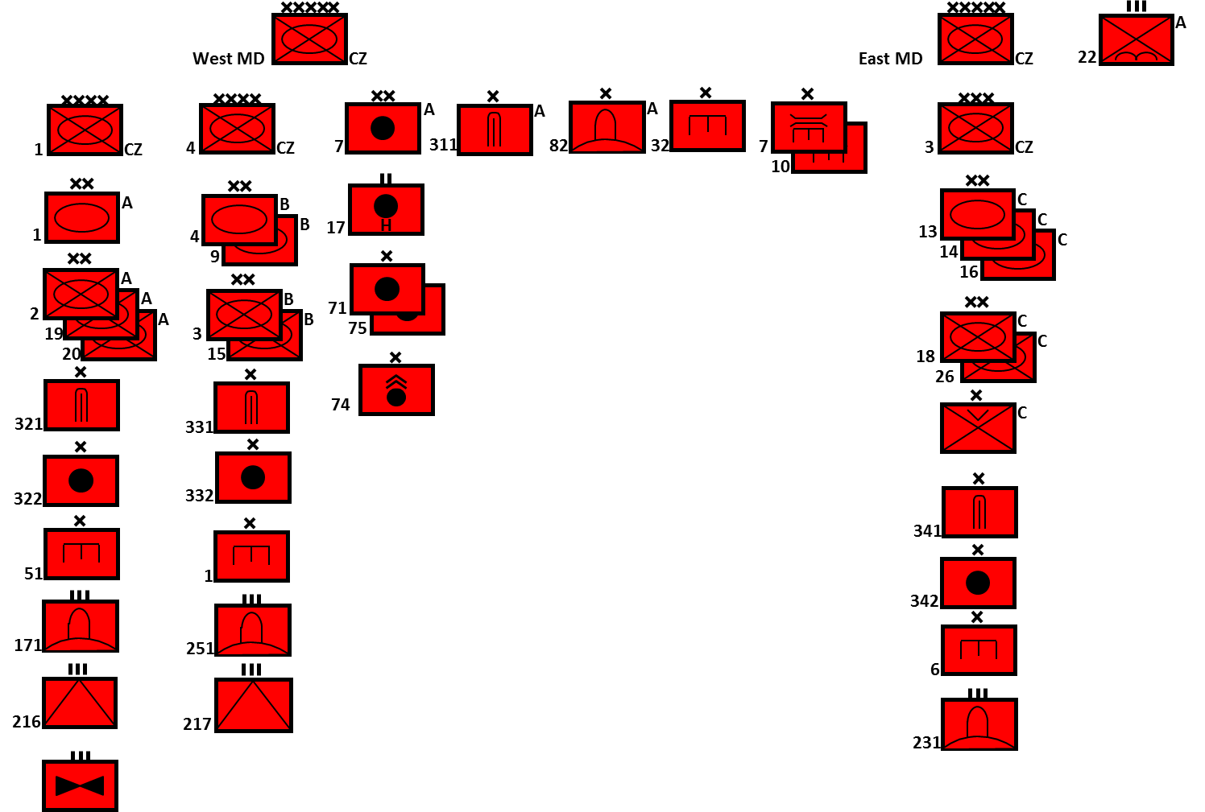

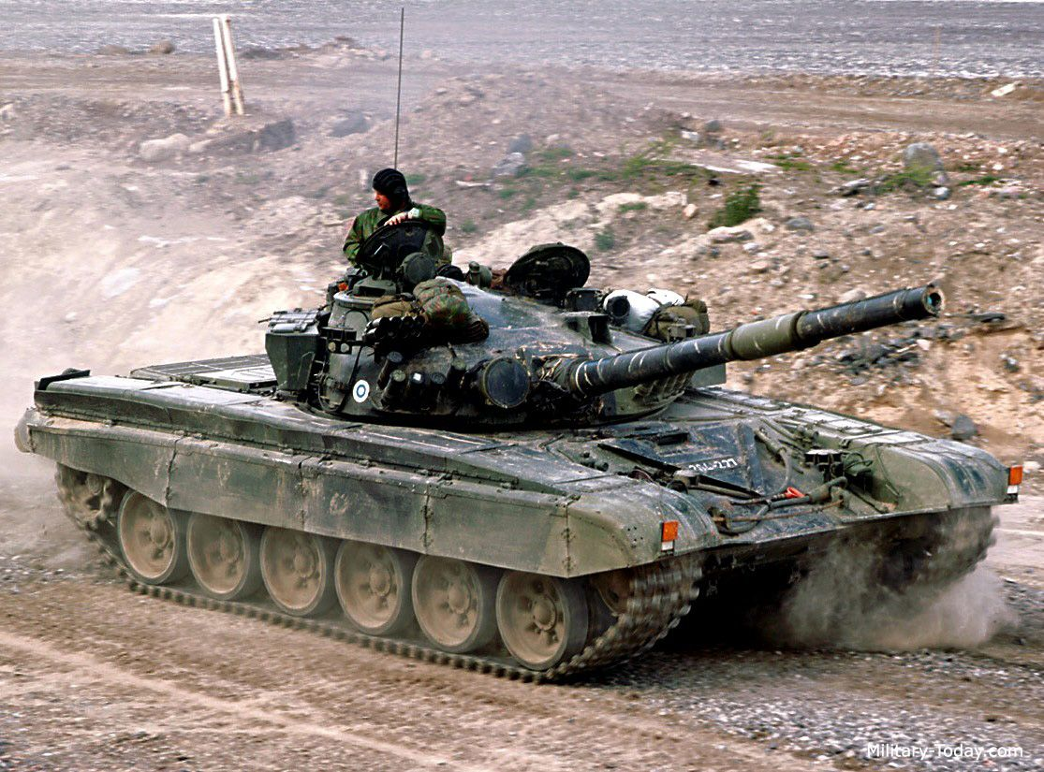

Home grown Czech equipment was usually superior in design and workmanship to Soviet built and the ‘OT’ family of armored Personnel carriers (APC) was widely exported.

|  |  |  |  |  |
| --- | --- | --- | --- | --- |
| **Role** | **Type** | **Variant** | **No** | **Remarks** |
| MBT | T-72 | T-72 | 70 | [T-72 Data](https://www.forecastinternational.com/archive/disp_pdf.cfm?DACH_RECNO=965) |
|  |  | T-72M | 200 |  |
|  |  | T-72M1 | 543 | Local modification, improved fire control and ERA |
|  | T-54/55 | T-54 | 1908 | Mostly upgraded Czech variants, some in storage |
|  |  | T-55 | 1800 | In Storage |
| IFV | BMP | BVP-1 | 1390 | Czech variant of the BMP |
|  |  | BVP-2 | 280 |  |
| APC |  | BTR-60 | 30 |  |
|  |  | OT-90 | 620 |  |
|  |  | [OT-64](http://www.military-today.com/apc/ot_64_skot.htm) | 1600 | Polish/Czech variant of the BTR-60 |
|  |  | OT-62 | 400 |  |
| Recon | BRDM | BRDM | 250 |  |
|  |  | BVP-1 | 1006 |  |
|  |  | OT-65A | 1000 |  |
|  |  | OT-66 | 200 |  |
| Arty | 100mm | M-53 | 250 |  |
|  | 122mm | [2S1](https://www.armyrecognition.com/russia_russian_army_vehicles_system_artillery_uk/2s1_gvozdika_122mm_self-propelled_howitzer_technical_data_sheet_specifications_pictures_video.html) | 36 |  |
|  |  | M-1938 | 148 |  |
|  |  | D-30 | 36 |  |
|  | 130mm | M46 | 148 |  |
|  | 152mm | DANA(SP) | 424 | Czech design and production |
|  | 203mm | 2S7 | 12 |  |
|  | 240mm | 2S4 | 4 |  |
|  |  | M-51 | 18 |  |
|  | MLR | RM-51 | 360 | Czech designed version of BM-13 |
|  |  | RM-70 | 320 | Czech designed version of BM-21 |
| AT | 85mm | Vz 52 | 120? | Czech designed version of D-44 AT gun |
|  | 100mm | Vz 53 | 600 | Czech designed version of M1944 field/AT gun |
|  | BRDM-2 | AT-5 | 600+ | Mounted on BRDM |
|  |  | AT-3/4 | 200+ | Mounted on BRDM (Cat C and Storage) |
| SSM | SS-1C |  | 24 |  |
|  | OTR-23 |  | 4 |  |
|  | 9K52 Luna-M | Frog-7 | 26 |  |
| AD | AAA | M53/65 | 1000 |  |
|  |  | 9K35 Strela |  |  |
|  | SAM | 9K33 Osa | 180 | SA-8 Gecko, Category A & B +1 Cat C Divs only |
|  |  | 2K12 Kub | 180 | SA-6 Gainful, Category A & B +1 Cat C Divs only |
|  |  | 9K35 Strela | 128 | Category A & B Divs only |
|  |  | MANPADS | Many | SA-18 replacing older versions |
|  |  | 2K11 Krug | 24 | SA-4 |
|  |  | S-75 Dvina | 24 |  |
|  |  | S-125 Neva | 48? |  |
|  |  | S-200 |  | 5 Bns |
|  |  | S-300 |  | 1 Bn |

