**Czechoslovakia** 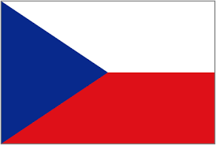

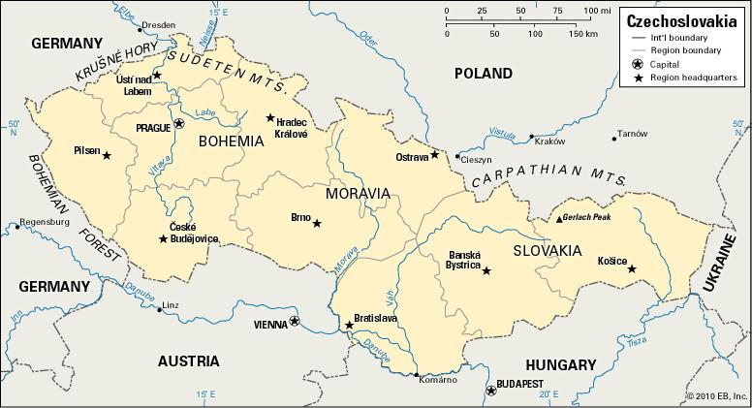

**Czechoslovakia** is one of the five remaining countries forming the Warsaw Pact, a situation that is complicated by over 350,000 Soviet troops currently stationed in a country about the same geographic size as the US state of Mississippi. Most of these troops came from their previous station in the former East Germany but also includes the 85,000 troops of the Soviet Central Group of Forces (CGF) which have been in Czechoslovakia since re-occupying it in 1968. To the Czechoslovak people, who had a small glimmer of freedom in 1989, this is seen as an army of occupation, but the Czechoslovakian Army is kept in line by improved training and equipment while the government is essentially held hostage.

The Czechoslovakian People’s Army (CVA) forms the bulk of the defence forces with only a riverine navy designed to assist the Soviet Logistics efforts, and a moderately sized air force of about 400 combat aircraft.