**Hungarian Air and Air Defence Forces**

The Hungarian Air Force operates about 230 front line combat aircraft, 120 helicopters, 15 transport and 30 training aircraft as well as air defence missile systems. Although mostly dated by 1994, an infusion of new and replacement aircraft from the Soviet Union has increased force readiness somewhat. There are about 200 front line Soviet aircraft based in Hungary including 120 MiG-29 so the primary focus of the Hungarian air force is to support the Army while relying on Soviet air forces based in Hungary to maintain air superiority.

The document at this [link](http://archiv.uni-nke.hu/downloads/aarms/docs/Volume7/Issue4/pdf/17mart.pdf) provides a useful history of MiG aircraft in the Hungarian inventory.

**MiG-21**

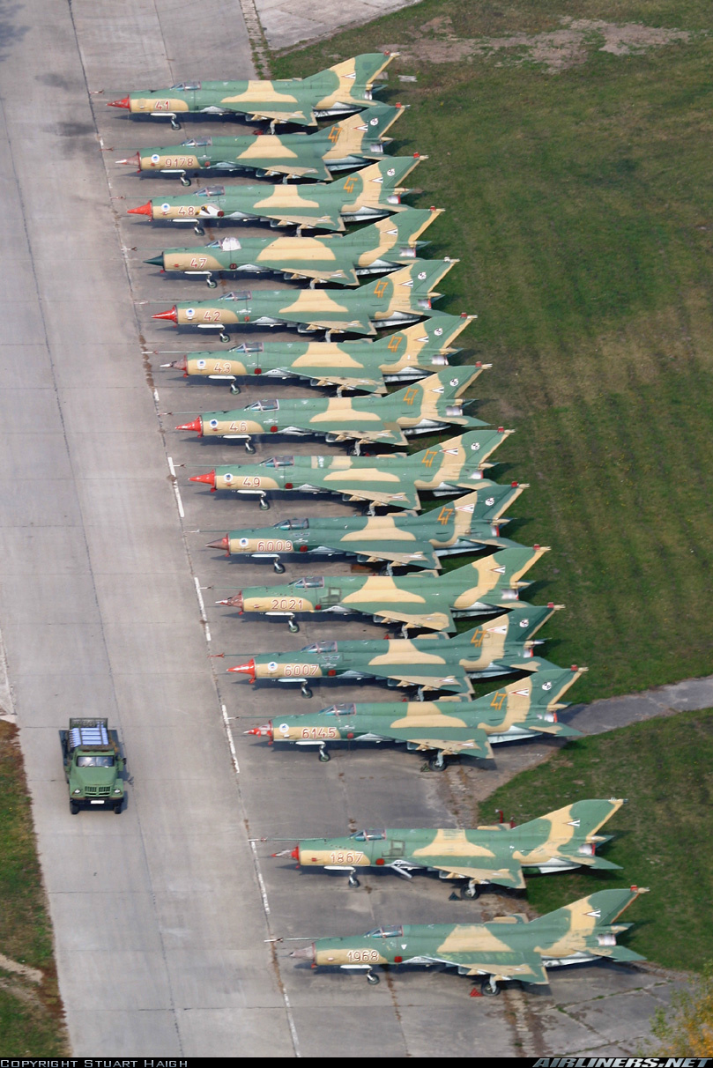

Three generations of the ubiquitous MiG-21 are currently serving in the Hungarian air force. The oldest remaining in service are the **MiG-21PF** ‘Fishbed F’, although 2nd generation these are only slightly improved 1st generation interceptors with a belly mounted gun pod and obsolete missiles. Only one Sqn of them remain and they should be retired shortly.

The next generation MiG-21s in use are the 12x **MiG-21RF** Fishbed-H reconnaissance variant and the 45x **MiG-21MF** Fishbed-J ground attack version, both are also on the books for retirement. It is likely that plans are in place to have the Mig-29s assume the ground attack role while the Su-22 will take over the reconnaissance task; however, this has not yet happened.

Destined to stay in the lineup for some time is the final production, sometimes called 3rd generation, **MiG-21bis** Fishbed-L. With a much more powerful engine, a redesigned airframe and better avionics this aircraft is a lighter, stronger and more agile aircraft with a look down radar and wide selection of munitions.

Additionally, about 40 two seat training variants operate in an air combat training squadron, the **MiG-21UM** Mongol-B has equivalent avionics to the 3rd generation MiG-21bis. All fighter pilots spend time on this type to learn the basics of air combat no matter which airframe they fly.

|  |  |  |  |  |
| --- | --- | --- | --- | --- |
| **Unit** | **Location** | **Type** | **No** | **Remarks** |
| 31st Ftr Regt | Kecskemét AB | MiG-21MF | 45 |  |
| 47th Ftr Regt | Pápa AB | Mig-21bis | 24 |  |
| 57th Ftr Regt | Kecskemét AB | MiG-21PF | 18 | To retire |
| 86th Ftr Regt | Taszár AB | Mig-21bis | 24 |  |
|  |  | MiG-21RF | 12 |  |

**MiG-23**

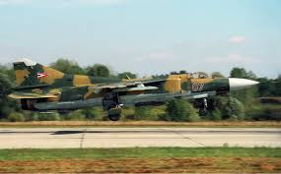

Hungary only operates 12x **MiG-23**MF Flogger-Bs. The variable wing geometry allows for a very flexible airframe and, until the acquisition of the MiG-29, this was the only air to air platform which could hold its own against NATO 3rd generation aircraft. However, it is decisively outclassed by newer 4th generation aircraft so are now limited to the ground attack role with the MiG-21bis of 47th Regt. There are also 2x **MiG-23UB** Flogger-C training aircraft.

|  |  |  |  |  |
| --- | --- | --- | --- | --- |
| **Unit** | **Location** | **Type** | **No** | **Remarks** |
| 47th Ftr Regt | Pápa AB | MiG-21MF | 12 |  |

**MiG-29**

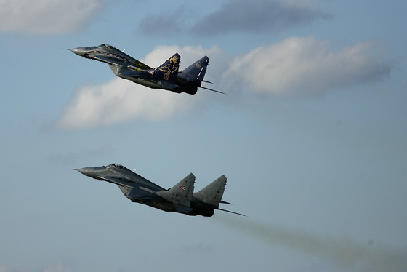

By far the most modern and capable aircraft in the Bulgarian inventory are the **MiG-29A**. A true multi-roll 4th generation aircraft able to match NATO air superiority fighters on an equal footing, the Fulcrum is very advanced, highly maneuverable, and quite rugged. Historically, Hungary received 22 Fulcrum A plus 6 two seat ‘UB’ trainers, while in Northern Fury and additional two have been provided with at least another 18 planned but not yet delivered. The primary task is to introduce modern ground attack capability into the Hungarian air force but they are also able to stand up against American F-16s and Italian Tornados working out of northern Italy.

|  |  |  |  |  |  |
| --- | --- | --- | --- | --- | --- |
| **Unit** | **Location** | **Type** | **No** | **Remarks** | **Unit** |
| 2/17th Ftr Regt | 2nd Air Div | Ravnets AB | MiG-29A | 24 |  |
|  |  |  | MiG-29UB | 6 | Combat capable |

**Su-22**

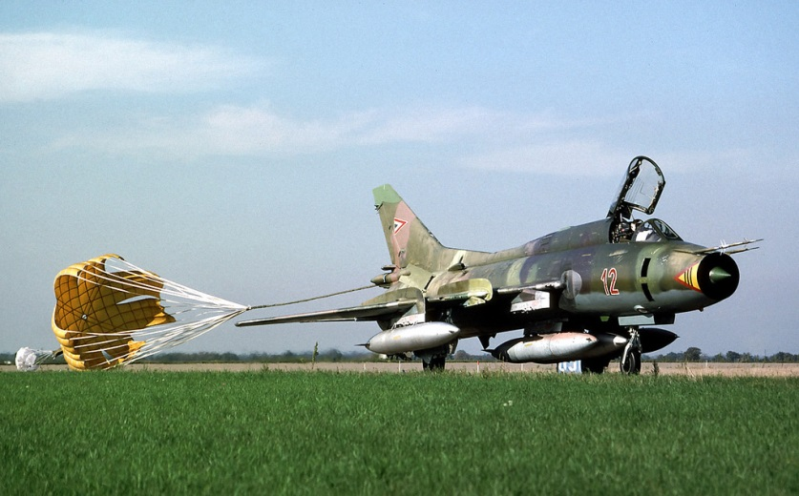

A dedicated ground attack aircraft, the variable geometry **Su-22** Fitter employed in the Hungarian air force is the slightly outdated **Su-22M-3K** which arrived in the early 1980’s. These 15 aircraft are employed in the strike/reconnaissance role, having the ability to conduct high speed low altitude reconnaissance as well as bombing tasks. They are capable of delivering a decent bomb load, are easy to maintain, and able to sustain tremendous abuse and survive.

|  |  |  |  |  |
| --- | --- | --- | --- | --- |
| **Unit** | **Location** | **Type** | **No** | **Remarks** |
| 101st F/B Regt | Taszár AB | Su-22M-3K | 15 |  |

**Su-25**

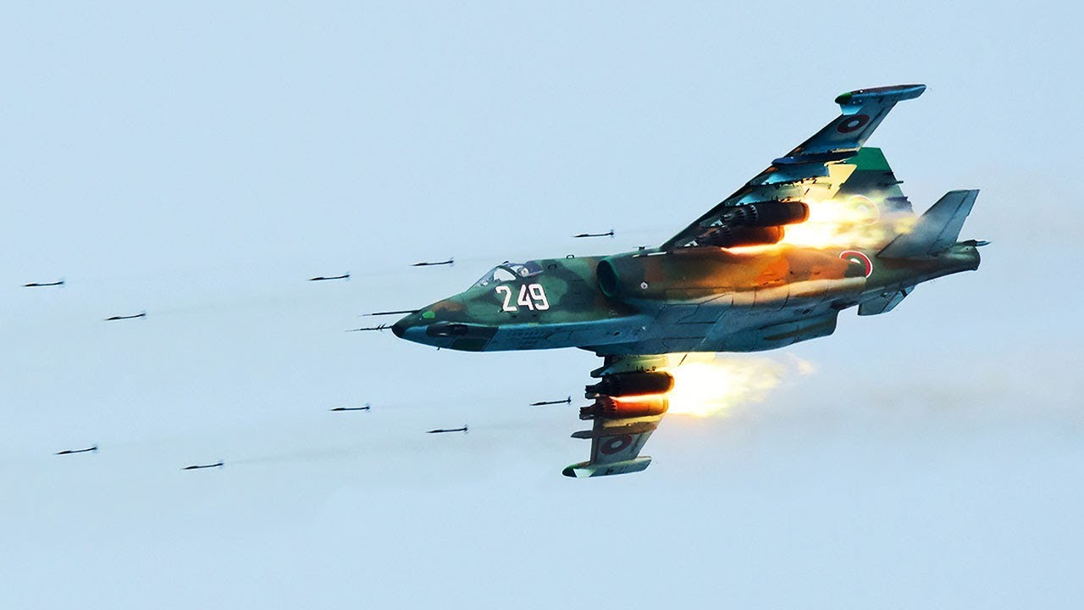

Specializing in close air support is the **Su-25** Frogfoot. This readily identifiable airframe is the Soviet answer to the American A-10 Warthog, and it is a very agile, rugged and capable bomber. Historically Hungary’s order for 40 **Su-25K** plus 4 **Su-25UBK** training variants was canceled in the early ‘90s but in Northern Fury the request was filled and they arrived by 1993.

|  |  |  |  |  |
| --- | --- | --- | --- | --- |
| **Unit** | **Location** | **Type** | **No** | **Remarks** |
| 102nd Aslt Regt | Buda West AB | Su-25K | 40 |  |

Some additional locations for more information can be found at these links:

<http://archiv.uni-nke.hu/downloads/aarms/docs/Volume7/Issue4/pdf/17mart.pdf>

<http://www.easternorbat.com/html/hungarian_air_force_eng.html>