**Hungarian Air and Air Defence Forces**

The Hungarian Air Force operates about 220 front line combat aircraft, about 120 helicopters, 15 transport and about 30 training aircraft as well as air defence missile systems. Although mostly dated by 1994, an infusion of new and replacement aircraft from the Soviet Union had increased force readiness. The primary focus of the air force is to support the Army, relying on Soviet air forces based in Hungary to maintain air superiority. There are about 200 front line Soviet aircraft based in Hungary including 120 MiG-29 and 40 Su-27.

The document at this [link](http://archiv.uni-nke.hu/downloads/aarms/docs/Volume7/Issue4/pdf/17mart.pdf) provides a useful history of MiG aircraft in the Hungarian inventory.

**MiG-21**

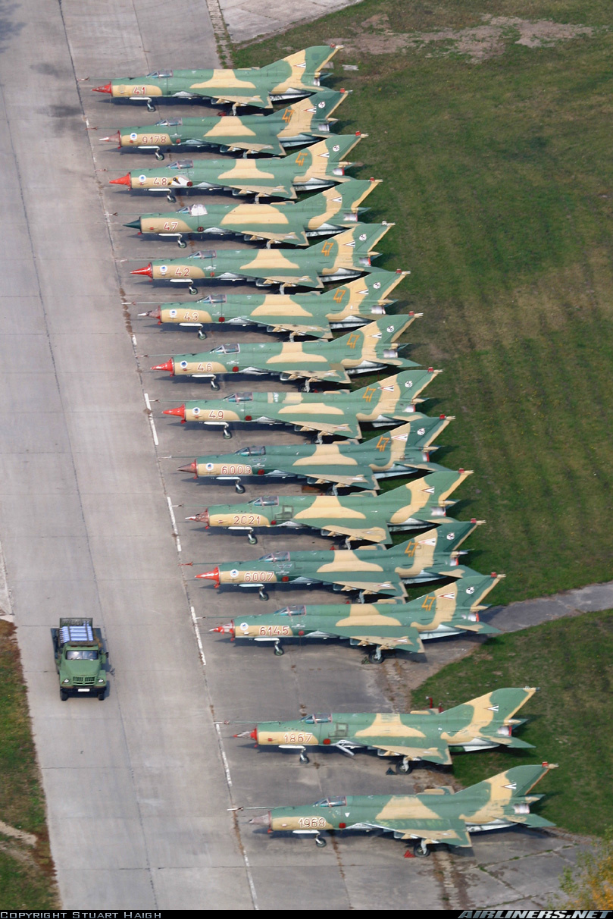Three generations of the ubiquitous MiG-21 are currently present in the Hungarian air force. The oldest remaining in service are the **MiG-21PF** ‘Fishbed F’. These are called 2nd generation but are only slightly improved 1st generation interceptors with a belly mounted gun pod and obsolete missiles. Only one Sqn of these are in service but they should be retired.

The next generation MiG-21s in service, the 12x **MiG-21RF** Fishbed-H, or reconnaissance variant and the 45x **MiG-21MF** Fishbed-J ground attack version are also on the books for retirement. It is likely that plans are in place to have the Mig-29s assume the ground attack role while the Su-22 will take over the reconnaissance role; however this has not yet happened.

Destined to stay in the lineup for some time is the final production, sometimes called 3rd generation, **MiG-21bis** or ‘plus’ Fishbed-L. This aircraft has a much more powerful engine, redesigned airframe and avionics resulting in a lighter, stronger and more agile aircraft with a look down radar and wider selection of munitions.

Additionally about 40 two seat training variants operated in an air combat training squadron, the **MiG-21UM** Mongol-B, with equivalent avionics to the 3rd generation MiG-21bis. All fighter pilots spend time on this type to learn the basics of air combat.

|  |  |  |  |  |
| --- | --- | --- | --- | --- |
| 31st Ftr Regt | Kecskemét AB | MiG-21MF | 45 |  |
| 47th Ftr Regt | Pápa AB | Mig-21bis | 24 |  |
| 57th Ftr Regt | Kecskemét AB | MiG-21PF | 18 | Repl by MiG-29 |
| 86th Ftr Regt | Taszár AB | Mig-21bis | 24 |  |
|  |  | MiG-21RF | 12 |  |

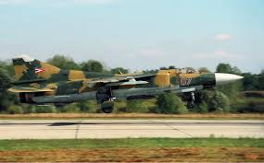**MiG-23**

Hungary only operates 12x **MiG-23**MF Flogger-Bs. The variable wing geometry allowed for a very flexible airframe and until the acquisition of the MiG-29, this was the only capable air to air platform which could hold its own against NATO 3rd generation aircraft. It is decisively outclassed by the newer 4th generation aircraft so they now work in the ground attack role with the MiG-21bis of 47th Regt. There are also 2x **MiG-23UB** Flogger-C training aircraft.

|  |  |  |  |  |
| --- | --- | --- | --- | --- |
| 47th Ftr Regt | Pápa AB | MiG-21MF | 12 |  |

**MiG-29**

By far the most modern and capable aircraft in the Bulgarian inventory is the **MiG-29A**. A true multi-roll 4th generation aircraft able to match NATO air superiority fighters on a near one to one bases, the Fulcrum was very advanced, highly maneuverable, and quite rugged. Historically Hungary received 22 Fulcrum A plus 6 two seat ‘UB’ trainers, while in Northern Fury and additional 2 have been provided with at least another 18 planned but not yet delivered. The primary task is to introduce modern ground attack capability into the Hungarian air force but they are also able to stand up against American F-16s and Italian Tornados working out of northern Italy.

|  |  |  |  |  |  |
| --- | --- | --- | --- | --- | --- |
| 2/17th Ftr Regt | 2nd Air Div | Ravnets AB | MiG-29A | 24 |  |
|  |  |  | MiG-29UB | 6 | Combat capable |

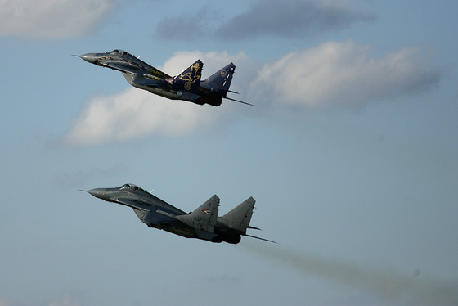

**Su-22**

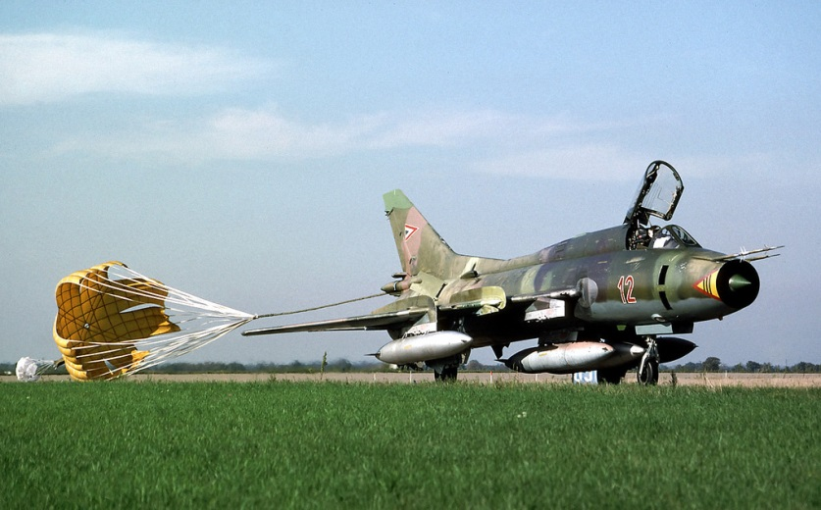A dedicated ground attack aircraft, the variable geometry Su-22 Fitter employed in the Hungarian air force was the slightly outdated **Su-22M-3K**, arriving in the early ‘80s. The 15 aircraft in service were employed in the strike/reconnaissance role, having the ability to conduct high speed low altitude reconnaissance as well as bombing tasks. They were capable of delivering a decent bomb load, easy to maintain, and able to sustain tremendous abuse and survive.

|  |  |  |  |  |
| --- | --- | --- | --- | --- |
| 101st Ftr/Bmbr Regt | Taszár AB | Su-22M-3K | 15 |  |

**Su-25**

Specializing in close air support is the Su-25 Frogfoot. This highly identifiable airframe is the Soviet answer to the American A-10 Warthog, and it is a very agile, rugged and capable bomber. Historically Hungary’s order for 40 **Su-25K** plus 4 **Su-25UBK** training variants was canceled in the early ‘90s but in Northern Fury the request was filled and they arrived by 1993.

|  |  |  |  |  |
| --- | --- | --- | --- | --- |
| 102nd Ftr/Bmbr Regt | Buda West AB | Su-25K | 40 |  |

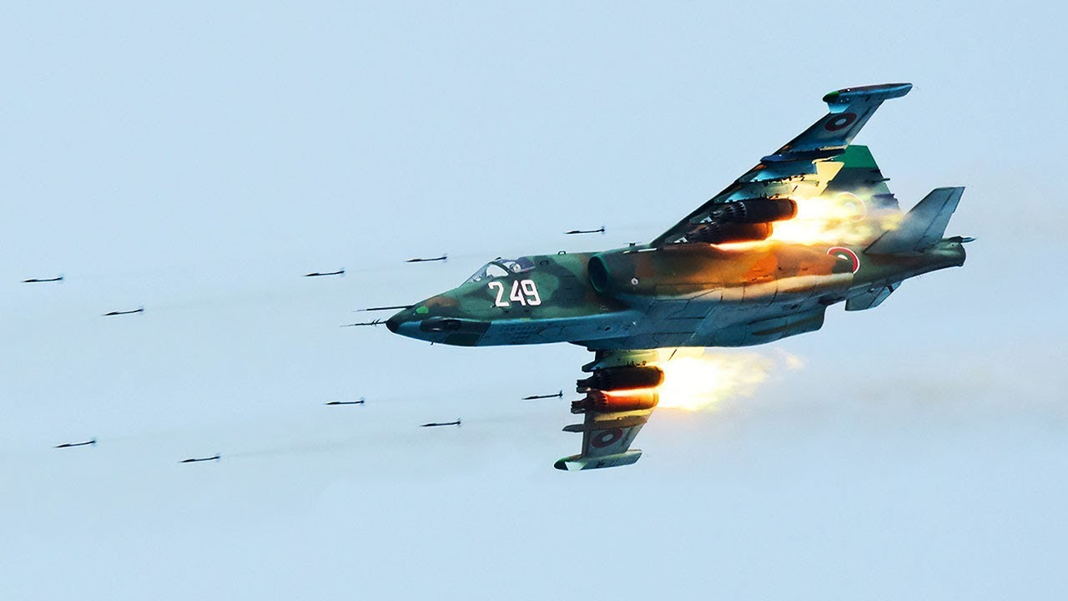

Some additional locations for more information can be found at these links:

<http://archiv.uni-nke.hu/downloads/aarms/docs/Volume7/Issue4/pdf/17mart.pdf>

<http://www.easternorbat.com/html/hungarian_air_force_eng.html>