**Hungarian People’s Army (HPA)**

The HPA remained in its pre-1989 structure and stuck with Soviet style organizations, the planned (and historically carried out) restructuring from a Motor Rifle Division (MRD) based configuration to a Brigade organization was meant to save command overhead and streamline the army, but never completed. The halt to the changes was due primarily to Soviet assurances that several MRDs would be placed under Hungarian command so the old structure, meant for rapid mobilization and expansion was maintained.

Along with the change in plans came a change in orientation for the HPA. Instead of reinforcing a push into southern Germany after transiting Czechoslovakia – the army was now looking to the west and southward towards the new states of the former Yugoslavia. With NATO forces essentially on the border, and with increasing civil unrest in Hungary itself, there was now a clear threat and no buffer state. Therefore 5th Hungarian Combined Arms Army (CAA) was tasked to look at both offensive and defensive operations oriented towards Zagreb or Ljubljana, with a view to forcing NATO forces to a standstill closer to Italy than Hungary.

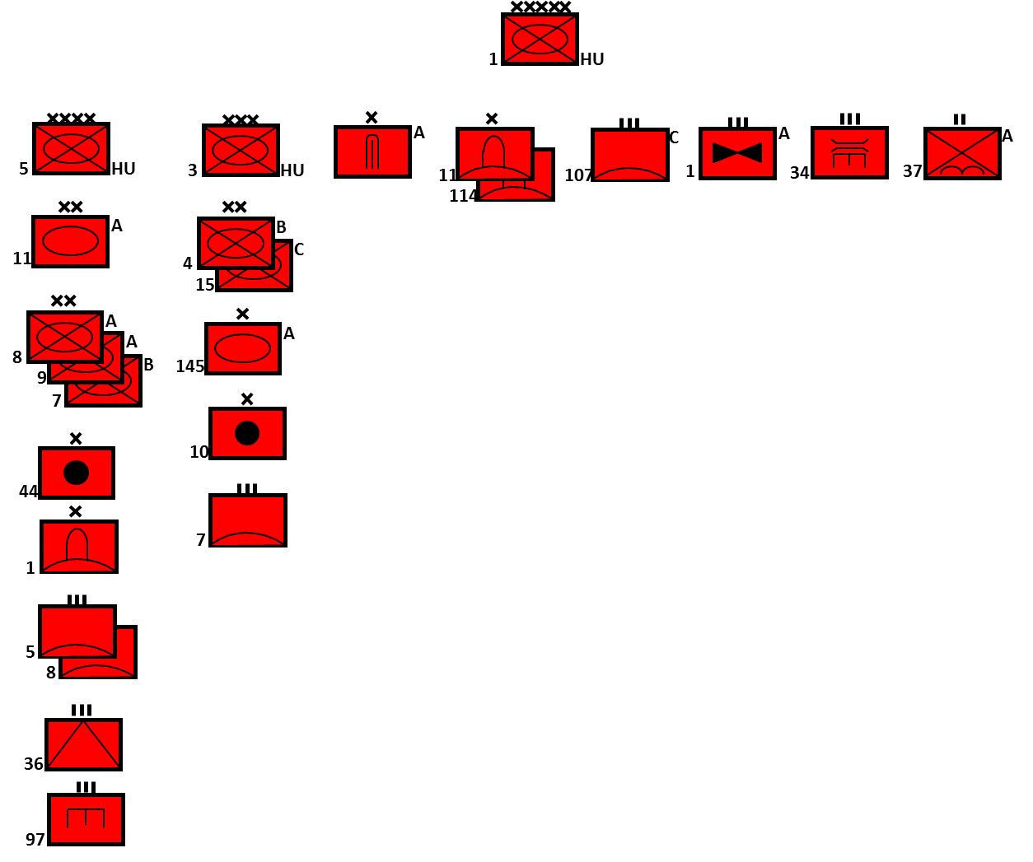

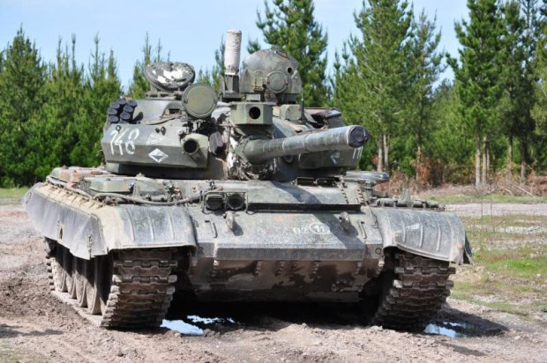

Organized largely along Soviet lines, much of the equipment such as the D-442 FUG-APC was designed and built domestically and exported to Poland as the FUG and Czechoslovakia as the OT-65 and the former East Germany as PSzH-IV, or the FUG-65 reconnaissance vehicle

|  |  |  |  |  |
| --- | --- | --- | --- | --- |
| **Role** | **Type** | **Variant** | **No** | **Remarks** |
| MBT | T-72 | T-72A | 100 | [T-72 Data](https://www.forecastinternational.com/archive/disp_pdf.cfm?DACH_RECNO=965) |
|  |  | T-72M | 150 |  |
|  |  | T-72M1 | 45 |  |
|  | T-54/55 | T-55AM | 144 |  |
|  |  | T-55AMH2 | 1200 |  |
|  |  | T-54 | 1800 | In storage |
|  |  | T-34/85 |  | In storage |
| IFV |  | BMP-1 | 502 |  |
| APC |  | BTR-80 | 691 | 178 are BTR-80A |
|  |  | BTR-60 | 165 | Plus AD |
|  |  | D-442 FUG | 1000 |  |
|  |  | BTR-50 | 150 |  |
| Recon |  | BRDM-2 | 300 |  |
|  |  | BWR-1D | ? |  |
|  |  | FUG-65 | 475 |  |
| Arty | 120mm | M-43 | 100 | Mortars |
|  | 122mm | M-30 | 225 | M-1938 WW2 era 122mm guns |
|  |  | 2S1 | 90 |  |
|  | 130mm | M-1943 | 50 | WW2 era 152mm guns |
|  | 152mm | 2S3 | 20 |  |
|  |  | D-20 | 100 |  |
|  |  | D-1 | 50 | WW2 era 152mm guns |
| AT | 85mm | D-44 | 100 |  |
|  | 100mm | D-12 | 50 |  |
|  | AT-3 | Sagger | 100 | Mounted on BRDM |
|  | AT-4 | Spiggot | 100 |  |
| MLR |  | BM-21 | 65 |  |
| SSM |  | Scud-B | 12 |  |
|  |  | Frog-7 | 12 |  |
| AAA | 57mm | S-60 | 80 |  |
|  | 23mm | ZSU 23-4 | 50 |  |
| SAM | SA-4 |  | 30 |  |
|  | SA-6 |  | 60 |  |
|  | SA-7 |  | 350 |  |
|  | SA-9 |  | 50 |  |

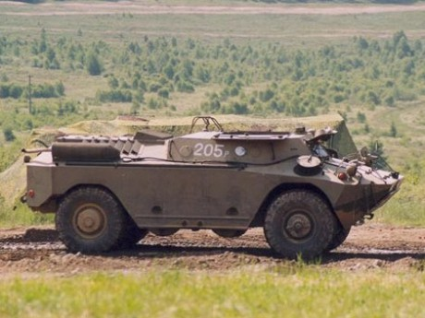

D-442 FUG

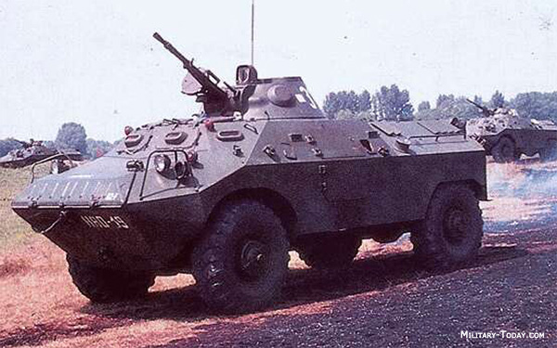

FUG-65