**Hungary** 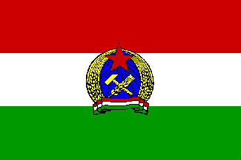

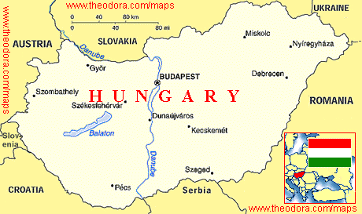

**Hungary** is one of the five remaining countries forming the Warsaw Pact but is a government at odds with its people. The current regime relies on Soviet assistance, both militarily and economically to remain solvent. To a lesser extent than in Czechoslovakia, displaced Soviet forces have established residence in Hungary, causing some violent friction with many localities. Hungarian state intelligence agencies have grown substantially and are kept quite busy maintaining visibility on dissident groups, and individuals traveling into the Balkans. The border with Austria is closed.

The Hungarian People’s Army (HPA) forms the bulk of the defence forces with a moderately sized but dated air force of about 230 combat aircraft. Recent arrivals of MiG-29 and Su-25s have greatly augmented capabilities which were otherwise all but perished. The Navy is composed of a fairly extensive riverine flotilla which will not be explored here.