**Polish Air Force**

The Polish Air Force is quite large with almost 1000 aircraft; unfortunately due to domestic turmoil it was suffering from failing maintenance and training. Organized along Soviet lines with an Air Force supporting the Army and an Air Defense Force focused solely on control of Polish airspace, the new reforms and organization promised by the Solidarity Government were largely stalled by intransigence and lack of political will or capacity. The one significant change that has occurred is that the Polish Naval Air Force has been folded into the Air Force. The domestic aircraft industry in Poland was very productive in throughout the Cold war, producing everything from light training/civil aircraft (PZL-104) and jet trainers (PZL I-22), to helicopters (PZL SM-2) to derivatives of the MiG-15 (PZL-Mielec Lim-1/2) and MiG-17 (PZL-Mielec Lim-5/6). As war breaks out in Northern Fury Poland is in even more disorder as military formations try and determine who is in control and where their loyalties lie.

**MiG-29**

Poland received 12 MiG-29 in 1989-1990 just before political troubles truncated any further delivery. Nine of the aircraft were MiG-29A while the remaining three were the training version (MiG-29UB). Allocated to the 1st Squadron of the 32nd Air Intercept Wing, these were meant to seize and maintain air superiority over the battlefield and prevent NATO aircraft, particularly the F-16 and A-10 from harassing Polish maneuver forces on the ground. Although they have the capacity for strike and close air support, this would be a purely secondary role for the Polish Fulcrums.

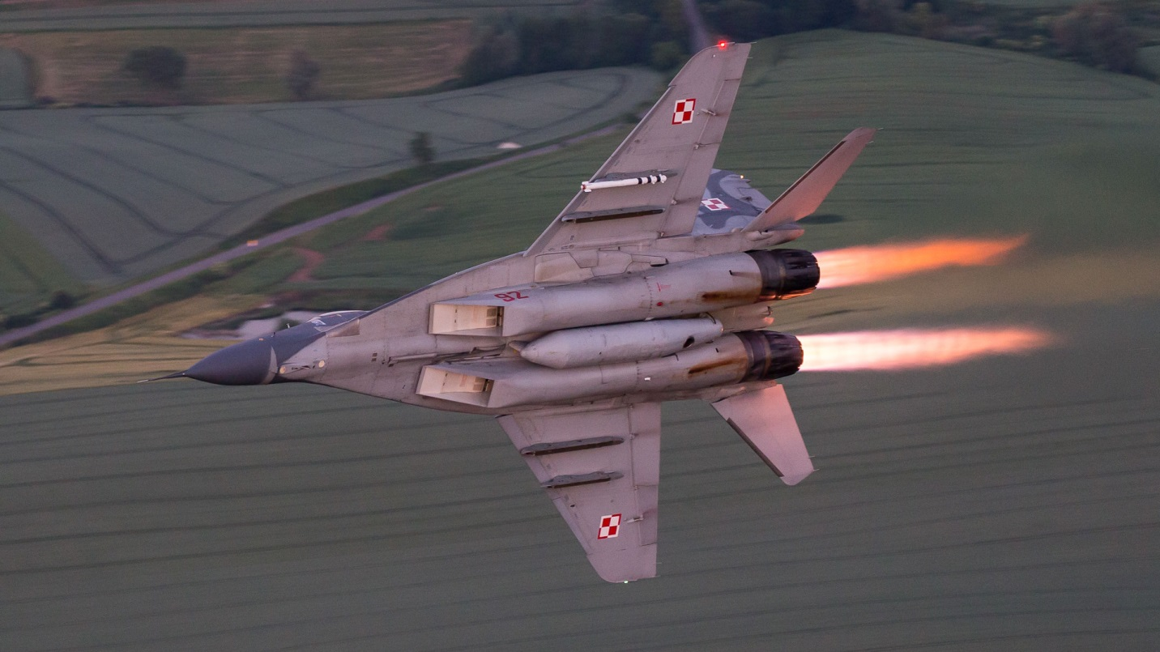

**MiG-23**

The Polish Air Force operated 36 MiG-23MF Flogger B’s and six MiG-23UB two seat training versions. The Floggers were also used primarily in the intercept mode to protect Polish ground formations although they could also be used in the ground attack role if needed.

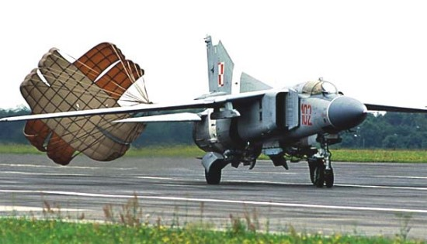

**MiG-21**

About 450 MiG-21 Fishbed are in service with about 100 more in reserve. Most of the more modern variants are maintained for the Air Defense role with 72 MiG-21bis, 120 MiG-21MF and 36 MiG-21M as well as one Regiment of 36 MiG-21PFM being the main component of the Air Defense force. The remaining Fishbeds in service are 90 MiG-21PFM in the Fighter Bomber role, 36 reconnaissance (R) versions supporting the army and about 50 two seat trainers (UB). There are about 80 older MiG-21PF as well as a few PFM, R and UB in ready reserve.

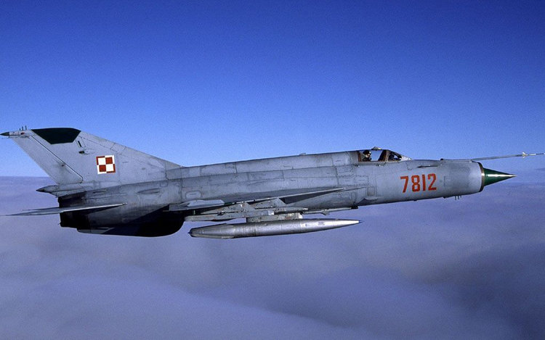

**Su-20/22**

The Su-20 and 22 Fitter are the primary ground attack aircraft used by the Polish Air Force. The 27 older Su-20s were acquired in the 1970s and are over-due for retirement or relegation to reserve status. During the 1980s 90 modern Su-22M4 were acquired with an intent to obtain a further 45, this later purchase was overtaken by the internal strife in the later part of the decade but 20 Su-22UM3K two seat trainers were delivered. The Fitters form the lead Regiment in each of the Fighter Bomber Divisions. About 40 of the much older Su-7 FITTER A variants are held in reserve.

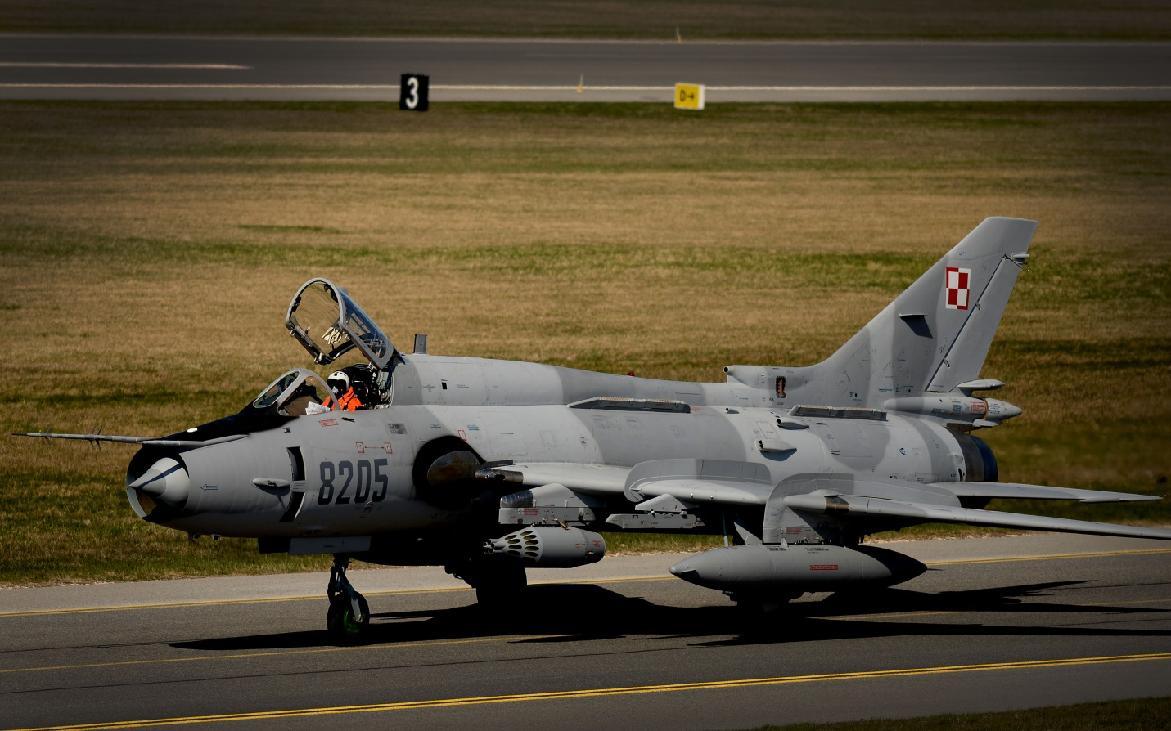

**Lim-6**

The domestic Polish aircraft industry was quite prolific and one of the main products was the Lim-6 Fresco, a derivative of the Soviet MiG-17. About 180 of these aircraft remain in service but are obsolete and poorly maintained. All have been upgraded to the Lim-6bis or are Lim-5 rebuilt to the same standard as the Lim-6M.

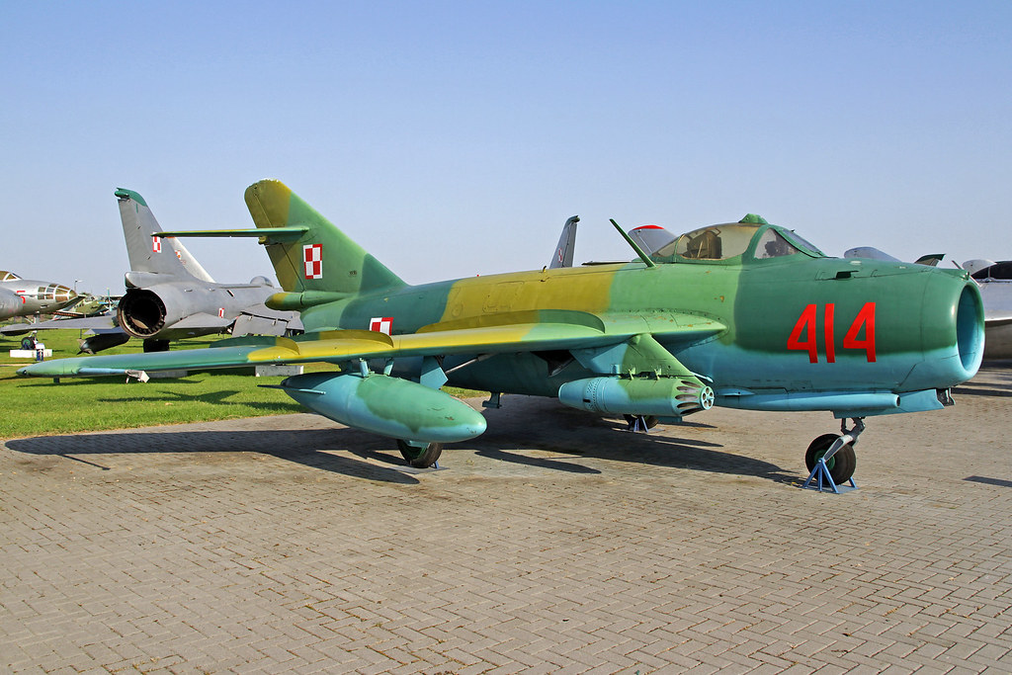

**Combat Aircraft organization**

|  |  |  |  |  |
| --- | --- | --- | --- | --- |
| 2nd F/B Div | Pila | Regt | 45x Su-22M4 |  |
|  |  | Regt | 45x MiG-21PFM |  |
|  |  | Regt | 45x Lim-6M/bis |  |
|  |  | Sqn | 12x Mig-21R |  |
| 3rd F/B Div | Swidwin | Regt | 45x Su-22M4 |  |
|  |  | Regt | 45x Lim-6M/bis |  |
|  |  | Regt | 45x Lim-6M/bis |  |
|  |  | Sqn | 12x Mig-21R |  |
| 4th F/B Div | Malbork | Regt | 27x Su-20 |  |
|  |  | Regt | 45x MiG-21PFM |  |
|  |  | Regt | 45x Lim-6M/bis |  |
|  |  | Sqn | 12x Mig-21R |  |
| 1st AD Corps | Minsk | 32nd Intercept wing | 12 x MiG-29A/UB  36x MiG-23 MF |  |
|  | Lask | Regt | 36x MiG21bis |  |
| 2nd AD Corps | Zegrze | Regt | 36x MiG21bis |  |
|  | Slupsk | Regt | 36x MiG21MF |  |
|  | Babie Doly | Regt | 36x MiG21M |  |
| 3rd AD Corps | Wroclaw | Regt | 36x MiG21MF |  |
|  | Mierzecice | Regt | 36x Mig-21MF |  |
|  | Pozanan | Regt | 36x MiG-21PFM |  |

**Surface to Surface Missile forces**

The Polish Air Force operates four Air Defense Brigades and one Regiment deployed at about 50 locations around the country. This force is in addition to Army Air Defences forces within the mobile formations. About 300 SA2 and SA3 systems are in operation.

**Air Transport**

The Polish Air Force operate a wide range of transport aircraft in three Regiments, two based in Warsaw (36th and 37th) and one in Krakow (13th). Together these units operate:

* 18x Yak-40 Codling
* 2x Tu-154 Careless
* 4x Tu-134 Crusty
* 6x Il-62 Classic
* 6x An-24 Coke
* 2x An-12 Cub
* 12x An-26 Curl
* 138x An-2 Colt (some retired)
* 25x M-28B Skytruck; Polish built, 19 passengers

**Helicopter Forces**

Two aviation Regiments support the Army and operate:

* 3x Mi-6 Hook
* 36x Mi-8 Hip
* 48x W-3; Polish built utility helicopter, 12 passengers
* 26x Mi-2 Hoplite

**Maritime Support**

Recently grouped as part of the air force, the maritime aviation elements are:

* 9x M28B Bryza 1R; Maritime patrol and reconnaissance
* 4x M28B Bryza 1E; Maritime ecological reconnaissance
* 12x Mi-14PL; ASW helicopter
* 4x Mi-14PS; SAR helicopter
* 4x Mi-2; Light utility and reconnaissance

**Training**

Air training is concentrated at the Air Force University located at Deblin which operates:

* 16x PZL I-22 Jet trainers
* 50x Mig-21UM
* 20x Su22UM3K
* 6x Mig-23UB
* 16x Mi-1 Hare

**Reserves**

Held in reserve are the following aircraft:

* 84 MiG-21PF
* 36 Mig-19
* 12 MiG-17
* 250 MiG-15
* 36 Su-7
* 700 Lim-1/2
* 200 Lim-5/6
* 72 Il-28
* 15 Il-28R
* 17 Il-14
* 5 Il-18
* 30 SM-1 (utility Helicopter)
* 17 Mi-4