**Polish Armed Forces** ([PVA](https://en.wikipedia.org/wiki/Polish_People%27s_Army_order_of_battle))

The Polish Army was organized along Soviet lines and until the rise of *Solidarity* was an integral part of Soviet plans. The army had some very good equipment, and despite the heavy reliance on conscript forces was highly trained in the early ‘80s, but has declined significantly in capability. Although the democratic government which came to power in late ’89 continued to fund the force, training and maintenance began to break down rapidly. Much of the old guard leadership was purged between 1989 and 1992 leaving significant gaps in experience as young western leaning officers were propelled into high places. From 1992 onwards, as failures in leadership and the outright breakdown in reorganization began to show, the PVA experienced increased pressure and influence from within to maintain many of the ‘old’ Soviet ways. Several of the new guard who had thrusted well beyond their abilities experienced a precipitous downfall, some were either summarily dismissed or jailed for corruption – real or perceived. The year before the start of Northern Fury was particularly tumultuous with a spike in suicides, high fatality rates during relatively simple training exercises and plummeting moral.

The three Combined Arms Armies (CAAs) consisted of a mix of Motor Rifle Divisions (MRD), Tank Divisions (TD) and supporting arms; these formations, like their Soviet equivalent have varying states of readiness:

* Category A-divisions which have 80% or more of their full strength
* Category B-those with between 30% and 50%
* Category C-those with between 5% and 10%

However, due to the troubles with leadership, moral, maintenance and training, these levels of readiness are hugely optimistic. Category A formations should be ready to move in the matter of a few hours, but with the exception of the Naval Infantry and Airborne Divisions will likely take several days to organize. Category B which are supposed to be ready in about 72 hours will likely take a week or more and Category C, if they mobilize at all will take longer than their prescribed 60 days.

Throughout the Cold War Polish forces were destined to join the Soviet Northern Group of Force, largely stationed in Poland, however, the unification of Germany and the democratic revolution in Poland significantly changed this plan. Although Poland is independent at the start of Northern Fury, the Soviet plan, which is known to some key Polish leaders involved in the 13 Feb Coup, is for the 1st Polish Army to join forces from the Baltic and Belorussian Military Districts advancing west into unified Germany. As the 2nd and 3rd Polish Armies come on line they will reinforce this thrust. There are special tasks assigned to both the 6th Airborne and 7th Naval infantry Divisions as well as the 3rd Surface to Surface Missile (SSM) Brigade, all of which are at a surprisingly high state of readiness.

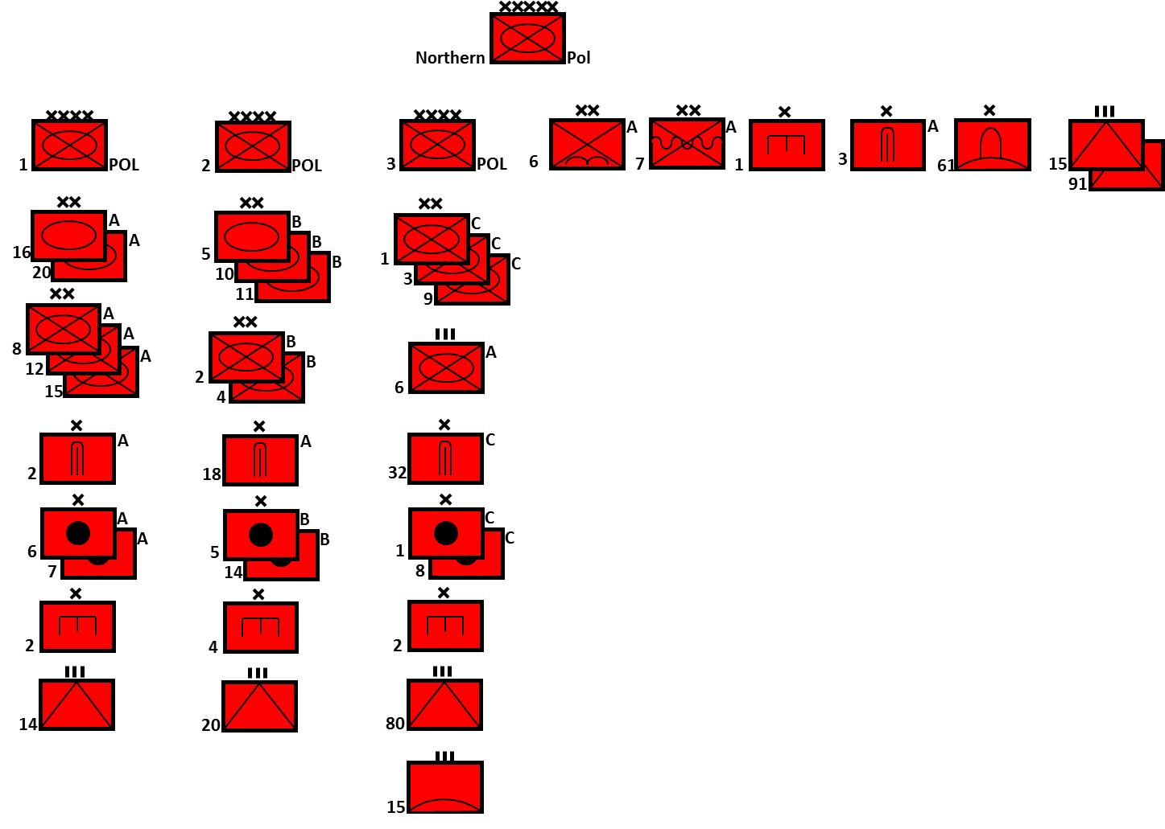

Although organizationally Polish units were almost identical to the Soviet design, much of its equipment was manufactured in Poland or in cooperation with Czechoslovakia. The basic designs were Soviet but Poland improved them in many ways and built a large export market within the Warsaw Pact and around the world.

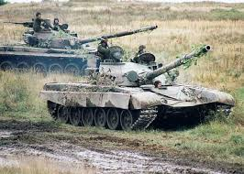

|  |  |  |  |  |
| --- | --- | --- | --- | --- |
| **Role** | **Type** | **Variant** | **No** | **Remarks** |
| MBT | T-72 | T-72PT91 | 98 |  |
|  |  | T-72M | 135 |  |
|  |  | T-72M1 | 586 |  |
|  | T-54/55 | T-55AM | 1207 |  |
|  |  | T-55M | 1000 |  |
|  |  | T-55 var | 1000 | In storage |
|  |  | T-54AM | 2000 | In storage |
|  |  | T-34 | 200 | Storage |
| IFV |  | BMP-1 | 1409 |  |
|  |  | BMP-2 | 62 |  |
| APC |  | BTR-60 | some |  |
|  |  | BTR-50 | some |  |
|  |  | OT-90 | 100 |  |
|  |  | OT-64 | 2700 |  |
|  |  | OT-62 | 200 |  |
| Recon |  | BRDM | 585 |  |
|  |  | BWR-1D | 38 |  |
|  |  | FUG | 100 |  |
| Arty | 120mm | Mor | 554 |  |
|  | 122mm | M-1938 | 715 |  |
|  |  | 2S1 | 498 |  |
|  |  | D-30 | 400? |  |
|  | 152mm | D-20 | 166 |  |
|  |  | Dana | 111 |  |
|  | 203mm | 2S7 | 8 |  |
| MLR |  | RM-70 | 30 |  |
|  |  | BM-21 | 232 |  |
| SSM |  | Frog-7 | 40 |  |
|  |  | Scud-B | 25 |  |
| AT | 85mm | D-44 | 722 |  |
|  |  | AT-3 | 271 |  |
|  |  | AT-4 | 115 |  |
|  |  | AT-5 | 18 |  |
|  |  | AT-6 | 8 |  |
| AAA | 57mm | S-60 | 500 |  |
|  | 23mm | ZSU 23-2 | 445 |  |
|  |  | ZSU 23-4 | 160 |  |
| SAMs | SA-6 |  |  |  |
|  | SA-7 |  |  |  |
|  | SA-9 |  |  |  |
|  | SA-13 |  |  |  |
|  |  |  |  |  |

