**Poland** 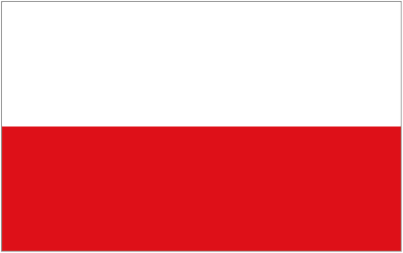

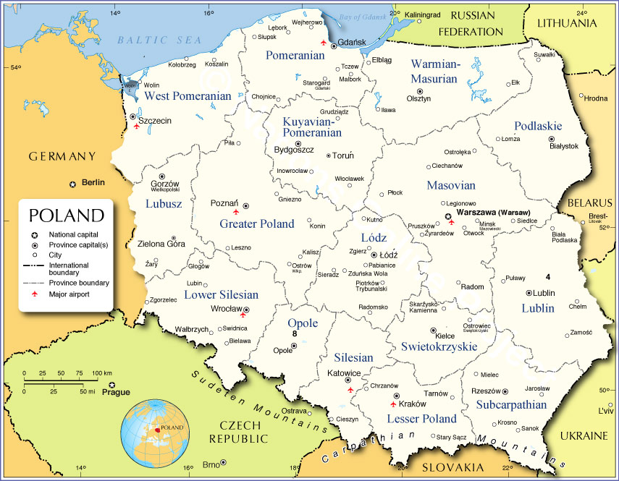

**Poland** is no longer a member of the Warsaw Pact, it relinquished its status in January 1991 after the Communist government was overthrown by the Solidarity movement and Lech Walesa was elected as president on 9 Dec 1990. Civil strife and turmoil have been almost nonstop from that moment forward however, and many calls to return to the stability of the ‘old ways’ ring throughout the country. A reorganization of the military was embarked upon through the summer of 1991 but the chaos that resulted from misdirection, poor communications, misappropriation of funds and deliberate obstinance brought the program to a halt by early 1992.

Low morale, poor leadership, atrocious maintenance and lack of training have crippled the Polish military for the past three years.

Poland is ripe for a change, and that change is likely unwelcome in the west.