**Romanian Air and Air Defence Forces**

The Romanian Air Force operates about 270 front line combat aircraft, 40 helicopters, 20 transport and about 100 training aircraft as well as many air defence missile systems. Although mostly dated by 1994, there is a thriving domestic aviation industry which produces Mi-8/17 helicopters and IAR-93 ground attack aircraft. The primary focus of the air force is to support the Army in its dual role of reinforcing Bulgaria to the south and Hungary to the northwest. There are no Soviet air elements hosted in Romania but there are plans for immediate reinforcement in the event of war.

**MiG-21**

These are quite dated and primarily used in the ground support role and in follow on strikes. There are over 150 in reserve including 100 Air Defence **MiG-21PFM** and **MiG-21PF** ‘Fishbed F’. Under development is the MiG-21 Lancer, production and exchange of technology limitations however will delay production into 1995.

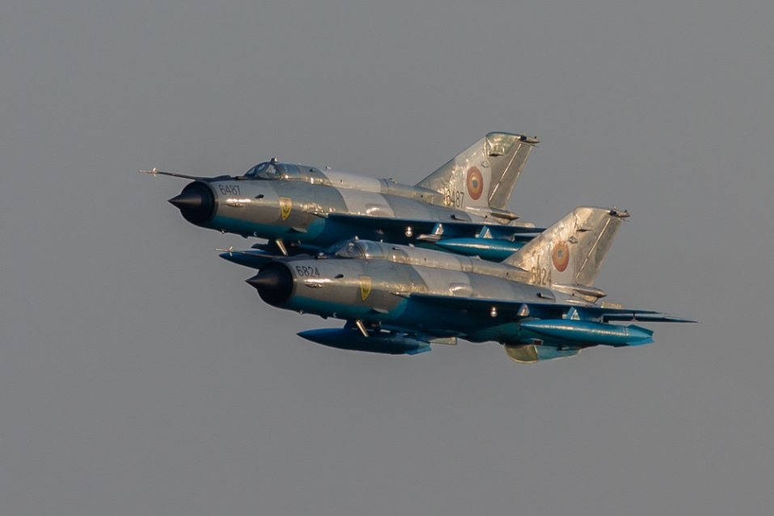

There are three versions of 2nd generation **MiG-21s** in service, the **MiG-21RF** Fishbed-H reconnaissance variant, nine of the original 12 remain in service. Forming the backbone of the air force with about half of the combat aircraft is the Fishbed-J, there are 68 **MiG-21M** and 110 **MiG-21MF** Fishbed-J in operation, 35 ‘**MF**s’ having been transferred to Romania from the former East Germany. Additionally about 35 two seat training variants operated in the air combat training schools, these are a mix of **MiG-21US** and **MiG-21UM** Mongol-B, with advanced avionics. All fighter pilots spent time on this type to learn the basics of air combat.

|  |  |  |  |  |
| --- | --- | --- | --- | --- |
| **Unit** | **Location** | **Type** | **No** | **Remarks** |
| 59th Ftr Regt | Timisoara AB | MiG-21MF | 35 | From DDR |
| 71st Ftr Regt | TurziiAB | MiG-21MF | 35 |  |
| 86th Ftr Regt | Borcea AB | Mig-21MF | 35 |  |
| 90th Ftr Regt | Bucharest AB | Mig-21MF | 25 |  |
|  |  | MiG-21RF | 9 |  |
| 91st Ftr Regt | Craiova AB | MiG-21M | 35 |  |

**MiG-23**

The Romanian air force operates one regiment of 33 **MiG-23MF** Flogger-B in the air superiority role. Although the aircraft is capable of air to ground operations, that is generally left to the MiG-21s. There six of the original 10 **Mig-23UB** training versions.

|  |  |  |  |  |
| --- | --- | --- | --- | --- |
| **Unit** | **Location** | **Type** | **No** | **Remarks** |
| 93rd Ftr Regt | Timisoara AB | MiG-23MF | 33 |  |

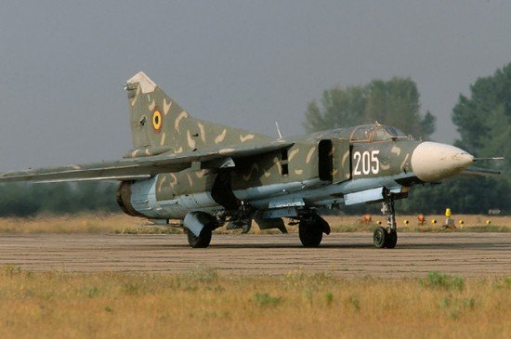

**MiG-29**

The most modern and capable aircraft available is the **MiG-29A**. A true multi-roll 4th generation aircraft able to match NATO air superiority fighters on a nearly equal bases, the Fulcrum is very advanced, highly maneuverable, and quite rugged. Romania received 17 Fulcrum A of which 13 remain in service plus 4 two seat ‘UB’ trainers.

|  |  |  |  |  |
| --- | --- | --- | --- | --- |
| **Unit** | **Location** | **Type** | **No** | **Remarks** |
| 57th Ftr Regt | Constanta AB | MiG-29A | 13 |  |
|  |  | MiG-29UB | 4 | Combat capable |

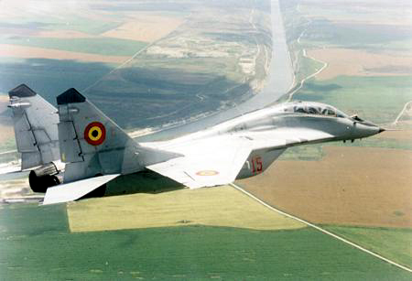

**IAR-93B**

The IAR-93 Vulture is a ground attack replacement for the older MiGs in Romanian and Yugoslav service. Designed and built in Romania (called the Orao in Yugoslavia), these are rugged, capable aircraft. Romania received 41 pre-production and ‘A’ variants with sub-sonic engines and 27 ‘B’ versions with afterburning engines, improved efficiency, hard-points and several other features. There were also 15 ‘MB’ variants with the airframe of the ‘B’ and the subsonic engines of the ‘A’. In Northern Fury, the 15 ‘MB’s were equipped with the better engines enabling the air force to field 42 IAR-93B.

|  |  |  |  |  |
| --- | --- | --- | --- | --- |
| **Unit** | **Location** | **Type** | **No** | **Remarks** |
| 49th Ftr Regt | Timisoara AB | IAR-93B | 20 |  |
| 67th Ftr Regt | Craiova AB | IAR-93B | 20 |  |

