**Romanian People’s Army (RPA)**

The Romanian Army is organized along Soviet lines but was long isolated from the Soviet Army by Nicolae Ceausescu’s hard line economic policies. Prohibited from importing equipment or even spare parts for existing equipment, Romanian industry created copies of Soviet equipment – almost all of a very inferior design. The dissolution of Yugoslavia into separate states and drawing NATO forces nearly adjacent to the Romanian border was a major factor in the renewed interest of the Soviet high command in bolstering the RPA. With the change in Soviet government in 1991, an agreement was reached where former East German (DDR) equipment, which had been temporarily held under Soviet protection, was gifted to Romania in a show of support and comradeship. Many believe it was the support given to Ceausescu by Soviet agencies in routing out dissident groups which convinced him to change his policy.

The long-standing plan for the RPA was to maintain four Combined Arms Armies (CAA), each roughly Corps strength by NATO standards. Romania would not field a ‘Front’ HQ but dispatch its CAAs to support other areas. One CAA (probably 1st) would be deployed to Bulgaria and reinforce the Balkan Front while the other three would follow the Czech and Hungarian forces into Germany as part of the Western Group of Forces. It is very possible however that this overall deployment plan has changed, and it is possible that Romania will now form a FRONT HQ – probably called the Serbian Front. This new organization, reinforced by Soviet and possibly Hungarian forces would move to prevent NATO interference in the former Yugoslavia.

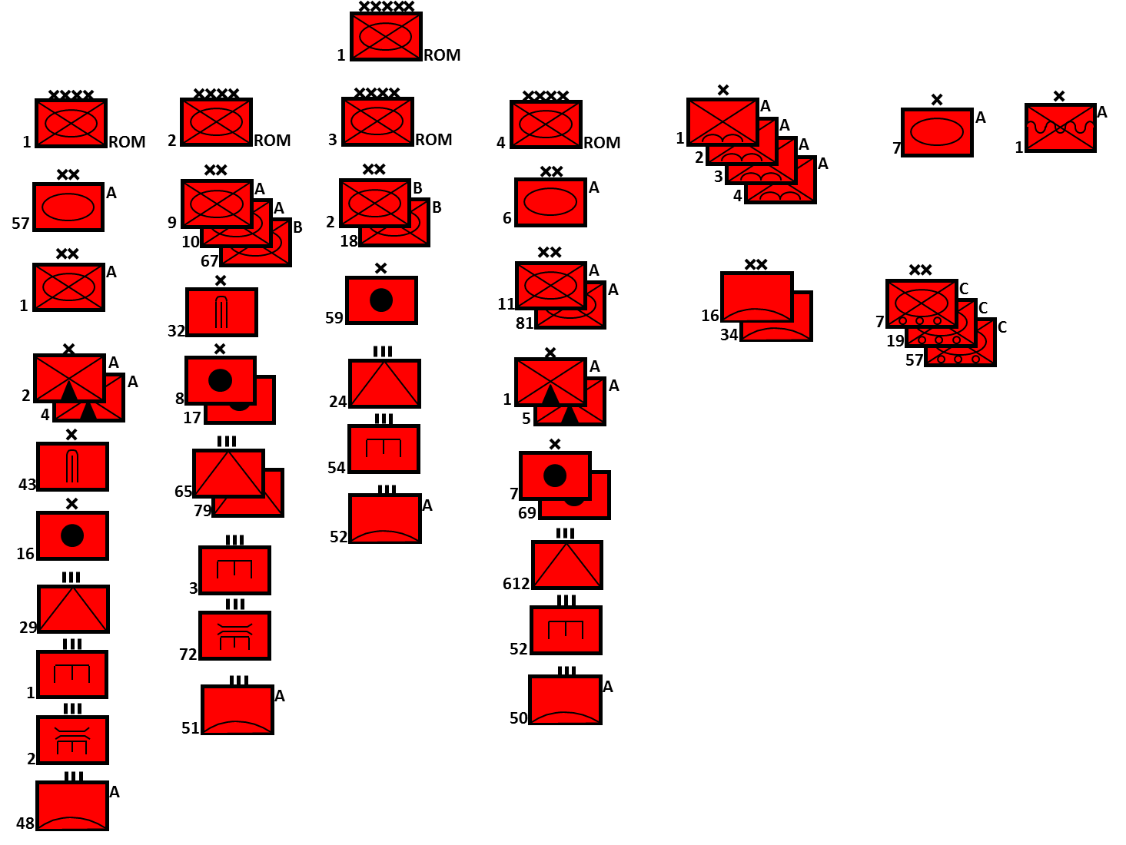

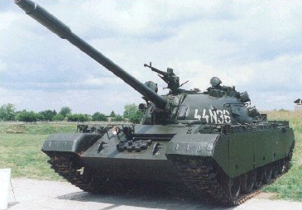

|  |  |  |  |  |
| --- | --- | --- | --- | --- |
| **Role** | **Type** | **Version** | **No** | **Remarks** |
| MBT | T-72 |  | 254 | Former DDR |
|  | T-72M |  | 193 | Former DDR |
|  | T-72M1 |  | 136 | Former DDR |
|  | T-55 | T-55AM | 850 | Romanian Conversions |
|  |  | TR-580 | 400 | Romanian design |
|  |  | TR-85 | 300 | Romanian design |
| IFV | BMP-1 |  | 1133 | Former DDR |
|  | MLI-84 |  | 156 | Romanian derivative of BMP-1 |
| APC | MLVM |  | 88 | Romanian design for mountain troops |
|  | TAB-33 |  | 69 | Romanian version of BTR-80 |
|  | TAB-77 |  | 167 | 4x4 Version of the BTR 70 for Recon |
|  | TAB-71 |  | 1872 | Romanian version of BTR-60 |
|  | BTR-60 |  | 1387 | 1,000 Former DDR |
|  | BTR-50 |  | 1000 | Mostly in storage |
| Recon | BRDM-2 |  | 621 | 500 Former DDR |
|  | TABC-79 |  | 430 | Romanian version of BTR-70 |
| Arty | 76mm | M82 | ? |  |
|  | 120mm | M1982 | 314 | Mortar |
|  | 122mm | M30 | 204 |  |
|  |  | 2S1 | 6 |  |
|  |  | M1989 | 42 | Romanian version of a 2S1 |
|  | 130mm | M-46 | 75 |  |
|  | 152 | M81 | 329 | Romanian copy of D-20 |
|  |  | M85 | 111 | Gun/Howitzer variant |
| MRL |  | APR-40 | 352 | Romanian version of a BM-21 |
|  |  | BM-21 | 100? |  |
|  |  | M-51 | 50? |  |
| AT | 100mm | M1977 | 208 | Romanian version of a T-12 |
|  |  | SU-100 | 175 | Assault guns |
|  | Malyutka | 9P122 | 12 | AT-3 Sagger B on BRDM-2 |
|  |  | 9P133 | 78 | AT-3 Sagger C on BRDM-2 |
|  |  | 9P148 | 48 | AT-4 Spigot on BRDM-2 |
|  | AT-4 |  | ? |  |
|  | AG-9 |  | ? | 73mm Recoilless Rifle on wheeled vehicle |
| AAA | 14.5mm | ZU-2 | ? | Twin AAMG, Romanian manufactured, several other variants |
|  | 23mm | ZSU-24-4 |  |  |
|  | 30mm | M1980/88 | 300 | Twin AAA |
|  | 100mm | KS-19 | 180 | 30 Batteries |
| SAM | SA-2 | S-75 | 98 | 18 Batteries |
|  | SA-3 | S-125 |  |  |
|  | SA-5 | S-200 |  |  |
|  | SA-6 | 2K12 | 40 | 8 Batteries |
|  | SA-8 | 9K33 | 24 | 4 Batteries |
|  | SA-9 | CA-95 | 48 | Romanian version |
| MANPAD | SA-7 | CA-94 | 297 |  |
| SSMs | SCUD-B |  | 18 |  |
|  | FROG-7 |  | 30 |  |

